**THE ARTIST & ARTWORK OF DISNEY’S FROZEN: MARVEL, STAR WARS, & DC COMICS COME TO TAMPA FOR THE HOLIDAYS!**

**EXPERIENCE A KINKADE HOLIDAY: A THOMAS KINKADE STUDIOS PRESENTATION IN ASSOCIATION WITH ROAD SHOW COMPANY**

**APPROVED EDITORIAL PRESS ASSETS:** [**CLICK HERE FOR APPROVED PRESS ASSETS**](https://nam04.safelinks.protection.outlook.com/?url=https%3A%2F%2Fwww.dropbox.com%2Fsh%2F6vgf9nf143u5kk9%2FAABeB96Ceku0E5gsqv2PSGJna%3Fdl%3D0.&data=05%7C01%7Ccleblanc%40firstcoastnews.com%7C1298c54b631c4f02288008da7fa065e1%7Cccd8a79b7268413b878971f8b6f4c0df%7C1%7C0%7C637962624151556441%7CUnknown%7CTWFpbGZsb3d8eyJWIjoiMC4wLjAwMDAiLCJQIjoiV2luMzIiLCJBTiI6Ik1haWwiLCJXVCI6Mn0%3D%7C3000%7C%7C%7C&sdata=3BVS1hka%2FOWdrdoDWlsqBjjadgrdrAG%2FRJD96uJAKC0%3D&reserved=0)

**PRESS & MEDIA INQUIRIES :  ZAC KINKADE IN PERSON:  AVAILABLE FOR INTERVIEWS VIA ZOOM/IN STUDIO/IN GALLERY/VIA TELEPHONE**

**Allison Zucker-Perelman**

[**allison@relevantcommunications.net**](mailto:allison@relevantcommunications.net)

**561.715.9525**

**THE ARTIST & ARTWORK OF DISNEY, MARVEL, & STAR WARS COME TO TAMPA FOR THE HOLIDAYS!**

**A THOMAS KINKADE STUDIOS PRESENTATION IN ASSOCIATION WITH ROAD SHOW COMPANY & MICHAEL MURPHY GALLERY**

***Tampa: Florida November 2022***:  [Michael Murphy Gallery](http://www.michaelmurphygallery.com/), Tampa’s premier contemporary art space, presents, in a limited engagement presentation, ***Christmas with Kinkade.*** This is a new exhibition from Thomas Kinkade Studios featuring Disney, Marvel, DC, and Star Wars characters. Works will be on exhibition and available for acquisition at the gallery from December 2 through December 11, 2022. Four not to be missed receptions with **Zac Kinkade** are planned for **Friday, December 9 from 5-7pm, Saturday, December 10 from 12-2 pm and 4-7 pm as well as Sunday, December 11 from 12-3 pm**. Bring the kids to a special fun-filled children’s event on Saturday, December 10from 11am-noon. All events are complimentary and open to the public. For additional information about this exhibition, contact 813-902-1414 or email [gallery@mmgart.com](mailto:gallery@mmgart.com). For more information, visit [www.mmgart.com](http://www.mmgart.com).

**ZAC KINKADE**

**Zac Kinkade will be appearing live in gallery in Tampa: Meet the Artist who carry on the extraordinary work of legend Thomas Kinkade and who create**

**these Iconic and highly Collectible works.  Experience the legacy.**

**Disney: A Victorian Christmas**

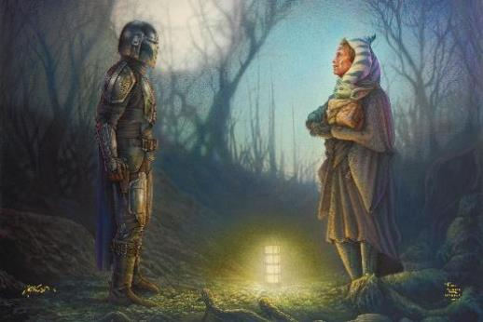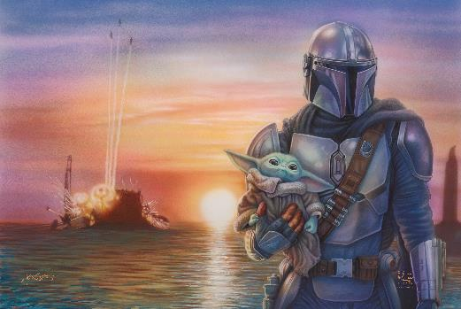

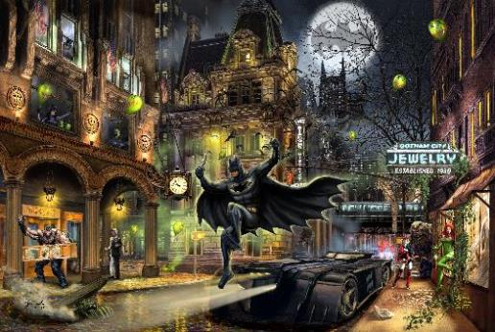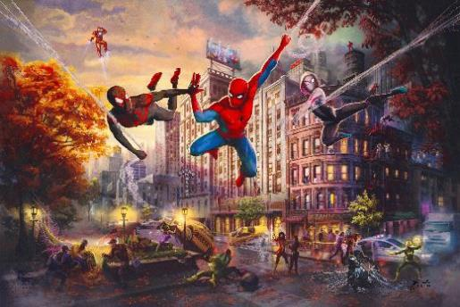

Batman™ Gotham City™    Spider-Man and Friends: The Ultimate Alliance

                        Disney Mickey and Minnie in Florida      Disney’s Frozen

|  |
| --- |
| **Photo Credits & Copyright Notices for all editorial usages must appear.**  **DISNEY VERSION**  **© The Thomas Kinkade Estate. All Rights Reserved.** |
| **© Disney** |
| **© & ™ Lucasfilm Ltd.** |
| **©2022 MARVEL** |
| **DC VERSION**  **© The Thomas Kinkade Estate. All Rights Reserved.**  **BATMAN and all related characters and elements © & ™ DC Comics. (s22)** |
| **SUPERMAN and all related characters and elements © & ™ DC Comics. (s22)** |
| **WONDER WOMAN and all related characters and elements © & ™ DC Comics. (s22)**   |