The Peter Max Experience! Comes to Santa Monica Place

Media Inquiries:

Allison Zucker-Perelman
allison@relevantcommunications.net
DD 561.715.9525

Interviews Available w/ Noted Peter Max Collection Curator Lesley Smith

Approved High Resolution Press Assets

The Peter Max Experience! Comes to Los Angeles

Los Angeles, California June 2022 Immerse yourself in the world of Iconic Pop Artist Peter Max as you have never seen it. The music, the art, the culture, the EXPERIENCE of the 60s and 70S. The Peter Max Experience is complimentary and open to the public in a limited engagement POP-UP presentation at the Road Show Gallery at Santa Monica Place (395 Santa Monica Place, Unit 166 – between Nordstrom and Tiffany & Co.). This exhibition is THE curated Collection of the finest original work of artist Peter Max: Previews begin on Friday, July 15, 2022 with an amazing opening party from 6-8 pm, and extends through Sunday, July 24; with two limited engagement, not-to-be-missed Gallery receptions complimentary to the public: Saturday, July 23 from 1-3pm and 6-8pm and Sunday, July 24 from 12-3 pm. Peter Max Curator Lesley Smith accompanies the Collection to LA. All artworks are on exhibition and available for acquisition. All events are complimentary and open to the public however RSVPs are requested at 866-900-6699 or Max@roadshowcompany.com. Private & Virtual Appointments Available Upon Request. All CDC Guidelines Observed. For more information, visit www.roadshowcompany.com

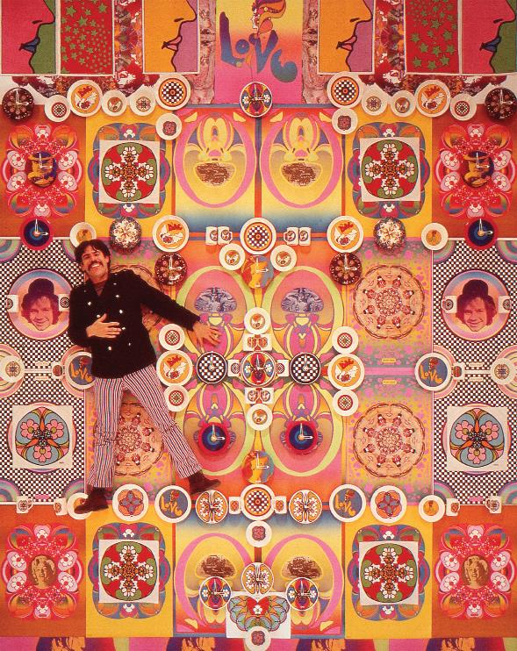
IMAGE: PETER MAX

POP ART ICONS: PETER MAX PAYS TRIBUTE TO ANDY WARHOL

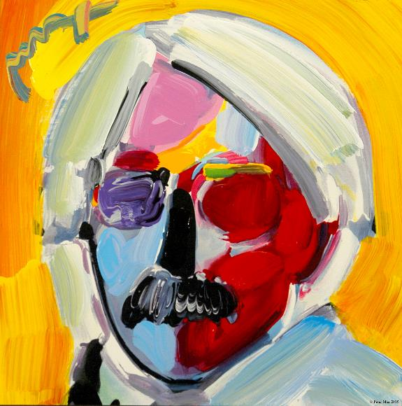
Image: Andy Warhol by Peter Max

Peter Max has had the distinct honor of being named the Official Artist of the Grammys, Super Bowl, World Cup Soccer
and the Official Artist of the Rock & Roll Hall of Fame

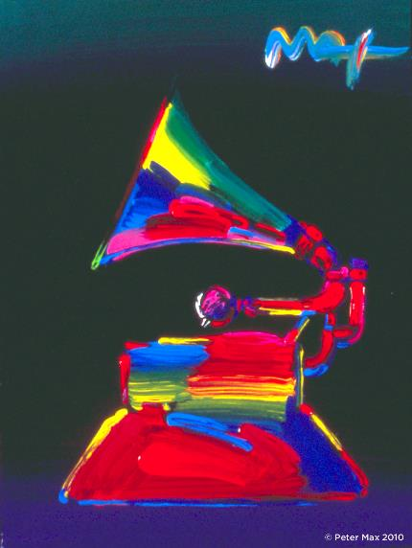

Image: THE GRAMMY

Celebrating the Pop Art Movement, Music and Artistic Vision:

Limited Engagement – July 15th through July 24th , 2022

Premier Original Signature Posters Circa 1960’s,1970’s On Exhibition

CLICK HERE FOR FULL PETER MAX POSTER CATALOG Peter Max Vintage Posters
All works will be on exhibition and available for acquisition, including a globally exclusive presentation of Peter Max Posters, circa 1960’s-1970’s. These are each signed and dated by the Artist, and their provenance and rarity are accompanied by an Exhibition at New York’s renowned Posterhouse Museum.

Over 100 works will be on exhibition and available for acquisition, including a globally exclusive presentation of Peter Max Posters: circa 1960-1970. These are signed and dated by the Artist, and their provenance and rarity are accompanied by New York’s renowned Posterhouse Museum Posterhouse Museum NYC: its’ presentation of the “PETER MAX: COSMIC ADVERTISING” Exhibition premiered Fall, 2021. This Exhibition truly honors and celebrates the artwork of the Iconic American Artist, and further solidifies the extraordinary legacy of the Artist and his works.

With paintings on exhibition in hundreds of museums and galleries worldwide, Peter Max and his vibrant colors have become part of the fabric of contemporary culture. Max has been successively called a Pop Icon, Neo Fauvist, Abstract Expressionist, and the United States "Painter Laureate."
The artist has had the distinct honor of painting the last seven Presidents of the United States and the world's best loved celebrities, among them the young sensation Taylor Swift and the amazing talents of “The Voice”

An ardent Environmentalist, Peter Max has been at the forefront of Environmental Preservation efforts for over five decades.

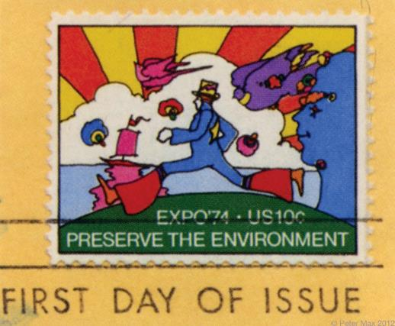

The First Environmental U.S. Postage Stamp
As Max’s poster art is associated with the spirit of ecology, the U.S. Postal Service commissions the artist to create the first ten-cent postage stamp commemorating Expo ’74 World’s Fair in Spokane, Washington. Max uses the line, “Preserve the Environment.”

“Throughout the years, I have painted so many beautiful, beautiful, imaginative musicians: Mick Jagger, Sting, The Beatles, David Bowie, Duke Ellington, Frank Sinatra, Pharrell Williams, Quincy Jones, Michael Jackson, Elton John, Jon Bon Jovi, Yes, Phil Collins, Gwen Stefani, Steven Tyler, Aretha Franklin, Norah Jones, Taylor Swift, Blake Shelton, Adam Levine and so many others. It’s mind-blowing when I think about it. I love great music and the amazingly talented people that make it.” Peter Max

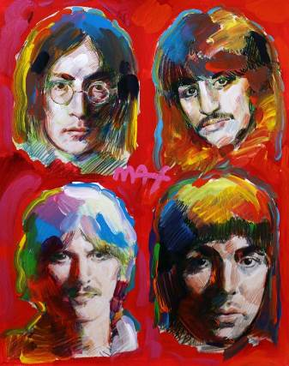
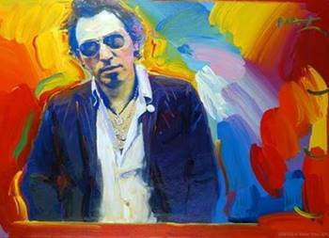
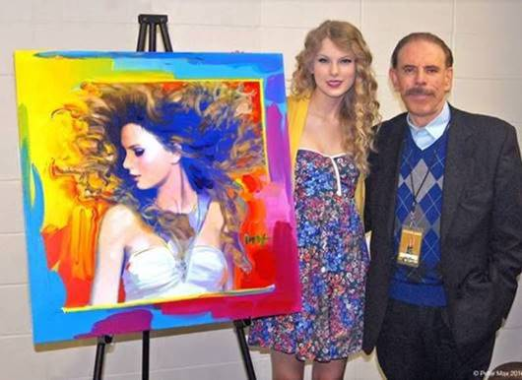
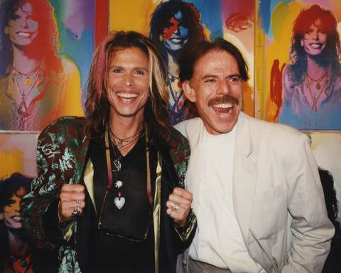
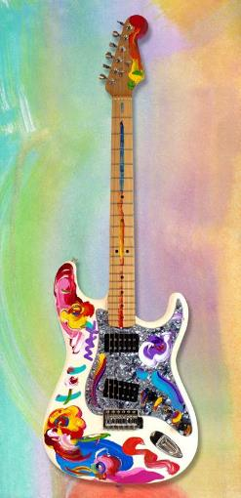

GUITAR ON EXHIBITION

“I really love my hand-painted Fender Telecaster guitars in this exhibition. I’ve painted some of my most iconic images on them: my Angel with Heart, Lady Liberty, my hearts, and a homage to da Vinci’s Mona Lisa. They’re colorful and unique. Guitar players and collectors tell me how much they love them”. Peter Max

Max’s "Be In" Love poster inspires several hundred thousand hippies to gather in New York City’s Central Park and immortalize the
Summer of Love.

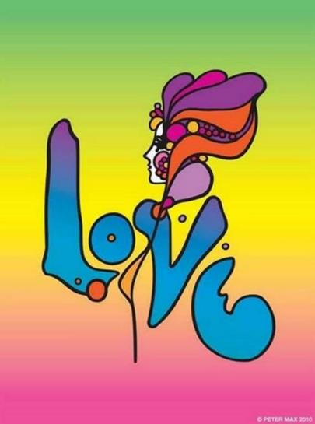

Image: LOVE All Images © ALP Inc.
Max’s iconic ‘Love,’ first created as his
acclaimed Art Nouveau-inspired ‘Love’
poster for the ‘60s generation, now
flows with his signature, expressionistic
brushstrokes.

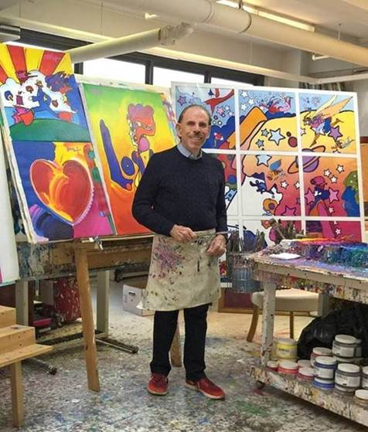

Image: The Artist in his Studio All Images © ALP Inc.

About Curator Ms. Lesley Smith: Ms. Smith is renowned for her tenure as a noted Peter Max historian and Collection Curator. Her work with the American Artist has spanned three decades and she remains a leading authority on the Iconic American Artist. Road Show Company is honored to have Ms. Smith in-gallery for the Los Angeles presentation.

