The Peter Max Experience! Comes to Omaha

Immerse yourself in the world of Iconic Pop Artist Peter Max as you have never seen it. The music, the fashion, the celebrity Icons, the culture, the EXPERIENCE of the 60s and 70s. The Peter Max Experience! is a not-to-be-missed Exhibition & is complimentary and open to the public in a limited engagement presentation at the Roberta & Bob Rogers Gallery in Omaha (1806 Vinton Street). This exhibition is a the most carefully curated Collection of the finest works of legendary Pop Icon American Artist Peter Max. Previews begin on Saturday, August 20, 2022 with a fabulous and fun opening party from 4-6 pm, and the exhibition extends through Sunday, August 28th 2022. Three limited engagement Gallery receptions are planned: Saturday, August 27 from 11am-1pm and 4pm-6pm and Sunday, August 28 from 12-3pm. Renowned Peter Max Curator Lesley Smith will accompany the Collection to Omaha and is available for in-gallery Q and A’s and discussions. This boutique Collection of Max’s works will be on exhibition and available for acquisition, including a unique presentation of never-before seen Peter Max Vintage Posters, circa 1960-1970. Each rare poster is signed and dated by the Artist, and their provenance is unparalleled. All events are complimentary and open to the public however RSVPs are requested at 402-496-4797 or jrogers@rbrg.org. Private & Virtual Appointments Available Upon Request. All CDC Guidelines Observed. For more information, visit www.rbrg.org . Do not miss this once-in-a-lifetime Experience at Omaha’s premier Art Space.

POP ART ICONS: PETER MAX PAYS TRIBUTE TO ANDY WARHOL

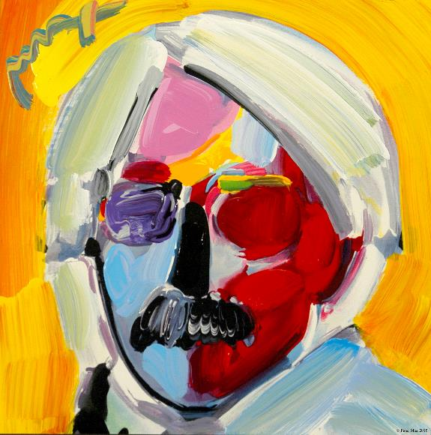
Image: Andy Warhol by Peter Max

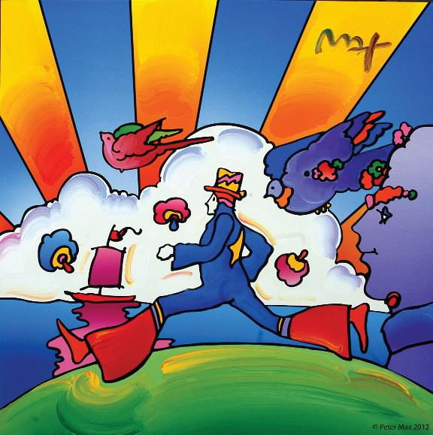

Image: Cosmic Runner - Peter Max

With paintings on exhibition in hundreds of museums and galleries worldwide, Peter Max and his vibrant colors have become part of the fabric of contemporary culture. Max has been successively called a Pop Icon, Neo Fauvist, Abstract Expressionist, and the United States "Painter Laureate."
The artist has had the distinct honor of painting the last seven Presidents of the United States and the world's best loved celebrities, among them the young sensation Taylor Swift and the amazing talents of “The Voice”

Premier Original Signature Posters Circa 1960’s,1970’s On Exhibition

CLICK HERE FOR FULL PETER MAX POSTER CATALOG Peter Max Vintage Posters

All works will be on exhibition and available for acquisition, including a globally exclusive presentation of Peter Max Posters, circa 1960’s-1970’s. These are each signed and dated by the Artist, and their provenance and rarity are accompanied by an Exhibition at New York’s renowned Posterhouse Museum.

Over 100 works will be on exhibition and available for acquisition, including a globally exclusive presentation of Peter Max Posters: circa 1960-1970. These are signed and dated by the Artist, and their provenance and rarity are accompanied by New York’s renowned Posterhouse Museum Posterhouse Museum NYC: its’ presentation of the “PETER MAX: COSMIC ADVERTISING” Exhibition premiered Fall, 2021. This Exhibition truly honors and celebrates the artwork of the Iconic American Artist, and further solidifies the extraordinary legacy of the Artist and his works.

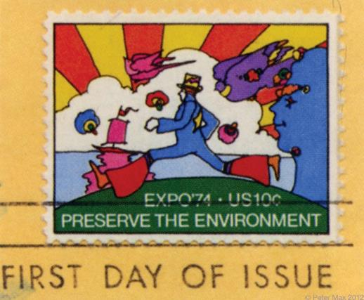

The First Environmental U.S. Postage Stamp
As Max’s poster art is associated with the spirit of ecology, the U.S. Postal Service commissioned the artist to create the first ten-cent postage stamp commemorating Expo ’74 World’s Fair in Spokane, Washington. Max uses the line, “Preserve the Environment.”

“Throughout the years, I have painted so many beautiful, beautiful, imaginative musicians: Mick Jagger, Sting, The Beatles, David Bowie, Duke Ellington, Frank Sinatra, Pharrell Williams, Quincy Jones, Michael Jackson, Elton John, Jon Bon Jovi, Yes, Phil Collins, Gwen Stefani, Steven Tyler, Aretha Franklin, Norah Jones, Taylor Swift, Blake Shelton, Adam Levine and so many others. It’s mind-blowing when I think about it. I love great music and the amazingly talented people that make it.” Peter Max

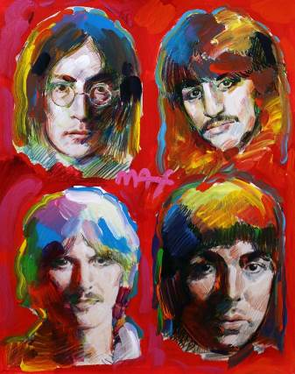
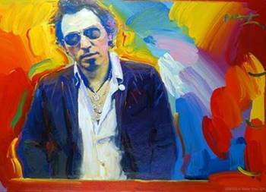
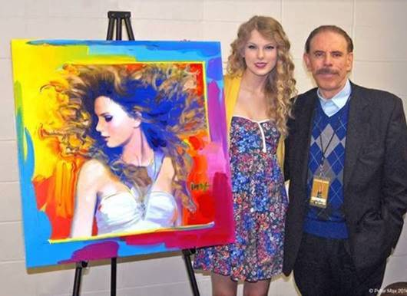
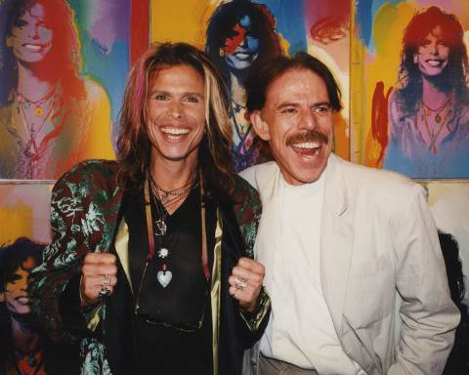

GUITAR ON EXHIBITION

“I really love my hand-painted Fender Telecaster guitars in this exhibition. I’ve painted some of my most iconic images on them: my Angel with Heart, Lady Liberty, my hearts, and a homage to da Vinci’s Mona Lisa. They’re colorful and unique. Guitar players and collectors tell me how much they love them”. Peter Max

Max’s "Be In" Love poster inspires several hundred thousand hippies to gather in New York City’s Central Park and immortalize the Summer of Love.

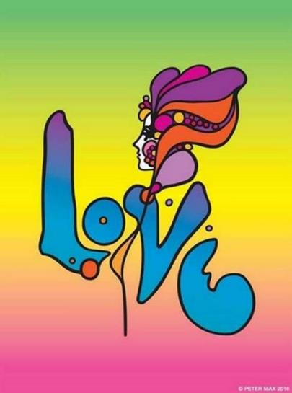

Image: LOVE All Images © ALP Inc.
Max’s iconic ‘Love,’ first created as his
acclaimed Art Nouveau-inspired ‘Love’
poster for the ‘60s generation, now
flows with his signature, expressionistic
brushstrokes.

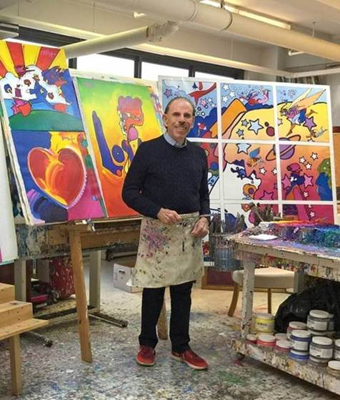

Image: The Artist in his Studio All Images © ALP Inc.

Max’s studies and training at the Art Students League and the School of Visual Arts, both in New York City, helped shape his extraordinary art and career. The Masters Series: interpretive works of Vincent Van Gogh, Monet, Pablo Picasso, Renoir, and Edgar Degas, are conceived in Max’s signature style and colors.

These works speak to both a maturation of the artist’s illustrious career, as well as to his formidable training at the 135-year-old Art Students League of New York and the cutting -edge School of Visual Arts in New York City.

Ms. Smith is renowned for her tenure as a noted Peter Max historian and Collection Curator. Her work with the American Artist has spanned three decades and she remains a leading authority on the Iconic American Artist. Road Show Company and the Christine Frechard Gallery are honored to have Ms. Smith in-gallery for this Omaha presentation.

