A ROAD SHOW COMPANY PRESENTATION

The Peter Max Experience Comes to Naples!

Limited Engagement: February 25th through March 6th 2022

THE MERCATO NAPLES

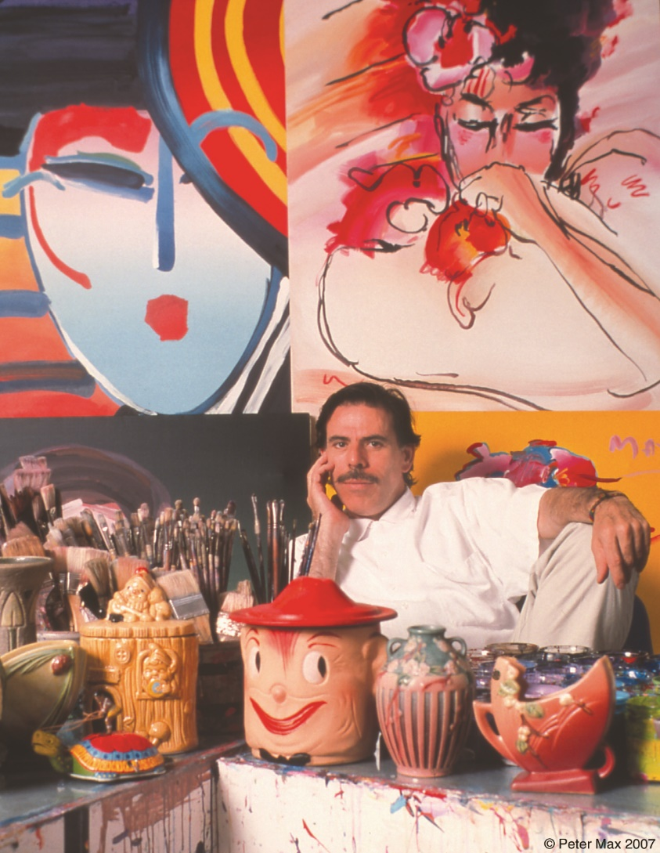

Immerse yourself in the world of Iconic Pop Artist Peter Max as you have never seen it! The music, the art, the culture, the EXPERIENCE of the 60s and 70S. The Peter Max Experience is complimentary and open to the public in a limited engagement presentation at Road Show Company Gallery in The Mercato (9105 Strada Place – Opposite Z Gallerie). The exhibition opens for previews on Friday, February 25. The Exhibition extends through Sunday,
March 6; with three limited engagement, not-to-be-missed Gallery receptions complimentary to the public: Saturday, March 5 from
2-4pm and from 6-8 pm and Sunday, March 6 from 12-3 pm. All artworks are on exhibition and available for acquisition. All events are complimentary and open to the public however RSVPs are requested at 866-900-6699 or rsvp@roadshowcompany.com. Private & Virtual Appointments Available Upon Request. All CDC Guidelines Observed.

