Iconic American Artist Peter Max Retrospective: CV Gallery brings back live artistic & cultural events to Indianapolis

Media Contact:

Allison Zucker-Perelman
allison@relevantcommunications.net
DD 561.715.9525

APPROVED PRESS ASSETS CLICK HERE FOR APPROVED PRESS HIGH RES IMAGES

The Peter Max Retrospective: Celebrating America, the Pop Art Movement, Music and Artistic Vision : In a global exclusive: Premier Original Signature Posters Circa 1960’s,1970’s On Exhibition

Exhibition To Present in Indianapolis 2021

Limited Engagement – October 2nd through October 10th 2021

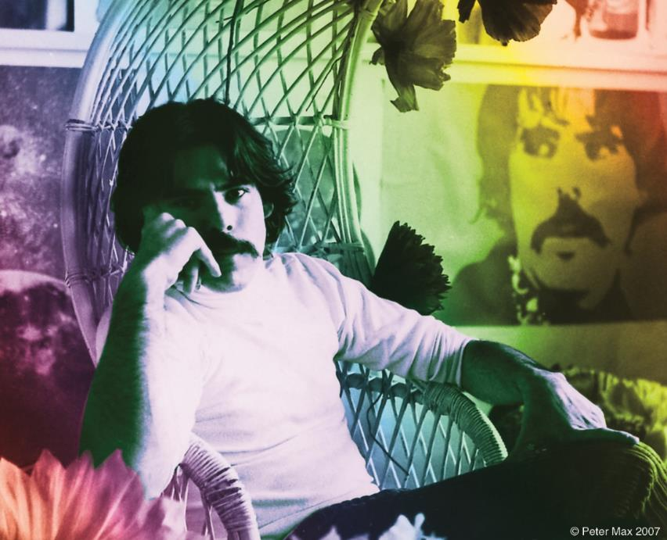
Image: The Artist in his Studio All Images © ALP Inc.

PETER MAX: The Retrospective 1960-2021
Collected Works from the Studio of America’s
Iconic Pop Artist
An artistic diversity that has defined American Art:
Captured by the Artist who began a new visual culture.

AN EXHIBITION OF OVER 100 WORKS FROM THE STUDIO OF AMERICA’S ICONIC ARTIST TO PRESENT IN INDIANAPOLIS

Indianapolis: Indiana August 2021: A Retrospective Collection, with a significant nod to music, the arts and the legacy of the Pop Art genre from the studio of artist legend, Peter Max, will be on exhibition and available for acquisition in a limited engagement presentation at CV ART GALLERY Indianapolis’ premier fine art gallery. The limited-engagement exhibition opens with a Preview reception on October 2nd and extends through October 10th, 2021.

EVENTBRITE LINK: CLICK HERE TO RSVP
110 South Main Street Zionsville, Indiana 46077

Over 100 works will be on exhibition and available for acquisition, including a globally exclusive presentation of Peter Max Posters, circa 1960-1970. These are signed and dated by the Artist, and their provenance and rarity is accompanied by New York’s renowned Posterhouse Museum Posterhouse Museum NYC: the museum has announced its’ presentation of the “PETER MAX: COSMIC ADVERTISING” Exhibition premiering Fall, 2021. This Exhibition truly honors and celebrates the artwork of the Iconic American Artist, and further solidifies the extraordinary legacy of the Artist and his works.

Two very special receptions are planned for Saturday, October 9th from 6-8 pm and Sunday, October 10th from
1-3 pm. All events are complimentary and open to the public. For more information, please contact the gallery at gallery@cvartandframe.com or 317.873.2976. RSVPs are requested through EVENTBRITE LINK: CLICK HERE TO RSVP The Gallery observes all present CDC Guidelines. Private appointments are available upon request, both in-person and virtually.

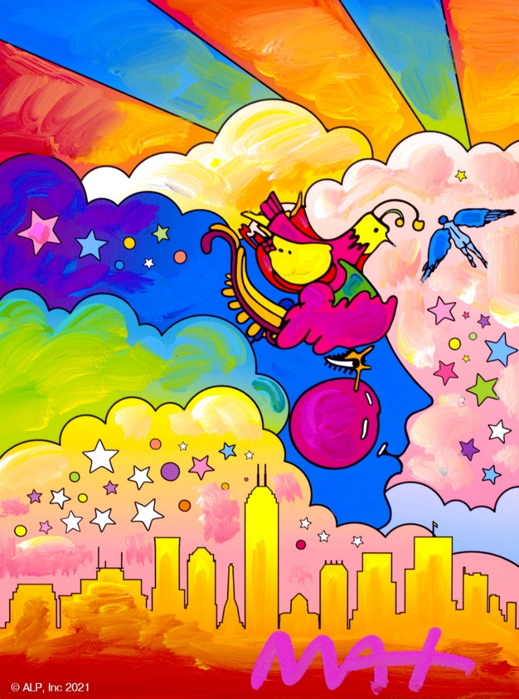
Image: Cosmic Indy Peter Max All Images © ALP Inc.

The artist has had the distinct honor of being named the Official Artist of the Grammys and the Official Artist of the Rock & Roll Hall of Fame.

“Throughout the years, I have painted so many beautiful, beautiful, imaginative musicians: Mick Jagger, Sting, The Beatles, David Bowie, Duke Ellington, Frank Sinatra, Pharrell Williams, Quincy Jones, Michael Jackson, Elton John, Jon Bon Jovi, Yes, Phil Collins, Gwen Stefani, Steven Tyler, Aretha Franklin, Norah Jones, Taylor Swift, Blake Shelton, Adam Levine and so many others. It is mind-blowing when I think about it. I love great music and the amazingly talented people that make it.” Peter Max

THE ARTIST ON CBS THIS MORNING CLICK HERE FOR CBS THIS MORNING VIDEO

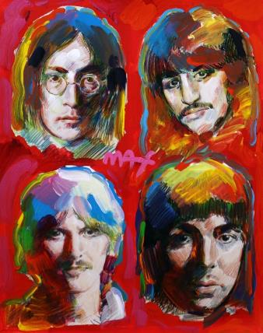
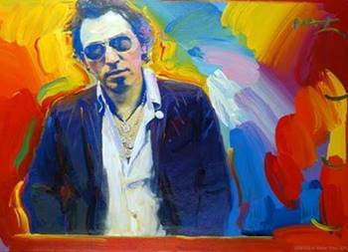
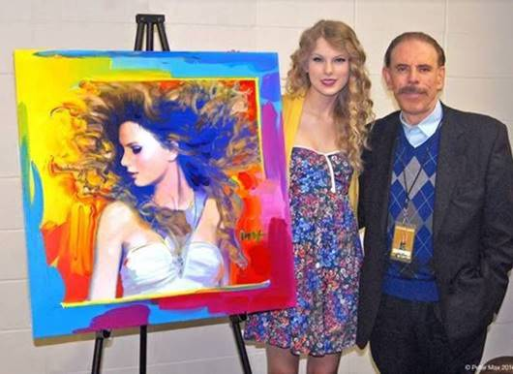
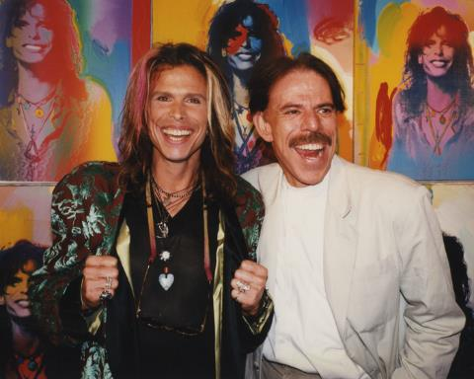
All Images © ALP Inc.

“I really love my hand-painted Fender Telecaster guitars in this exhibition. I have painted some of my most iconic images on them: my Angel with Heart, Lady Liberty, my hearts, and a homage to da Vinci’s Mona Lisa. They are really colorful and unique. Guitar players and collectors tell me how much they love them.” Peter Max

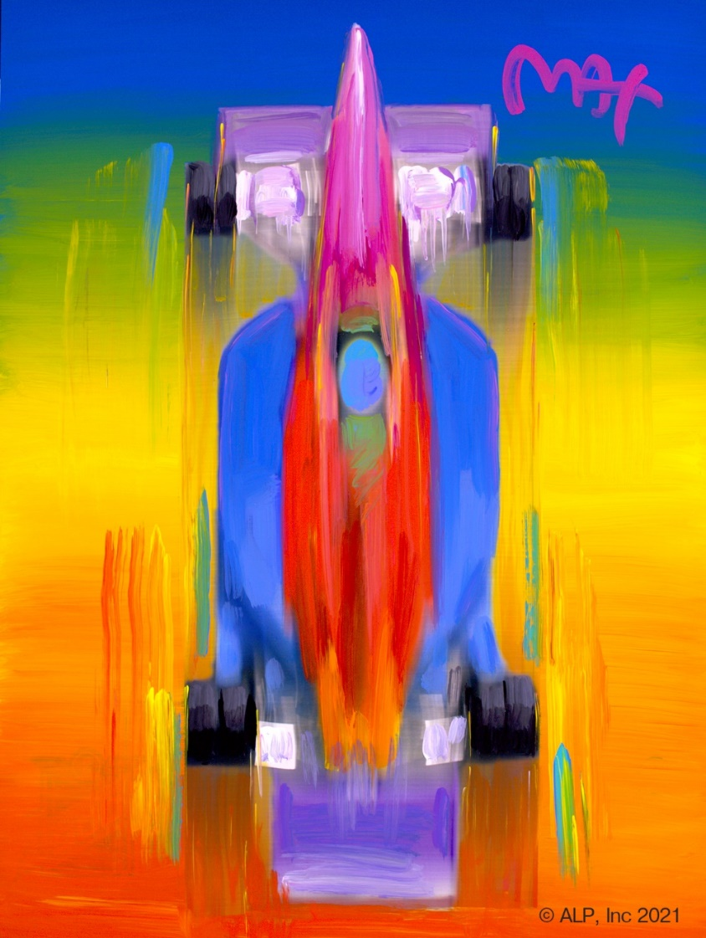
Image: Indy Car All Images © ALP Inc.

All artworks are on exhibition and available for acquisition. All events are complimentary and open to the public: RSVPs are strongly recommended.
@ 317.873.2976 or gallery@cvartandframe.com

Private & Virtual Appointments Available Upon Request All CDC Guidelines Observed

With paintings on exhibition in hundreds of museums and galleries worldwide, Peter Max and his vibrant colors have become part of the fabric of contemporary culture. Max has been successively called a Pop Icon, Neo Fauvist, Abstract Expressionist, and the United States "Painter Laureate." These works speak to both a maturation of the artist’s illustrious career, as well as to his formidable training at the 135-year-old Art Students League of New York and the cutting -edge School of Visual Arts in New York City.

The artist has had the distinct honor of painting the last seven Presidents of the United States and the world's best loved celebrities, among them the young sensation Taylor Swift and the amazing talents of “The Voice.”

The Indianapolis presentation features and premiers the signed vintage posters, Max’s iconic and best-known pieces as well, among them the Woodstock Commemorative, “Statue of Liberty,” Max’s famous “Flag” pieces, “Umbrella Man” and the prestigious “Cosmic Runner.”

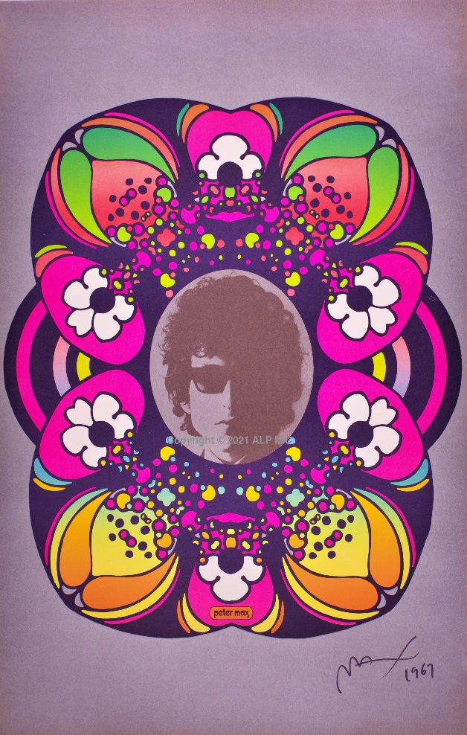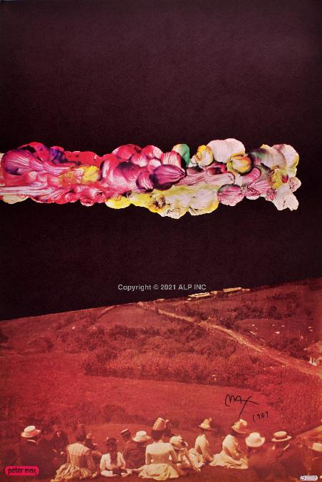
Bob Dylan: Circa 1967 Signed By the Artist Psychedelic Cloud Circa 1967 Signed by the Artist

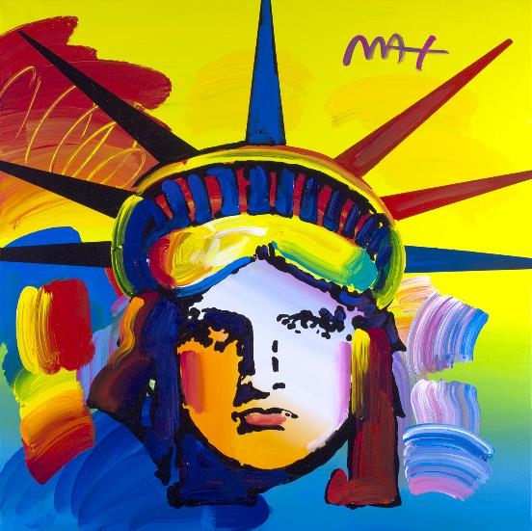
Image: LIBERTY All Images © ALP Inc.

Max’s iconic ‘Liberty” first created as his
acclaimed commemorative for the generations, now
flows with his signature, expressionistic
brushstrokes.

______________________________

New York’s renowned Posterhouse Museum POSTERHOUSE MUSEUM NYC has just announced its’ presentation of the “PETER MAX: COSMIC ADVERTISING” Exhibition premiering Fall, 2021. This Exhibition truly honors and celebrates the artwork of the Iconic American Artist, and further solidifies the extraordinary legacy of the Artist and his works.

Peter Max: Cosmic Advertising
October 14, 2021–March 27, 2022
CURATOR
Angelina Lippert
EXHIBITION DESIGN
Mihoshi Fukushima Clark
Peter Max is the most commercially successful pop artist to emerge from the psychedelic period of the 1960s. His fantastical, colorful designs have emboldened everything from bed sheets to the body of a Boeing 777, with prestigious clients like the Grammy Awards, the Super Bowl, the NHL All-Star Game, the World Cup USA, the New York City Marathon, and even the Manhattan Yellow Pages commissioning him for his brand of whimsy.

And yet, his early posters have rarely been explored in depth. Whether advertising a quirky clothing store or inspiring young minds to read, the imagery present in these graphics reveals a designer experimenting with a variety of styles and motifs while also exploring the concepts of space, time, and history through promotional visuals.

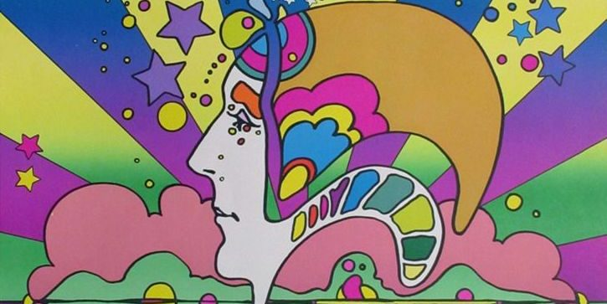
Image: Peter Max Poster on Exhibition Circa 1960’s & 1970’s
All Images ©ALP Inc.

Max’s studies and training at the Art Students League and the School of Visual Arts, both in New York City, helped shape his extraordinary art and career. The Masters series: interpretive works of Vincent Van Gogh, Monet, Pablo Picasso, Renoir, and Edgar Degas, are conceived in Max’s signature style and colors.

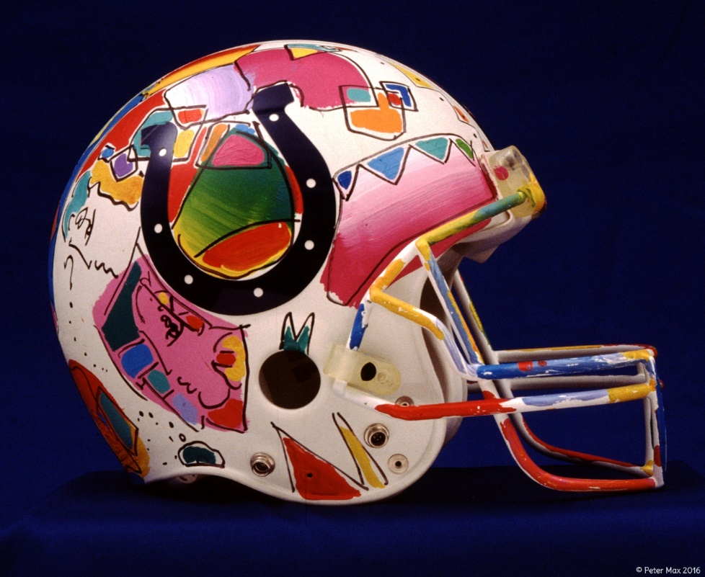
Image: Indianapolis Colts Helmet Peter Max All Images © ALP Inc.

