Iconic American Artist Peter Max Brings 2021 Retrospective to Raleigh

APPROVED PRESS ASSETS Click here for Approved Press Images

Interviews Available. Media Inquiries: Allison Zucker-Perelman
Relevant Communications
allison@relevantcommunications.net
Direct Mobile: 561.715.9525

The Peter Max Retrospective : Celebrating America, the Pop Art Movement, Music and Artistic Vision

Exhibition To Present In Raleigh 2021

Limited Engagement – July 15th through July 25th 2021

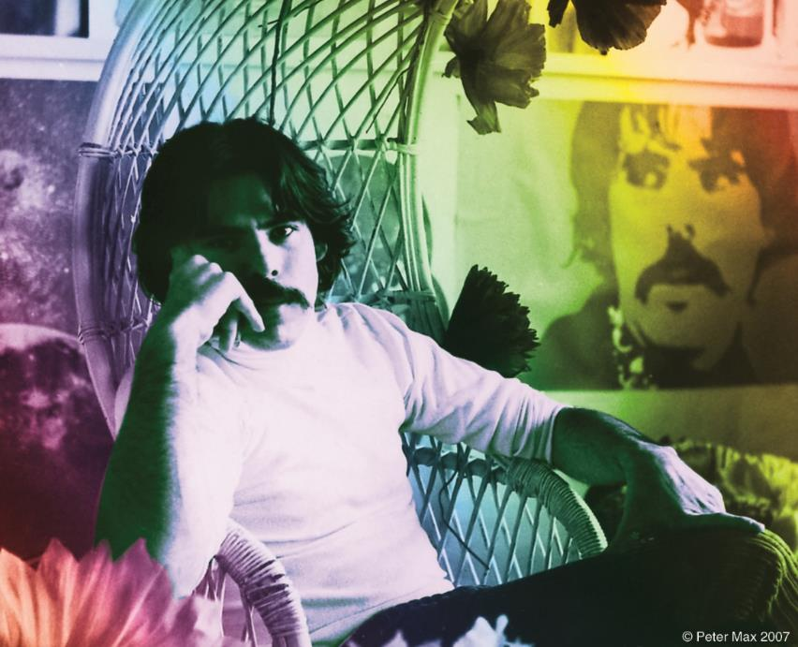
Image: The Artist in his Studio All Images © ALP Inc.

PETER MAX : The Retrospective 1960-2021
Collected Works from the Studio of America’s
Iconic Pop Artist

An artistic diversity that has defined American Art:
Captured by the Artist who began a new visual culture

AN EXHIBITION OF OVER 100 WORKS FROM THE STUDIO OF AMERICA’S ICONIC ARTIST TO PRESENT IN RALEIGH

Raleigh, North Carolina– (June 2021) –A Retrospective collection, with a significant nod to music, the arts and the legacy of the Pop Art genre from the studio of artist legend, Peter Max, will be on exhibition and available for acquisition in a limited engagement presentation at LaMantia Gallery LaMantia Gallery Raleigh’s premier fine art gallery. Previews for this limited-engagement presentation begin Thursday, July 15th , 2021 from 5-7 pm with an uncrating event and press preview, and just announced: Special gallery events Thursday, July 22nd through Sunday, July 25th, 2021. All events are open to the public with RSVP’s strongly recommended and complimentary at EVENTBRITE .

RSVP HYPERLINK: EVENTBRITE

LaMantia Gallery

Gallery Events

Thursday & Friday 7/22 & 7/23 from 5 to 7 pm, Saturday 7/24 from 2-5 pm, Sunday 7/25 from Noon to 3 pm

All artworks are on exhibition and available for acquisition. All events are complimentary and open to the public however RSVP’s are requested
919-900-8453 or james@lamantiagallery.com
Private & Virtual Appointments Available Upon Request All CDC Guidelines Observed

With paintings on exhibition in hundreds of museums and galleries worldwide, Peter Max and his vibrant colors have become part of the fabric of contemporary culture. Max has been successively called a Pop Icon, Neo Fauvist, Abstract Expressionist and the United States "Painter Laureate."
The artist has had the distinct honor of painting the last seven Presidents of the United States and the world's best loved celebrities, among them the young sensation Taylor Swift and the amazing talents of “The Voice”

The artist has had the distinct honor of being named the Official Artist of the Grammys and the Official Artist of the Rock & Roll Hall of Fame.

“Throughout the years, I have painted so many beautiful, beautiful, imaginative musicians: Mick Jagger, Sting, The Beatles, David Bowie, Duke Ellington, Frank Sinatra, Pharrell Williams, Quincy Jones, Michael Jackson, Elton John, Jon Bon Jovi, Yes, Phil Collins, Gwen Stefani, Steven Tyler, Aretha Franklin, Norah Jones, Taylor Swift, Blake Shelton, Adam Levine and so many others. It’s mind-blowing when I think about it. I love great music and the amazingly talented people that make it”. Peter Max

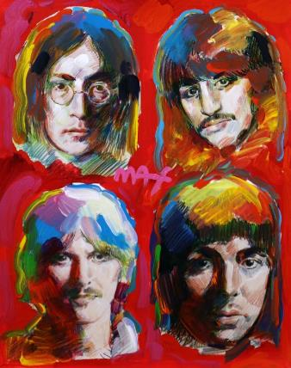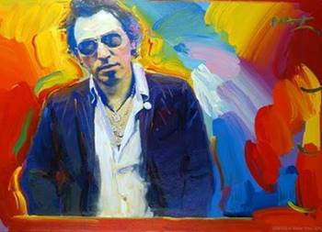

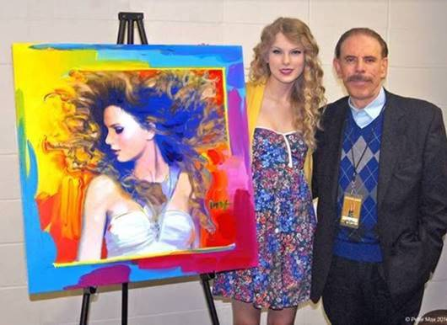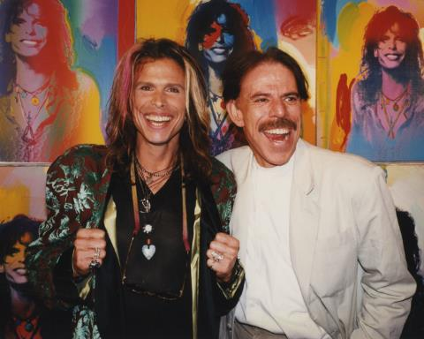

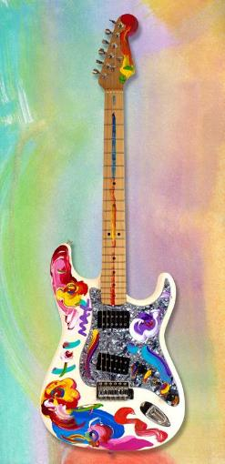
All Images © ALP Inc.

“I really love my hand-painted Fender Telecaster guitars in this exhibition. I’ve painted some of my most iconic images on them: my Angel with Heart, Lady Liberty, my hearts and a homage to da Vinci’s Mona Lisa. They’re really colorful and unique. Guitar players and collectors tell me how much they love them”. Peter Max

The Raleigh presentation features Max’s iconic and best-known pieces as well, among them the Woodstock Commemorative, “Statue of Liberty,” Max’s famous “Flag” pieces, “Umbrella Man” and the prestigious “Cosmic Runner.”

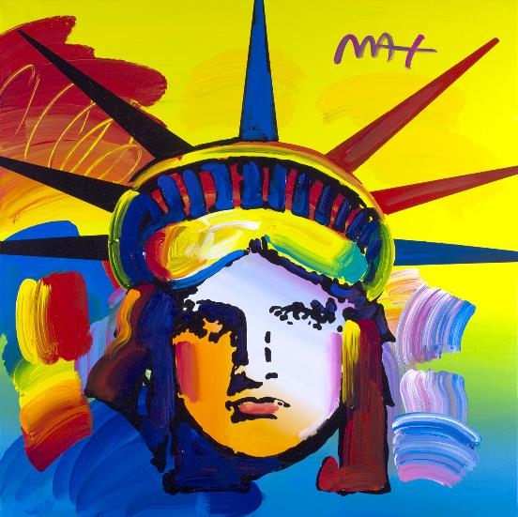

Image: LIBERTY All Images © ALP Inc.
Max’s iconic ‘Liberty” first created as his
acclaimed commemorative for the generations, now
flows with his signature, expressionistic
brushstrokes.

“To celebrate the Bicentennial, on July 4, 1976, I painted my first portrait of the Statue of Liberty on Independence Day. It became an annual tradition, and each year since I have painted her in an increasing number: in 1977, I painted two portraits; in 1978, three; and so on. In 1981, I was delighted when Nancy Reagan invited me to paint six portraits of the Statute of Liberty at the White House for that upcoming July Fourth. It was Ronald Reagan’s first year in office and it was the sixth year of my Liberty painting tradition; she said they would be honored if I would paint for them.” Peter Max

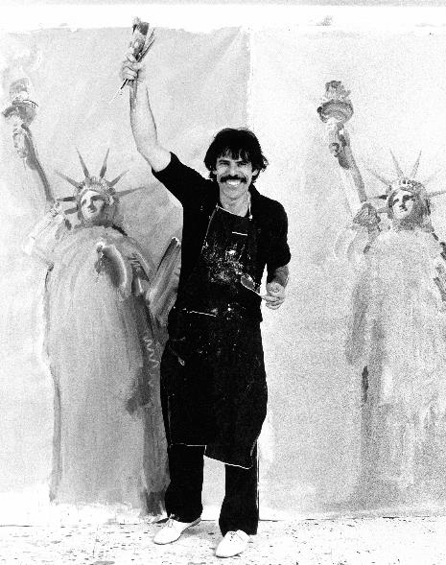
Peter Max Painting Lade Liberty at the White House All Images © ALP Inc.
______________________________

Max’s studies and training at the Art Students League and the School of Visual Arts, both in New York City, helped shape his extraordinary art and career. The Masters series; interpretive works of Vincent Van Gogh, Monet, Pablo Picasso, Renoir, and Edgar Degas, are conceived in Max’s signature style and colors.

These works speak to both a maturation of the artist’s illustrious career, as well as to his formidable training at the 135-year-old Art Students League of New York and the cutting -edge School of Visual Arts in New York City.

LaMANTIAGALLERY
440 DANIELS STREET
RALEIGH, NORTH CAROLINA

LaMantia Gallery

919.900.8453

