The Peter Max Retrospective : Celebrating Sports, Music and All Things Dallas: Exhibition Presents In Dallas October of 2019

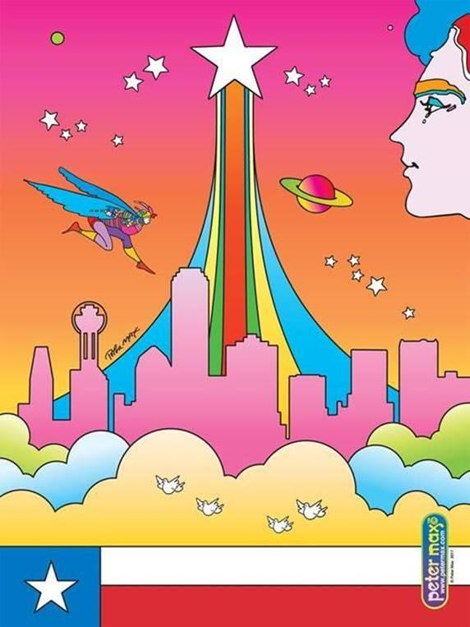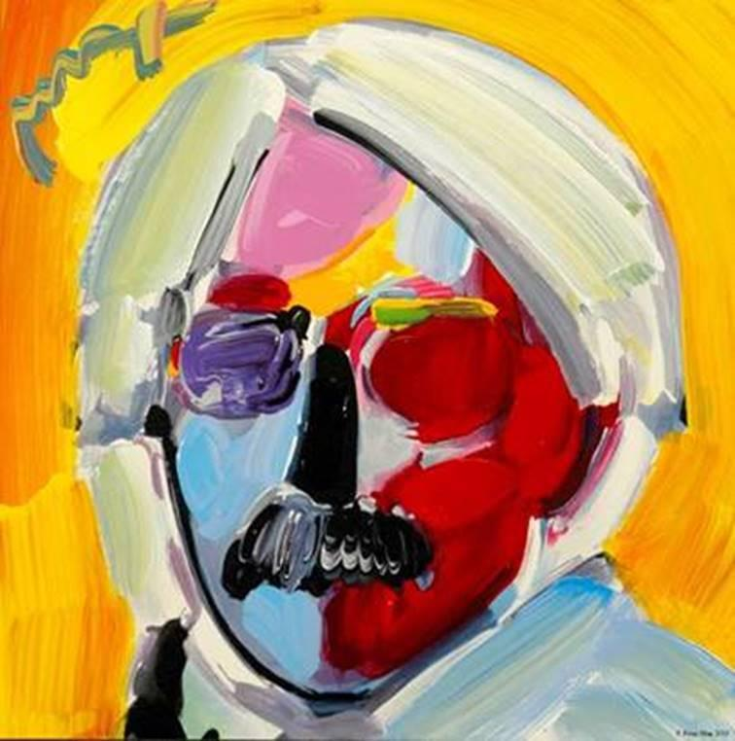
Images: Cosmic Texas Andy Warhol All Images © ALP Inc.

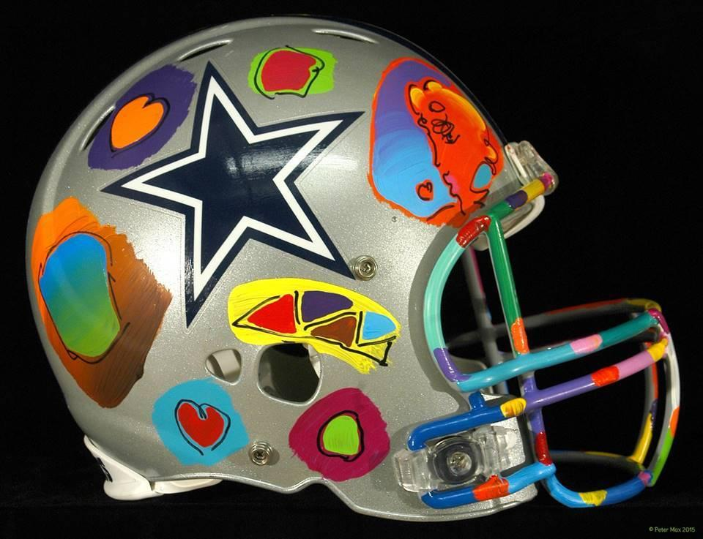

Image: Hand-Painted Dallas Cowboys Helmet © ALP Inc.

PRESS ASSETS: HIGH RESOLUTION PRESS ASSETS

PETER MAX : The Retrospective 1960-2019
Collected Works from the Studio of America’s
Iconic Pop Artist

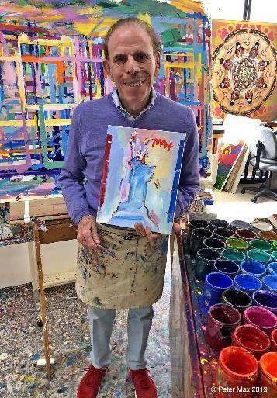
Image: Statue of Liberty Collection of Statue of Liberty Museum © ALP Inc.
Artist Peter Max, often called ‘America’s Painter Laureate’ with the ‘Statue of Liberty’ painting he created especially for the new Statue of Liberty Museum which opened to the public on Thursday, May 16, 2019 on Liberty Island near the Statue of Liberty. Peter Max has painted the Statue of Liberty since America’s Bicentennial in 1976 for U.S presidents, the Liberty Centennial, museums, embassies, magazine covers and for his collectors and gallery shows. Max spearheaded the full-restoration of the Statue of Liberty in the early ‘80s with Chrysler Chairman Lee Iacocca ahead of the statues 100th anniversary in 1986.
Road Show hosts Fine Art Pop-Up featuring Works from the studio of

Pop Artist Icon Peter Max

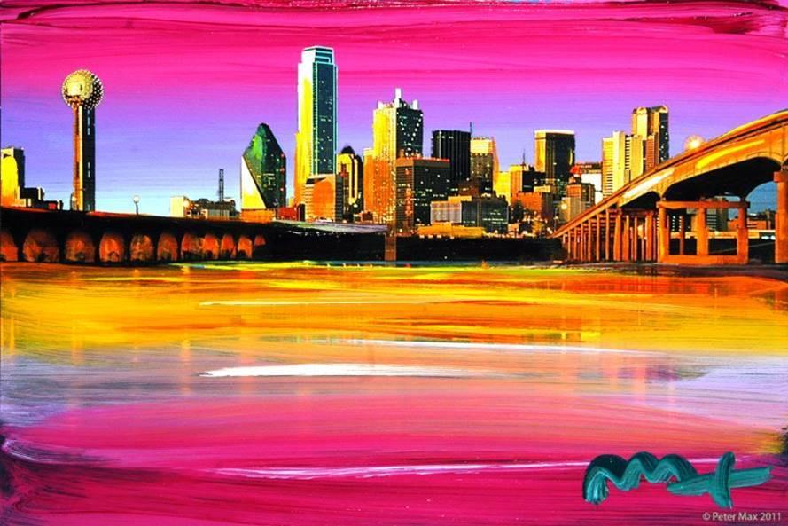
Image: Dallas Skyline © ALP Inc.

An artistic diversity that has defined American Art:
Captured by the Artist who began a new visual culture

AN EXHIBITION OF OVER 100 WORKS FROM THE STUDIO OF AMERICA’S ICONIC ARTIST

Dallas, Texas – (September 2019) –A Retrospective collection, with a significant nod to the City of Dallas: sports, music, the arts and the legacy of the Pop Art genre from the studio of artist legend, Peter Max, will be on exhibition and available for acquisition in a limited engagement presentation by Road Show Company, the industry leader in traveling Fine Art presentation. Road Show Company

The exhibition opens with an evening preview event on Friday, September 27th 2019 from 6-8 pm, and the Exhibition extends through Sunday, October 6th 2019, with three limited engagement, not-to-be-missed event receptions for the public:

Saturday October 5th from 1 to 3 pm and 6 to 8 pm and Sunday, October 6th 2019 from 1 to 3 pm

All artworks are on exhibition and available for acquisition. All events are complimentary and open to the public however RSVP’s are required:
866.900.6699 or dallas@roadshowcompany.com

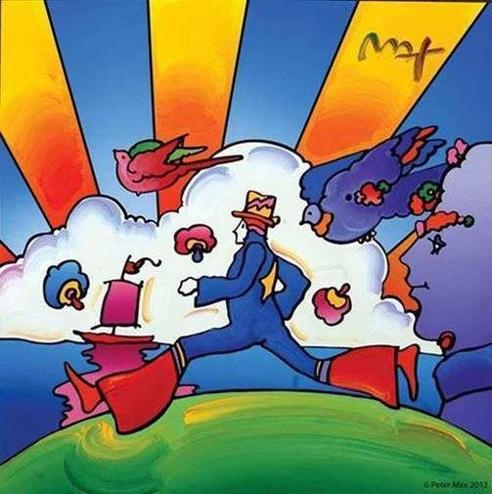
IMAGE: Cosmic Runner © ALP Inc.

With paintings on exhibition in hundreds of museums and galleries worldwide, Peter Max and his vibrant colors have become part of the fabric of contemporary culture. Max has been successively called a Pop Icon, Neo Fauvist, Abstract Expressionist and the United States "Painter Laureate."
The artist has had the distinct honor of painting the last seven Presidents of the United States and the world's best loved celebrities, among them the young sensation Taylor Swift and the amazing talents of “The Voice”

The artist has had the distinct honor of being named the Official Artist of the Grammys and the Official Artist of the Rock & Roll Hall of Fame.

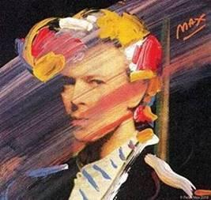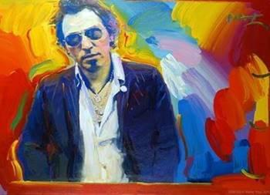

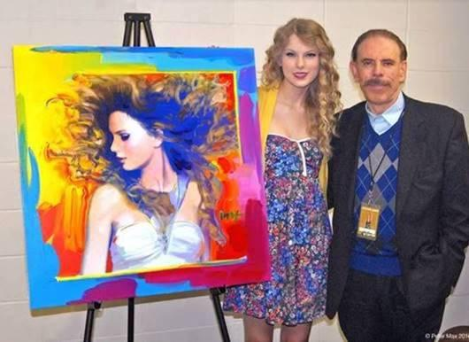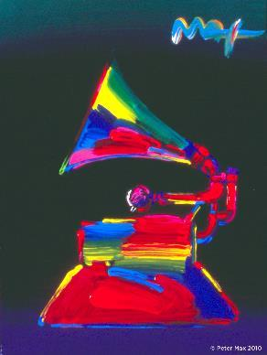

This exhibit features his iconic and best-known pieces as well, among them the Woodstock Commemorative, “Statue of Liberty,” Max’s famous “Flag” pieces, “Umbrella Man” and the prestigious “Cosmic Runner.”

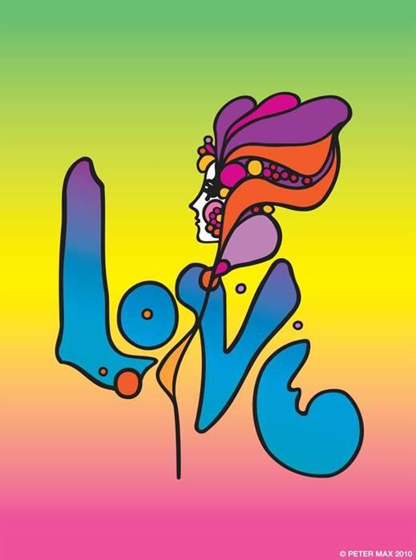

Image: LOVE © ALP Inc.
Max’s iconic ‘Love,’ first created as his
acclaimed Art Nouveau-inspired ‘Love’
poster for the ‘60s generation, now
flows with his signature, expressionistic
brushstrokes.
______________________________

With paintings on exhibition in hundreds of museums and galleries worldwide, Peter Max and his vibrant colors have become part of the fabric of modern culture.

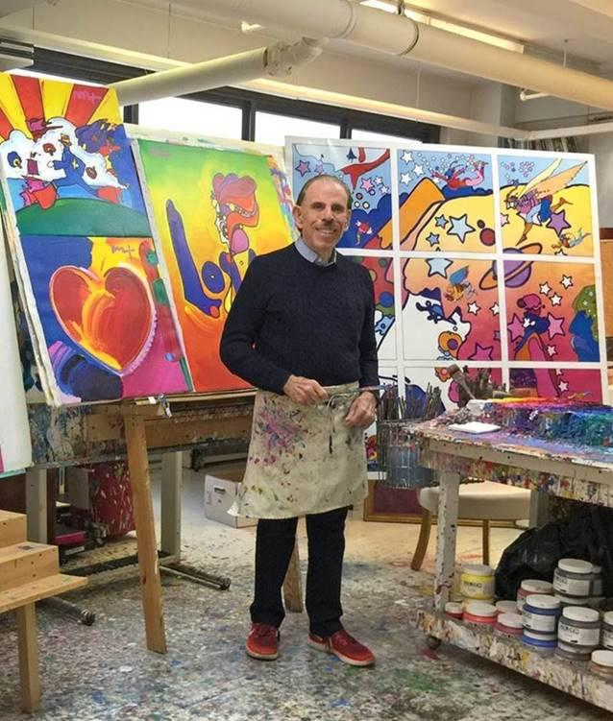
Image: The Artist in his Studio © ALP Inc.

Peter Max CBS This Morning
www.cbsnews.com/videos/artist-peter-maxs-colorful-creations-span-50-years/

Max’s studies and training at the Art Students League and the School of Visual Arts, both in New York City, helped shape his extraordinary art and career. The Masters series; interpretive works of Vincent Van Gogh, Monet, Pablo Picasso, Renoir, and Edgar Degas, are conceived in Max’s signature style and colors.

These works speak to both a maturation of the artist’s illustrious career, as well as to his formidable training at the 135-year-old Art Students League of New York and the cutting -edge School of Visual Arts in New York City.

FINE ART POP UP RESENTED BY ROAD SHOW COMPANY
INTERNATIONAL DESIGN CENTER ON TURTLE CREEK
150 TURTLE CREEK BLVD. #1048
DALLAS, TEXAS 75207

866.900.6699
RSVP: dallas@roadshowcompany.com

