World-renowned Artist Alexandra Nechita makes Florida stop on North American Tour

Media Interviews are coordinated by:
Allison Zucker-Perelman
Relevant Communications
561.715.9525
allison@relevantcommunications.net

For Immediate Release

World Renowned Artist Alexandra Nechita embarks on a North American Fine Art Tour
California Artist to Present in Florida

Click HERE for High Resolution & Digital Media Assets

Click HERE to view Alexandra Nechita discussing her work and inspiration. Film by renowned filmmaker Viken Kazandjian #VVK_films

Wikipedia https://en.wikipedia.org/wiki/Alexandra_Nechita

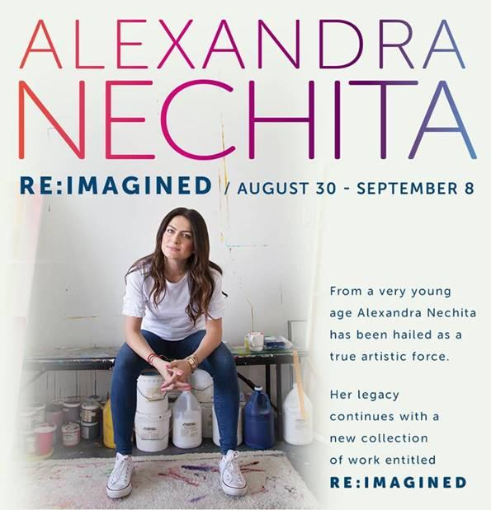
Jacksonville, Florida (July 2019) - Jacksonville, Florida is proud to welcome “Alexandra Nechita: Reimagined” in its United States debut. The extraordinary collection of new works will be on exhibition and available for acquisition at Gallery 725, Jacksonville’s premier Fine Art Gallery. GALLERY 725. The limited engagement exhibition will open in previews August 30th, 2019, and there are three not-to-be missed Artist appearances in the gallery:

SATURDAY, SEPTEMBER 7TH, 2019 11:00 AM – NOON SPECIAL CHILDREN’S EVENT

SATURDAY, SEPTEMBER 7TH, 2019 6 :00 PM – 8:00 PM

SUNDAY, SEPTEMBER 8TH, 2019 1:00 PM – 3:00 PM

From a very young age, Alexandra Nechita has been hailed as a true Artistic Force. Born in Romania in 1985, Nechita immigrated to the United States at one and a half years old. She began drawing as a toddler. At seven she was working with oil paints and acrylics and by eight years of age, she held her first solo exhibition at a local Los Angeles Library. Alexandra exploded onto the art scene at the age of nine. Her talent was instantly recognized as crowds came to see her often monumental paintings. Art critics and the media began telling the world about this rarest of child prodigies - a master of line and color – an artist with a visual language of her own. That visual language has been unfolding over the last several years, resulting in an extraordinary new body of work that will tour North America in 2019 and 2020. These works represent the years and growth between her time as a celebrated prodigy and the now mature Artist who sees the world through a different lens; while still capturing elements that made her a force in the Art World.

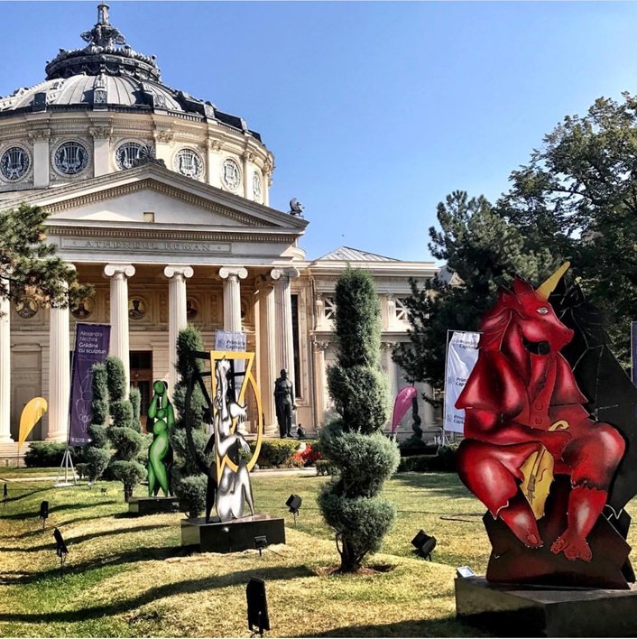
Image: The Romanian Athenaeum Park Installation

The Romanian born Artist was commissioned in 2017 by the City of Bucharest for a public art installation; her extraordinary sculptures grace the Romanian Athenaeum. This body of work was made as a tool to help democratize the art experience by virtue of public display. The sculptures are made of two aluminum sheets welded together and hand painted by Alexandra Nechita.

“This ensemble of 8 sculptures function both literally and figuratively as a dialogue about duality and
paradoxes. Formally speaking, the sculptures themselves are duplicitous in their composition and structure.
Thematically, I wanted to address the duality between what is and what is not, the parallels and the
contradictions that exist between reality and fantasy, between duty and aspiration. The concept of time and timing as a judge of our fate, is represented in the seemingly intangible whimsy of each piece; the past, the present, the future, ourhuman nature to incessantly put up a fight against time. This body of work is a reconciliation of all these conflicts “.

Alexandra Nechita

CLICK HERE FOR EXHIBITIONS & COLLECTIONS

SELECTED PUBLIC COLLECTIONS

•Petit Palais Museum, Geneva, Switzerland
•Tennessee State Museum, Nashville, Tennessee
•Lowe Art Museum, Coral Gables, Florida
•Bowers Museum, Santa Ana, California
•Alexander Brest Museum, Jacksonville, Florida
•The Special Olympics Collection, Washington, D.C.
•Embassies: London, The Hague, Rome, Paris, Geneva
•Downey Museum of Art, Downey, California
•Imperial Collection, His Majesty Emperor Akihito, Tokyo
•Florida International University Art Museum, Miami, Florida
•International Children’s Art Museum, Geneva
•Museum of Contemporary Art, Lake Worth, Florida
•National Academy of Recording Arts & Science, Los Angeles, California
•Pensacola Museum of Art, Pensacola, Florida
•Coral Springs Museum of Art, Florida
•Rock and Roll Hall of Fame, Cleveland, Ohio
•Vatican Collection, Rome
•National Museum of Art, Romania
•City of Vallauris, France
•Beverly Hills Cancer Center- Beverly Hills
•Ville de Meudon- Musee D’art et D’Histore- France
•National Museum of Singapore

Collectors:

Oprah Winfrey
Alec Baldwin
Melissa Ethridge
Lee Iococca
Calvin Klein
Whoopi Goldberg
Paul Stanley
Little Richard

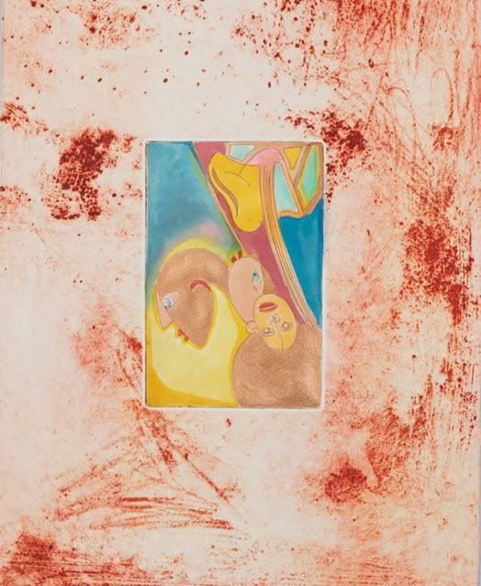
Artwork: Halfway Won’t Do

About the Artist:

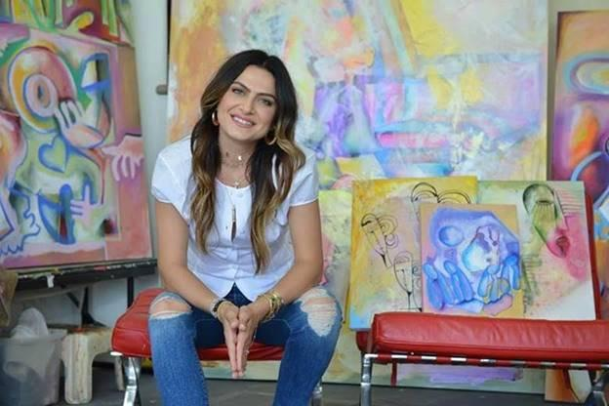

In 1997 she was chosen as the official artist for the 39th Annual Grammy Awards and In November of 1999, Nechita was selected by the World Federation of the United Nations Associations to lead a Global Arts Initiative including more than 100 nations. In 2001, in her hometown of Vaslui, Romania Alexandra Nechita had a school named in her honor.

In 2003 the Alexandra Nechita Center for The Performing arts was unveiled in Orange County. In April 2004, Teen People called Alexandra Nechita, “One of 20 Teens Who Will Change the World!” The young Artist was named Official Artist of the 2004 World Peace Music Awards. In 2005, Nechita’s designs were chosen for a set of legal tender commemorative coins entitled, “Peace Is the Only Option!” Struck in pure gold, silver and platinum, the designs were specially approved by Queen Elizabeth II whose effigy also adorns the coins. In the summer of 2005, Nechita presented her massive 16-foot tall bronze monument entitled “Let There Be Peace” to the people of Singapore, which is permanently housed in the sculpture garden on the National Museum of Singapore. These are just some of the accolades she has received in her 25-year career as an artist.

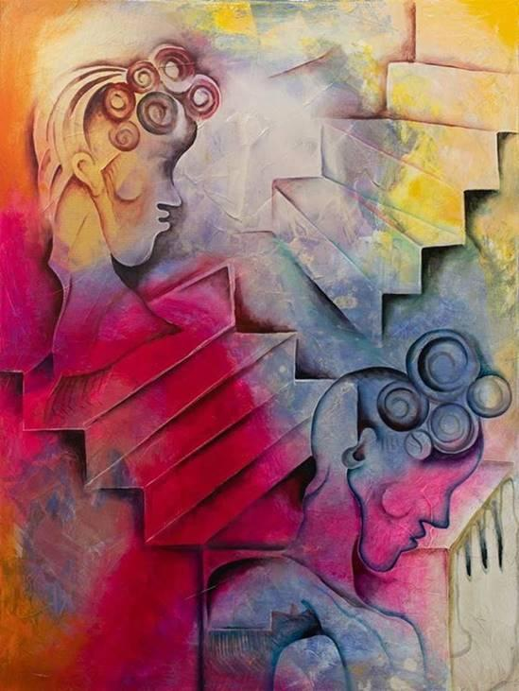
Artwork: The Ghosts of Doubt, Acrylic

Her work has always reflected an expression of personal sentiments- that intimacy and storytelling continues to be the prism through which she navigates her creative vocabulary. This new work is the perfect embodiment of who she is, as it comprehensively encompasses her growth and transitions, both as a woman, a mother and simply a humanist on a profound and endless search for her greater purpose.

Alexandra’s work has been displayed internationally, including exhibitions in Romania, Switzerland, Netherlands, Italy, France, England, Singapore, Japan, Australia and New Zealand. Her art sits in the permanent collections of museums throughout the world, including the Vatican Collection in Rome and The Rock and Roll Hall of Fame in Cleveland. Alexandra’s work is also in the private collections of A-List celebrities, including Oprah Winfrey, Debra Messing, Calvin Klein, Whoopi Goldberg and David Letterman.

Alexandra graduated from the University of California at Los Angeles in 2008 with a degree in Fine Arts and currently resides in Los Angeles.

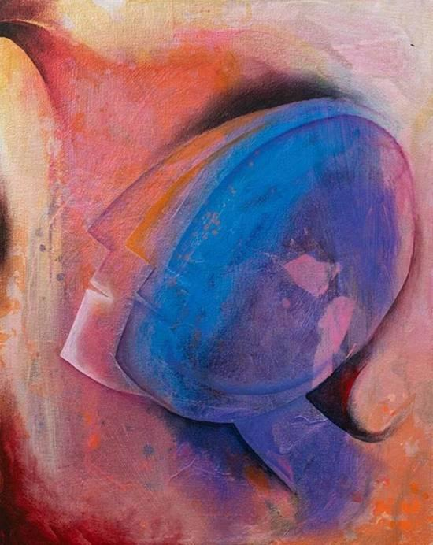
Artwork: Where No One Knows My Name, Acrylic

Live B-Roll Link: Click HERE for B-ROLL

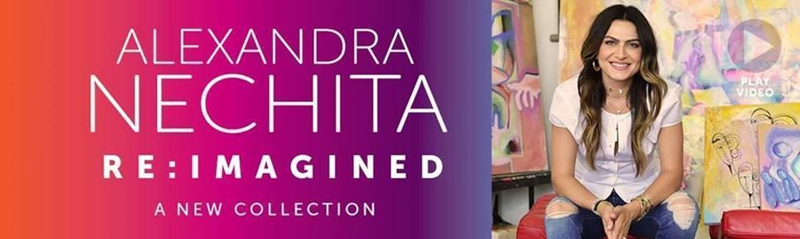

ARTWORKS ON EXHIBITION & AVAILABLE FOR ACQUISITION

GALLERY RECEPTIONS W/ ARTIST APPEARANCES

Saturday September 7th from 6 - 8pm
Sunday September 8th from 1 - 3pm

^{Children’s Event:}
Saturday September 7th from 11am - Noon

Preview Event (artist will not attend)
Friday, August 30th from 6 - 8pm

RSVP: www.gallery725@gmail.com or 904.345.9320

GALLERY 725
1250 Beach Boulevard
Jacksonville Beach, Florida 32250

COMPLIMENTARY TO THE PUBLIC – RSVP’S REQUESTED

This exhibition is presented in collaboration with

Road Show Company

