Peter Max The Retrospective Back to Woodstock 50th Anniversary

Limited Engagement Houston, Texas August 17th – August 25th 2019

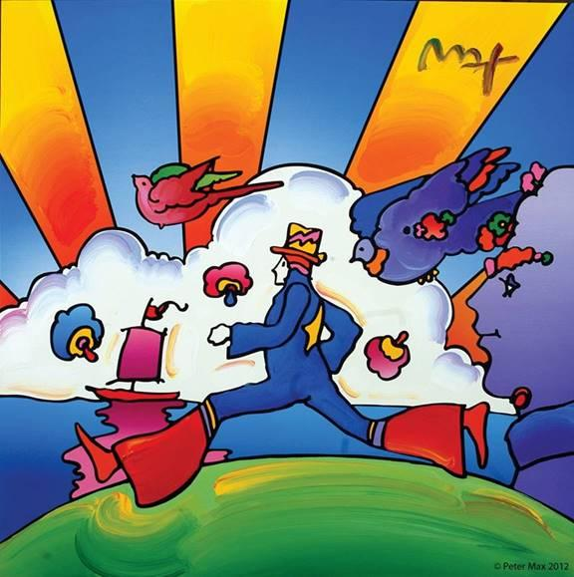
IMAGE: COSMIC RUNNER © ALP Inc.

Peter Max The Retrospective Back to Woodstock 50th Anniversary

AN EXHIBITION OF OVER 100 WORKS FROM THE STUDIO OF AMERICA’S ICONIC ARTIST

An artistic diversity that has defined American Art:
The Artist who began a new visual culture

PRESS ASSETS: CLICK HERE FOR HIGH RESOLUTION IMAGE ASSETS

Houston, Texas – (July 2019) – A Retrospective collection with a significant nod to Woodstock and the legacy of the from the studio of artist legend, Peter Max, will be on exhibition and available for acquisition in a limited engagement presentation at Off The Wall gallery, Houston’s premier fine art gallery. OFF THE WALL GALLERY

The exhibition opens with an evening preview event on Saturday, August 17th, 2019 from 5-7 pm & the Exhibition extends through Sunday, August 25th 2019. Two limited engagement, not-to-be-missed Gallery receptions for the public have been announced:

Saturday August 24th 5 to 8 pm and Sunday, August 25th , 2019 1 to 3 pm

All artworks are on exhibition and available for acquisition. All events are complimentary and open to the public however RSVP’s are required:

713.871.0940 or rsvp@offthewallgallery.com

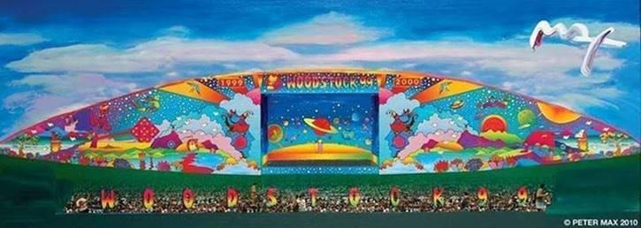

IMAGE: WOODSTOCK 99 © ALP Inc.

Peter Max, in his sixth decade as America’s most popular, quintessentially American and world-renowned Pop Artist, has been the Official Artist of the Grammys, the Rock & Roll Hall of Fame, Five Super Bowls, and has captured just about every American celebrity and Rock Star. This summer will see a celebration of the 50th Anniversary of Woodstock. The Iconic Artist created the stage banner art and posters for the 30th Anniversary of Woodstock in 1999.

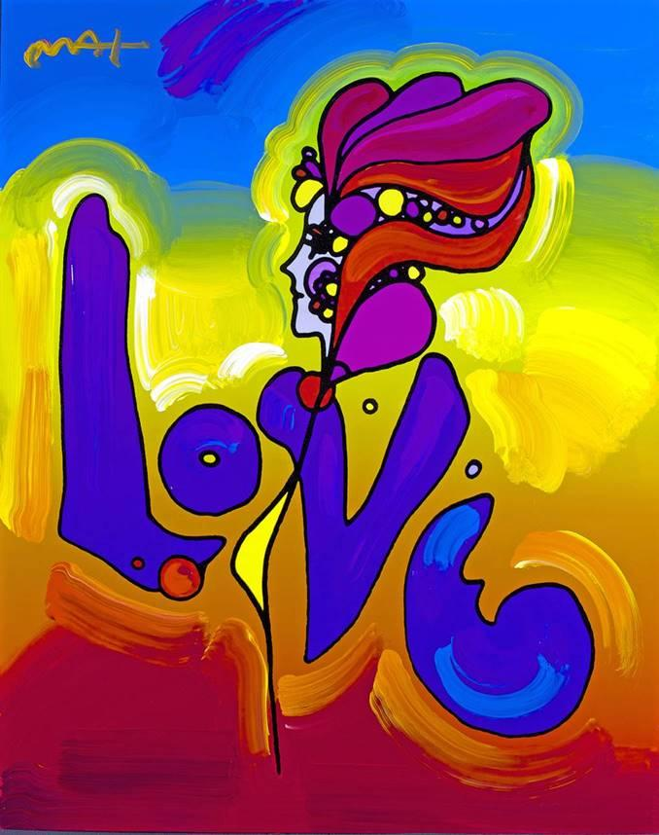

IMAGE: LOVE © ALP Inc.

Max’s iconic ‘Love,’ first created as his
acclaimed Art Nouveau-inspired ‘Love’
poster for the ‘60s generation, now
flows with expressionistic, signature
brushstrokes.

With paintings on exhibition in hundreds of museums and galleries worldwide, Peter Max and his vibrant colors have become part of the fabric of modern culture. Max has been successively called a Pop Icon, Neo Fauvist, Abstract Expressionist and the United States "Painter Laureate." The artist has had the distinct honor of painting the last seven Presidents of the United States and the world's best loved celebrities, among them the young sensation Taylor Swift and the amazing talents of “The Voice”.

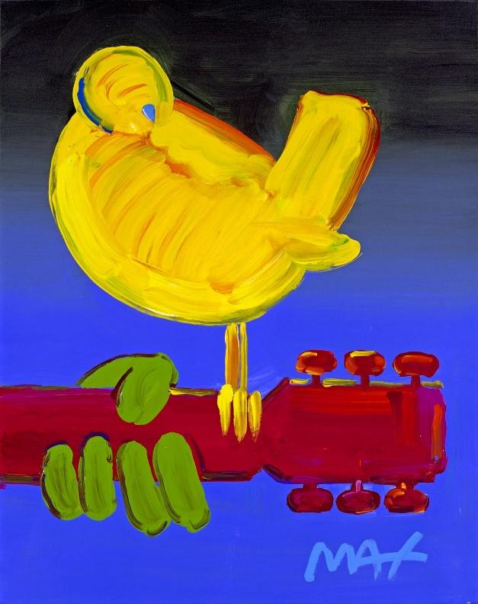
IMAGE: WOODSTOCK BIRD © ALP Inc.

From the era of Woodstock and the Summer of Love to our world in 2019: Peter Max has had the distinct honor of being named the Official Artist of the Grammys and the Official Artist of the Rock & Roll Hall of Fame.

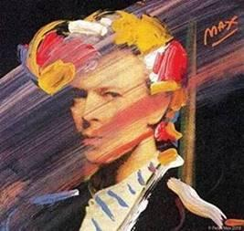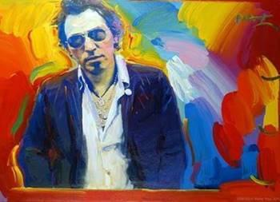

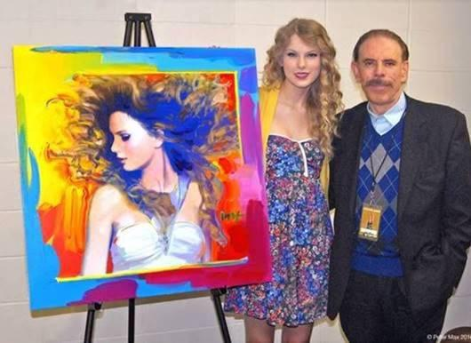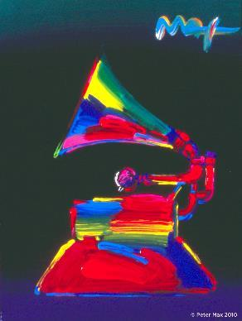
ALL IMAGES COURTESY OF ©ALP Inc.

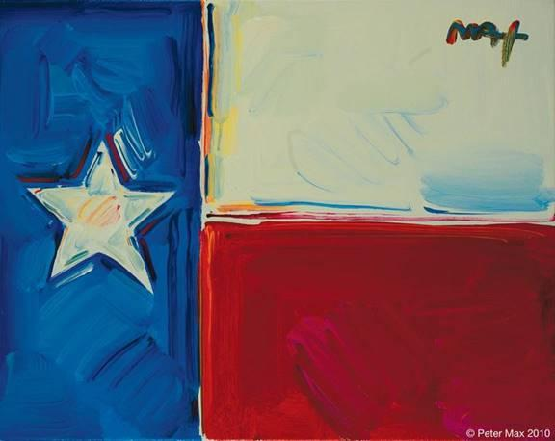
IMAGE: FLAG OF TEXAS © ALP Inc

With paintings on exhibition in hundreds of museums and galleries worldwide, Peter Max and his vibrant colors have become part of the fabric of modern culture.

Image: The Artist in his Studio © ALP Inc.

Peter Max CBS This Morning
www.cbsnews.com/videos/artist-peter-maxs-colorful-creations-span-50-years/

Max’s studies and training at the Art Students League and the School of Visual Arts, both in New York City, helped shape his extraordinary art and career. The Masters series; interpretive works of Vincent Van Gogh, Monet, Pablo Picasso, Renoir, and Edgar Degas, are conceived in Max’s signature style and colors.

These works speak to both a maturation of the artist’s illustrious career, as well as to his formidable training at the 135-year-old Art Students League of New York and the cutting -edge School of Visual Arts in New York City.

OFF THE WALL GALLERY
5015 WESTHEIMER ROAD
HOUSTON, TEXAS 77056
(located adjacent to Neiman Marcus’ valet facing Post Oak Blvd.)
WWW.OFFTHEWALLGALLERY.COM
713.871.0940
#OFFTHEWALLGALLERY




