ICONIC AMERICAN ARTIST
PETER MAX TO EXHIBIT IN LA JOLLA
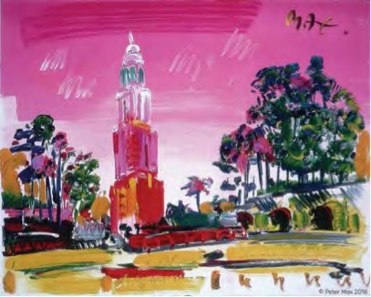
Image: Balboa Park Peter Max All Rights Reserved 2016

America’s Favorite Living Artist to Appear At
Monarch/Arredon Contemporary Art

Media Interviews are coordinated by: Allison Zucker-Perelman, Relevant Communications, 561.715.9525 allison@relevantcommunications.net

B-Roll, High Resolution 300dpi Images available interview with Peter Max upon request

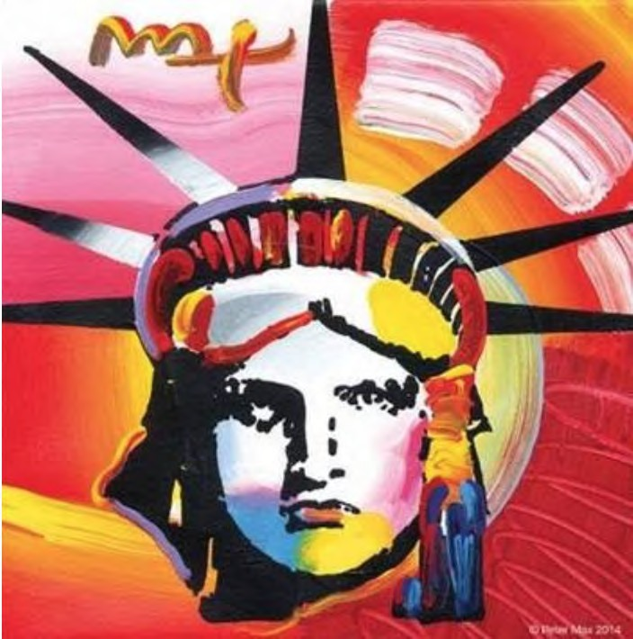
Image: Liberty Peter Max 2014

America’s most popular living Artist celebrates America and the symbols that gave us our freedom.

Max’s iconic ‘Love,’ first created as his acclaimed Art Nouveau-inspired ‘Love’ poster for the ‘60s generation, now flows with his signature, expressionistic brushstrokes.

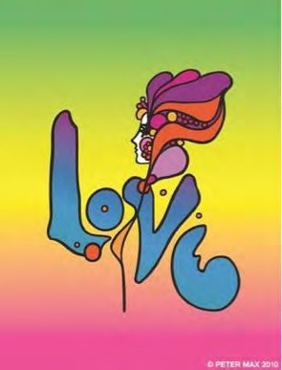
Image: Love Peter Max 2010

FOR IMMEDIATE RELEASE:

PETER MAX - THE RETROSPECTIVE
1960 - 2016

AN EXHIBITION OF WORKS FROM AMERICA’S ICONIC ARTIST
An artistic diversity that has defined American Art: Captured by the Artist who began a new visual culture

La Jolla, California – (June 2016) – A newly-curated collection by artist legend, Peter Max’s exquisite paintings will be on exhibition and available for acquisition in a presentation at Monarch/Arredon Contemporary Art, La Jolla’s premier contemporary fine art gallery.

www.monarchfineart.com

Peter Max will make two very special appearances at the gallery and all appearances are complimentary and open to the public with RSVP’s required.

Previews begin Saturday, October 15th 2016 with a Preview Event on Friday, October 14th from 6-8 pm. There are two scheduled Meet the Artist receptions: Saturday, October 22nd, from 4-7 pm and Sunday, October 23rd 2016 from 1-4 pm. All artworks are on exhibition and available for acquisition.

RSVP’s are required: 858.454.1231 or info@monarchfineart.com

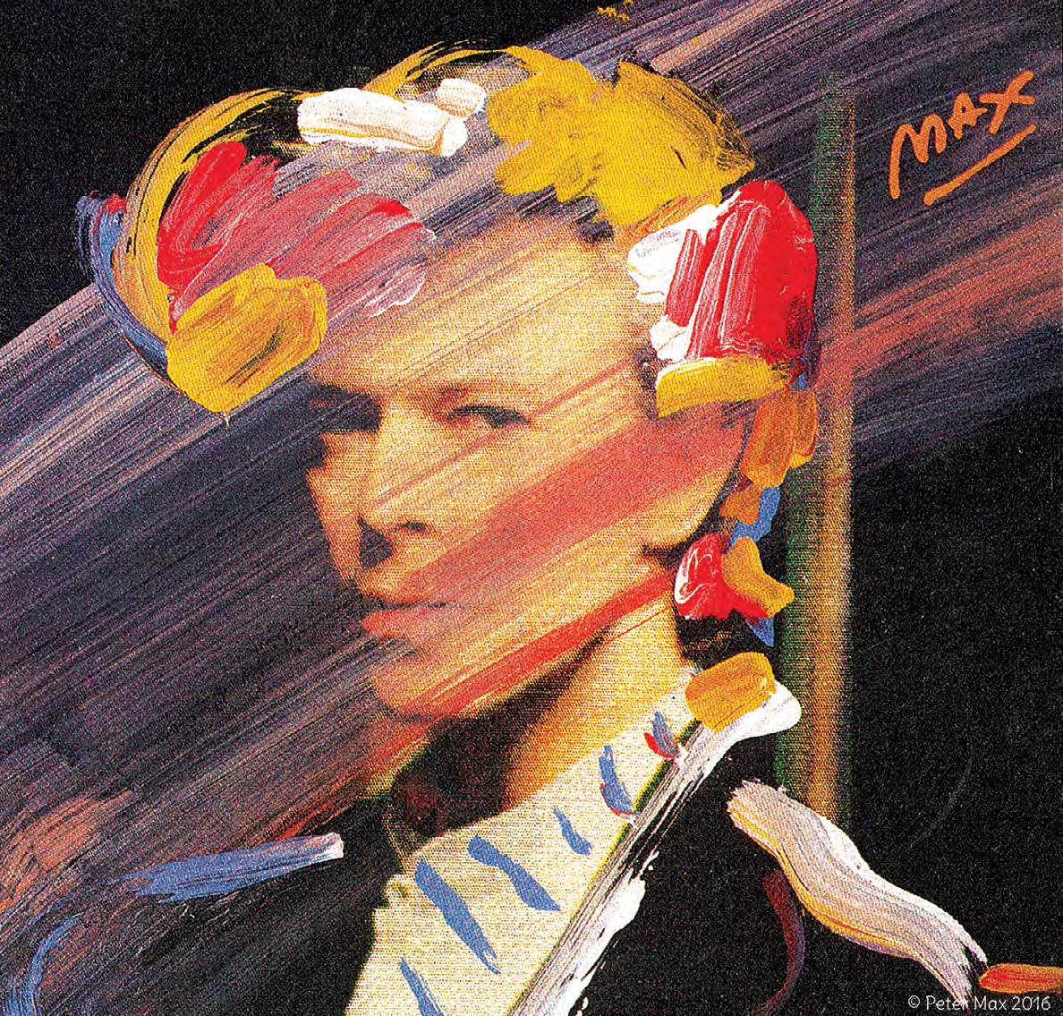
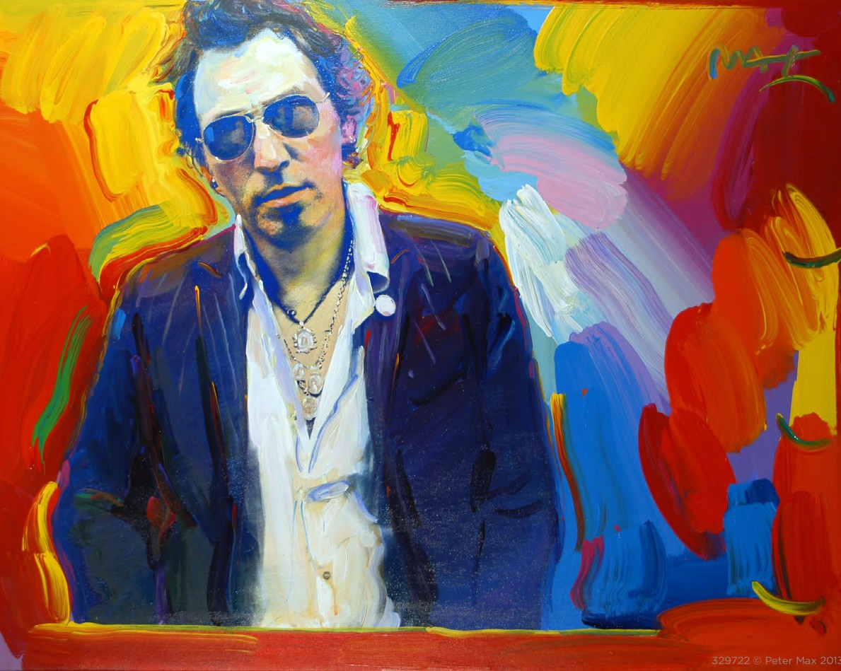
With paintings on exhibition in hundreds of museums and galleries worldwide, Peter Max and his vibrant colors have become part of the fabric of contemporary culture. Max has been successively called a Pop Icon, Neo Fauvist, Abstract Expressionist and the United States “Painter Laureate.” The artist has had the distinct honor of painting the last seven Presidents of the United States and the world’s best-loved celebrities, among them the young sensation Taylor Swift.

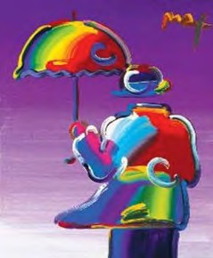
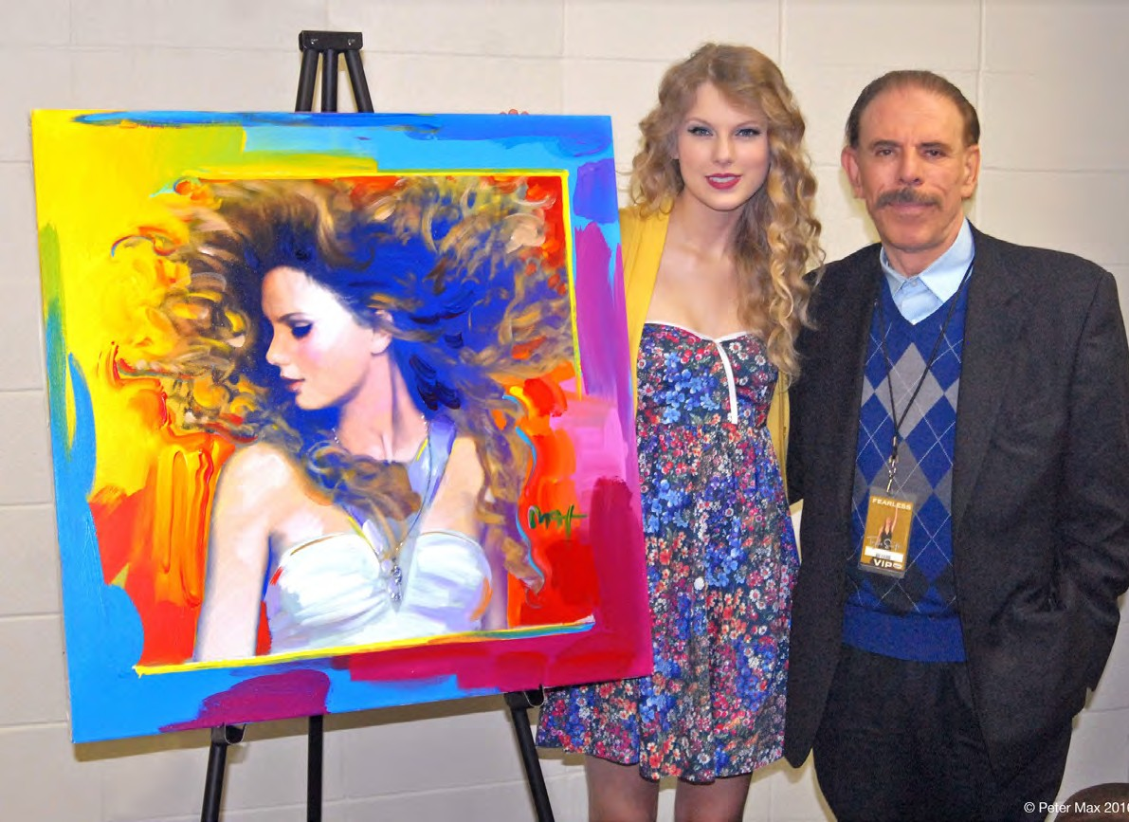
This exhibit features his iconic and best-known pieces as well, among them “Statue of Liberty”, Max’s famous “Flagz” pieces, “Umbrella Man” and the prestigious “Cosmic Runner”. There will also be presentations of his celebrity portraiture in Omaha, as Peter Max is revered for his celebrity commissions and portraits.

PETER MAX CREATES NBC’S
THE VOICE FALL PREMIERE CAMPAIGN

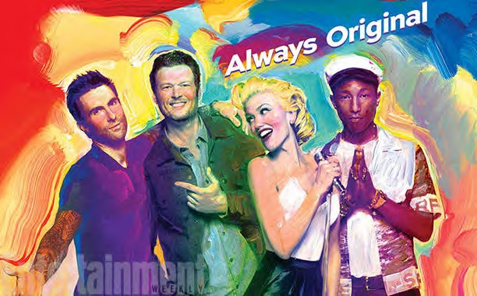

CliCk to load web page:
http://www.nbC.Com/the-voiCe/video/peter-max-brings-his-Color-to-the-voiCe/2905555

The Artist has assembled a collection of his greatest and most-revered imagery spanning four decades: from his iconic Pop Art designs commemorating Woodstock to the 2013 unveiling of Max’s design for the cruise ship Breakaway and the 2016 exquisite Masters series. This new exhibition speaks to the evolution and maturation of America’s most popular living Artist.

W H O W I L L B E N E X T ?

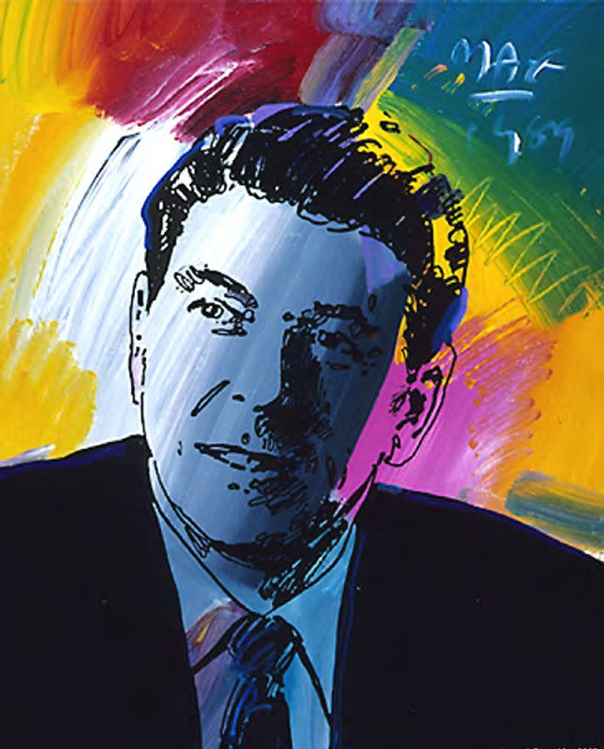
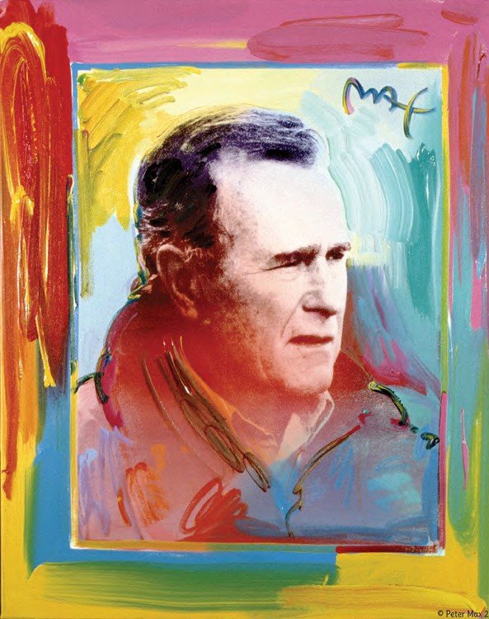
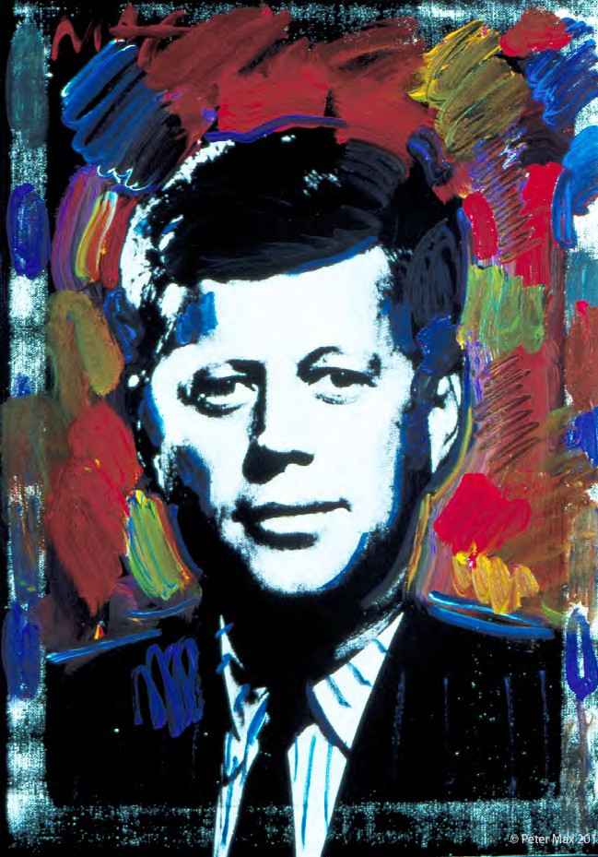
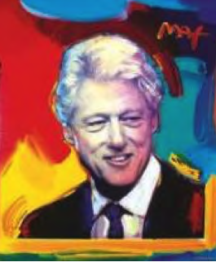
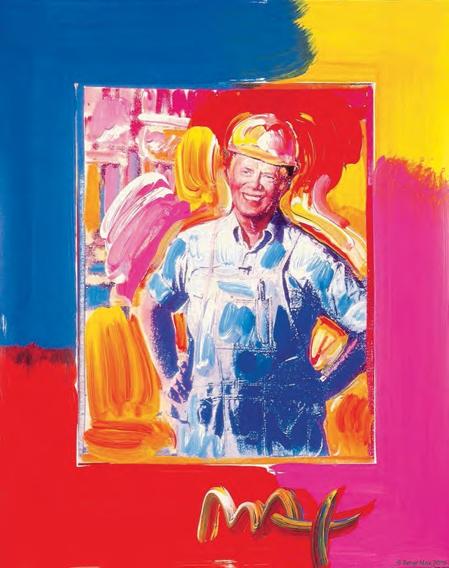
With paintings on exhibition in presidential libraries, museums and hundreds of galleries worldwide, Peter Max and his vibrant colors have become part of the fabric of contemporary culture. Max has been successively called a Pop Icon, Neo Fauvist, Abstract Expressionist and the United States “Painter Laureate.”

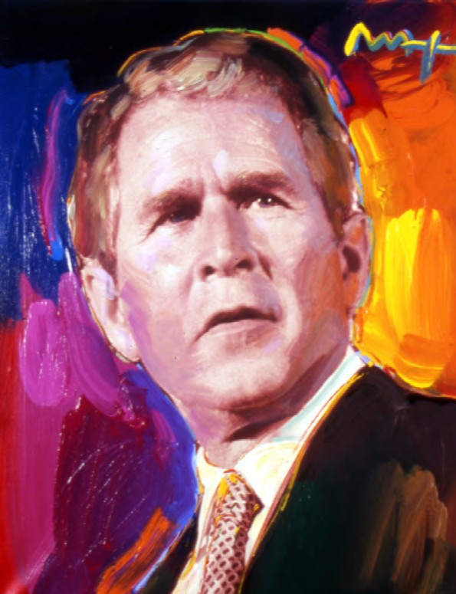
The artist has had the distinct honor of painting
seven Presidents of the United States.

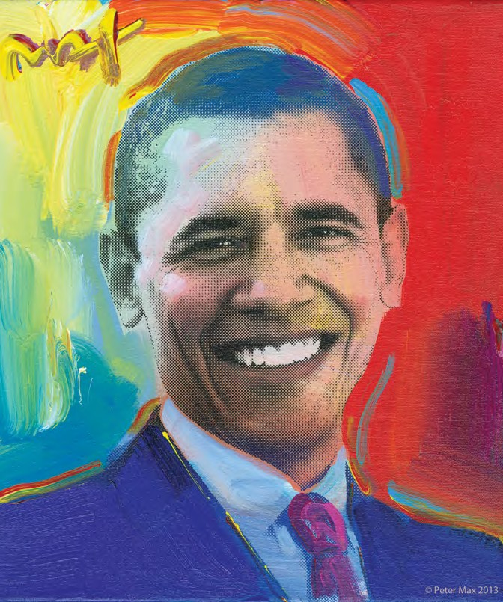

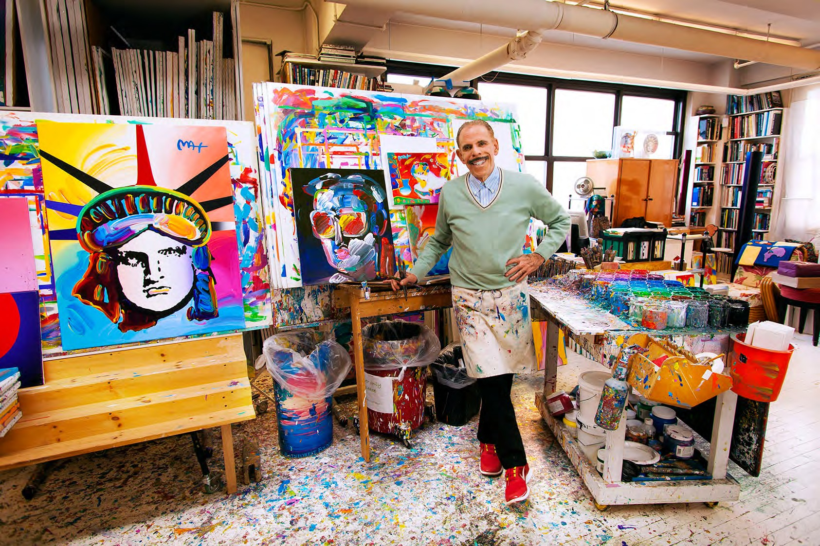
He has been the Official Artist of the Grammy’s, five NFL Super Bowls, the 2006 Olympics, the World Cup USA, The World Series, The U.S. Open, The Indy 500, The NYC Marathon and The Kentucky Derby.

Image: The Artist in his Studio
Peter Max CBS This Morning 1/2/2015
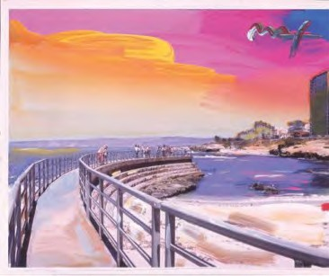
www.cbsnews.com/videos/artist-peter-maxs-colorful-creations-span-50-years/

Max’s Art Students League scholarly influence inspired all of his extraordinary artwork, and of late, his new Masters series; his interpretive works of Vincent
Van Gogh, Monet, Pablo Picasso, Renoir, and Edgar Degas, conceived in Max’s signature style
and colors.

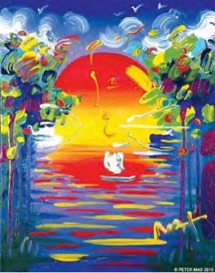
Image: A Better World Peter Max
Image: La Jolla, Peter Max- Available at Presentation

These works speak to both a maturation of the artist’s illustrious career, as well as to his formidable training at the 130
year-old Art Students League of New York.

Important pieces of the Retrospective Collection and the Masters Series will be available for acquisition in the La Jolla presentation.

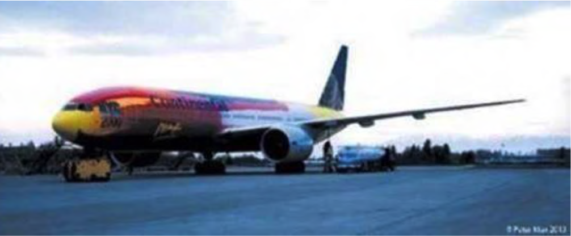
Image: The Artist Piloting His Flying Work of Art

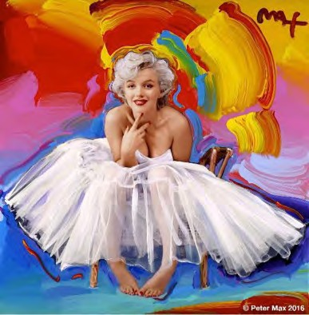
Image:
Marilyn In Honor of her 90th Birthday Year Peter Max 2016

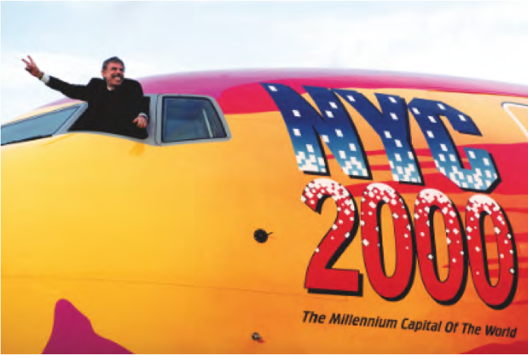
mage: Peter Max Designed Continental Boeing 707

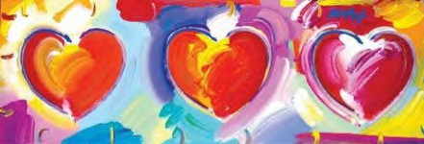
Image: Hearts New Series Peter Max 2016

website:
www.monarchfineart.com

RSVP’s are required:
858.454.1231
or info@monarChfineart.Com

where:
Monarch/Arredon Contemporary Art 7629 Girard Avenue
La Jolla, California 92037

when:
Receptions with Peter Max Saturday, October 22nd 2016 from 4-7 pm Sunday, October 23rd 2016 from 1-4 pm

All artwork is on exhibition and available for acquisition.

Media interviews are coordinated by: Allison Zucker-Perelman, Relevant Communications, 561.715.9525 allison@relevantCommuniCations.net

A full biography, b-roll, video clips and 300 dpi photography are available upon request @
allison@relevantcommunications.net

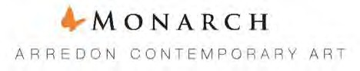

© Peter Max 2016 must appear next to each image in all print and digital/online displays. All photos courtesy of the artist.

