**ICONIC AMERICAN ARTIST**

**PETER MAX**

**TO EXHIBIT IN INDIANAPOLIS**

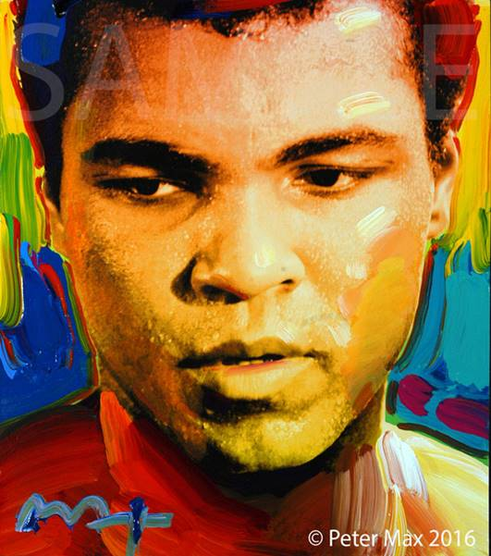

**Image: Portrait of Muhammad Ali   Peter Max All Rights Reserved 2016**

America’s Favorite Living Artist to Appear at

CV Art Gallery

**MEDIA INTERVIEWS are coordinated by:**

**Allison Zucker-Perelman, Relevant Communications,**

**561.715.9525** **allison@relevantcommunications.net**

**B-Roll, High Resolution 300dpi Images available interview with Peter Max upon request**

**America’s most popular living Artist celebrates America and the symbols that gave us our freedom.**

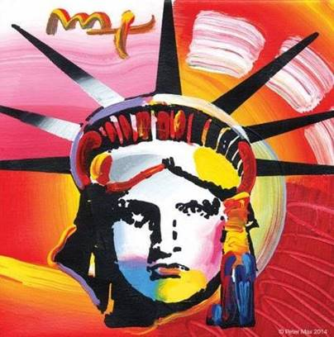

**Image: Liberty Peter Max 2014**

**Max's iconic ‘Love,’ first created as his acclaimed Art Nouveau-inspired 'Love' poster for the '60s generation, now flows with his signature, expressionistic brushstrokes**

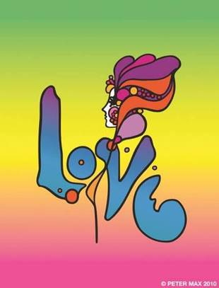

**Image: Love Peter Max 2010**

**FOR IMMEDIATE RELEASE:**

**PETER MAX - THE RETROSPECTIVE**

**1960 - 2016**

AN EXHIBITION OF WORKS FROM AMERICA’S ICONIC ARTIST

An artistic diversity that has defined American Art: Captured by the Artist who began a new visual culture

**Indianapolis, IN – (July 2016) –** A newly-curated collection by artist legend, Peter Max’s exquisite paintings will be on exhibition and available for acquisition in a presentation at CV Art Gallery, Indianapolis’s premier fine art gallery.

[www.cvartandframe.com](http://www.vcvartandframe.com)

Peter Max will make three very special appearances at the gallery and all appearances are complimentary and open to the public with RSVP’s required.

Previews begin **Saturday, October 1st, 2016 with a Preview Event Friday, September 30th from 6-8 pm.**There are three scheduled *Meet the Artist receptions****:* Friday October 7th, from 7-9pm, Saturday, October 8th 2016 from 4-*7pm and Sunday October 9th from Noon – 2pm.*** All artworks are on exhibition and available for acquisition.

**VIDEO CLIP:** [**http://Roadshowcompany.com/peter-max/**](http://Roadshowcompany.com/peter-max/)

**RSVP’s are required:   317.873.2976 or**

[**info@cvartandframe.com**](mailto:info@cvartandframe.com)

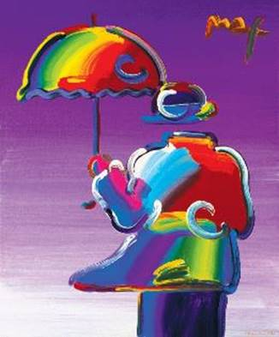

**Image: Umbrella Man Peter Max**

With paintings on exhibition in hundreds of museums and galleries worldwide, Peter Max and his vibrant colors have become part of the fabric of contemporary culture. Max has been successively called a Pop Icon, Neo Fauvist, Abstract Expressionist and the United States "Painter Laureate."  The artist has had the distinct honor of painting the last seven Presidents of the United States and the world's best loved celebrities, among them the young sensation Taylor Swift. This exhibit features his iconic and best-known pieces as well, among them “Statue of Liberty”, Max’s famous “Flag” pieces, “Umbrella Man” and the prestigious “Cosmic Runner”.  There will also be presentations of his celebrity portraiture in Indianapolis, as Peter Max is revered for his celebrity commissions and portraits.

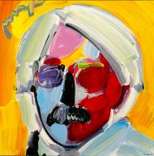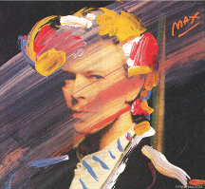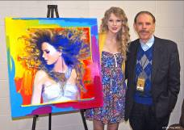

**PETER MAX CREATES NBC’S**

**THE VOICE FALL PREMIERE CAMPAIGN**

<http://www.nbc.com/the-voice/video/peter-max-brings-his-color-to-the-voice/2905555>

[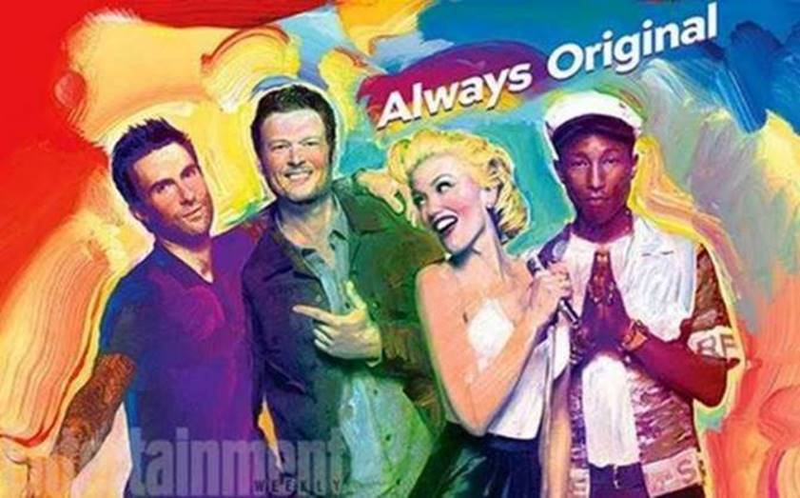](http://www.ew.com/article/2015/08/20/the-voice-season-9-key-art-peter-max)

The Artist has assembled a collection of his greatest and most-revered imagery spanning four decades: from his iconic Pop Art designs commemorating Woodstock to the 2013 unveiling of Max’s design for the cruise ship ***Breakaway and the 2016 exquisite Masters series.*** This new exhibition speaks to the evolution and maturation of America’s most popular living Artist.

**WHO WILL BE NEXT?**

With paintings on exhibition in presidential libraries, museums and hundreds of galleries worldwide, **Peter Max** and his vibrant colors have become part of the fabric of contemporary culture. Max has been successively called a Pop Icon, Neo Fauvist, Abstract Expressionist and the United States "Painter Laureate."

The artist has had the distinct honor of painting seven Presidents of the United States.

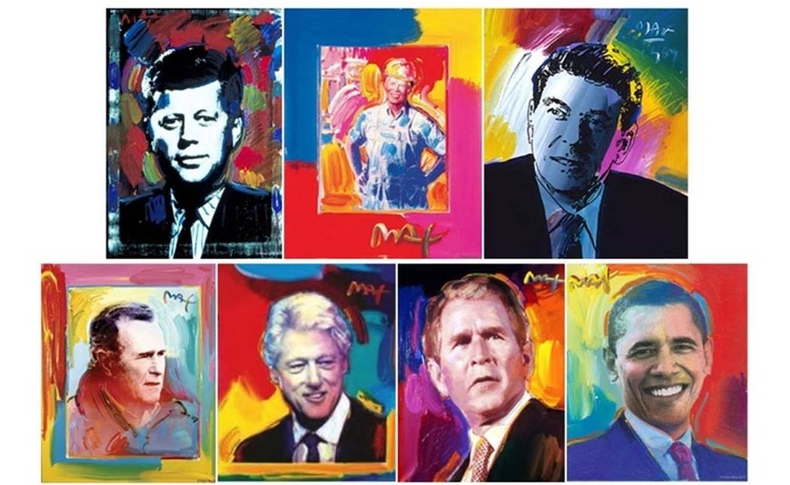

**He has been the Official Artist of the Grammy’s, five NFL Super Bowls, the 2006 Olympics, the World Cup USA, The World Series, The U.S. Open, The Indy 500, The NYC Marathon and The Kentucky Derby.**

**Peter Max CBS This Morning 1/2/2015**

[www.cbsnews.com/videos/artist-peter-maxs-colorful-creations-span-50-years/](http://www.cbsnews.com/videos/artist-peter-maxs-colorful-creations-span-50-years/)

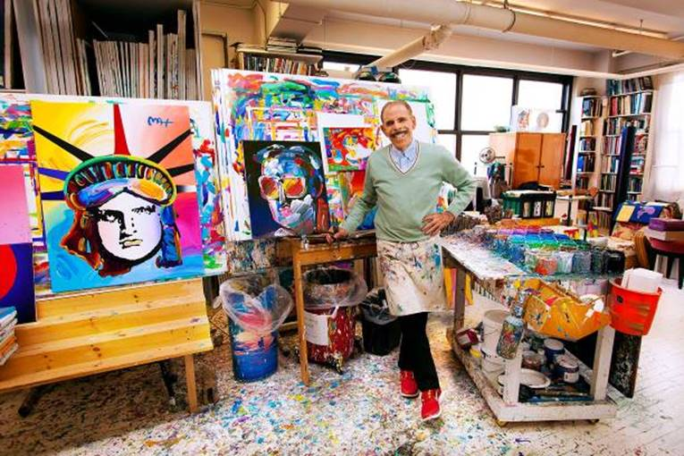

**Image: The Artist in His Studio 2016**

Max’s Art Students League scholarly influence inspired all of his extraordinary artwork, and of late, his new Masters series; his interpretive works of **Vincent Van Gogh**, **Monet, Pablo Picasso, Renoir, and Edgar** **Degas**, conceived in Max’s signature style and colors.  These works speak to both a maturation of the artist’s illustrious career, as well as to his formidable training at the 130-year- old Art Students League of New York.

**Important pieces of the Retrospective Collection and the Masters Series will be available for acquisition in the Indianapolis presentation.**

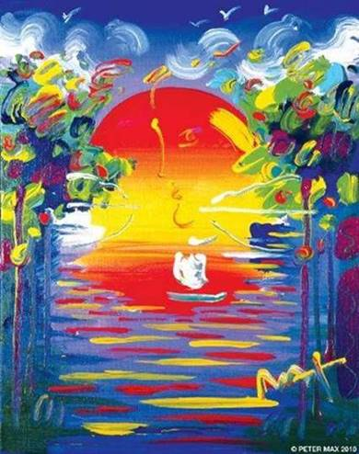

**Image: A Better World Peter Max 2010**

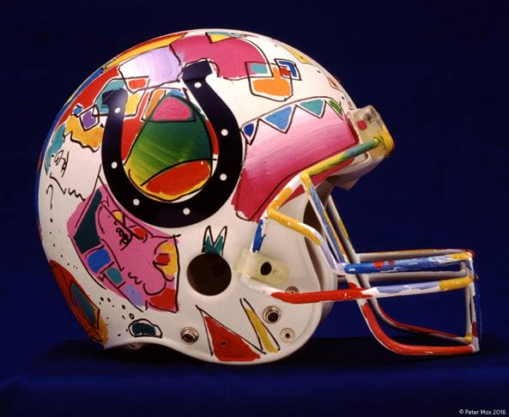

**Image:  Colts Helmet   Peter Max Available at Presentation**

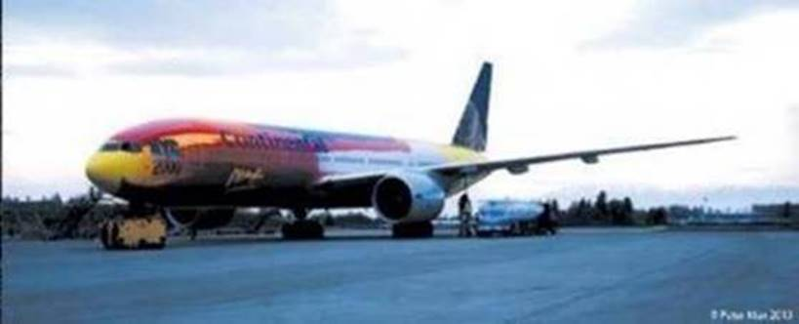

**Image: Peter Max Designed Continental Boeing**

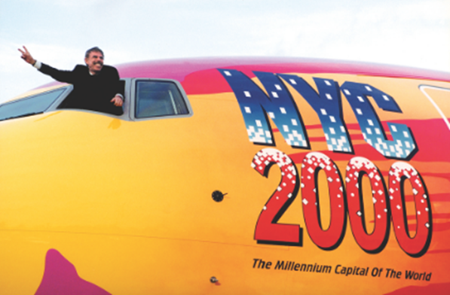

**Image:  The Artist Piloting His Flying Work of Art**

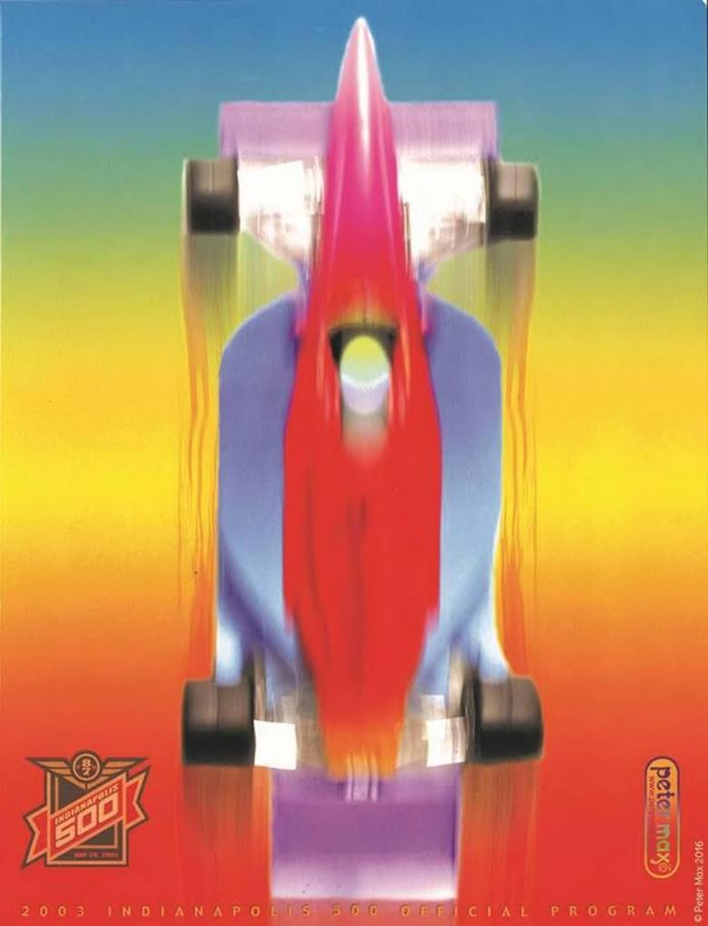

**Image   “Indy 500”    Peter Max**

**Website:** [www.cvartandframe.com](http://www.cvartandframe.com)

**RSVP’s are required:**

317.873.2976

[info@cvartandframe.com](mailto:info@cvartandframe.com)

**Where:** 110 South Main Street

Zionsville, Indiana 46077

**When:**Receptions with Peter Max

**Friday, October 7th, 2016 from 7-9 pm**

**Saturday, October 8th,  2016 from 4-7 pm**

**Sunday, October 9th, 2016 from Noon to 2 pm**

***All artwork is on exhibition and available for acquisition.***

**MEDIA INTERVIEWS are coordinated by:**

Allison Zucker-Perelman, Relevant Communications,

561.715.9525   allison@relevantcommunications.net



A full biography, b-roll, video clips and 300 dpi photography are available upon request @ allison@relevantcommunications.net

***Peter Max 2016 must appear next to each image in all print and digital/online displays. All photos courtesy of the artist.***