**Actress, Fine Artist & Philanthropist Jane Seymour to Appear in Naples**

**Interviews Available with Ms. Seymour**

**MEDIA INTERVIEWS are coordinated by:**

Allison Zucker-Perelman, Relevant Communications

561-715-9525 or [Allison@relevantcommunications.net](mailto:Allison@relevantcommunications.net)

**For Immediate Release**

**EMMY AWARD-WINNING ACTRESS JANE SEYMOUR TO EXHIBIT NEW COLLECTION IN NAPLES**

***ART ON EXHIBITION AND AVAILABLE FOR ACQUISITION AT THE MERCATO IN NAPLES, FLORIDA***

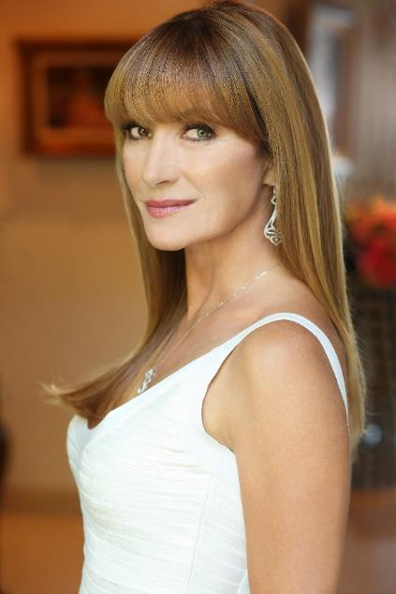

***Image:  Ms. Jane Seymour   2018***

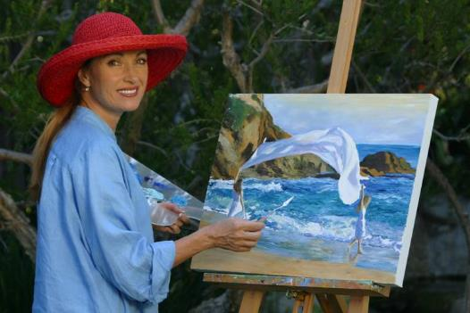

***Image:  The Artist    2018***

**Naples Fla. – (January 2018**) – An impressive new collection of original artwork by EMMY AND GOLDEN GLOBE award-winning actress, **JANE SEYMOUR**, will be on exhibition and available for acquisition at the Road Show Pop-Up Gallery in Naples, Florida.  Meet Ms. Seymour in person during two artist appearances; **Saturday, March 10th  from 6-8 pm and Sunday March 11th , 2018 from 2-4 pm.** This is a once-in-a-lifetime opportunity to meet Jane Seymour and experience her extraordinary art.    Exhibit previews begin **March 3rd  2018.** [**www.roadshowcompany.com**](http://www.roadshowcompany.com)

**CLICK HERE FOR DROPBOX HIGH RESOLUTION ASSETS:** [**CLICK HERE**](https://www.dropbox.com/sh/w2r3l228mfjlwaj/AAB2eNMZSd3p1nherpu535cla?dl=0)

***Artwork is on exhibition & available for acquisition and all appearances are open and complimentary to the public.***

**RSVP'S Requested   RSVP Telephone:** **866.900.6699** **and online @** [naples@roadshowcompany.com](mailto:naples@roadshowcompany.com)

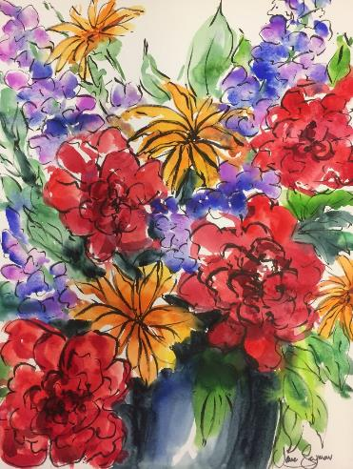

***Image: Watercolor w/ Pen & Ink on Paper***

**Website:** [**www.roadshowcompany.com**](http://www.roadshowcompany.com)

**COMPLIMENTARY TO THE PUBLIC - RSVP’S REQUIRED**

**866.900.6699 or** [**naples@roadshowcompany.com**](mailto:naples@roadshowcompany.com)

**Road Show Pop-Up Art Exhibition  
9115 Strada Place (Opposite Bravo)  
Naples, Florida  34108**

**Receptions with Ms. Jane Seymour**

**Saturday, March 10th , 2018               6:00pm – 8:00pm**

**Sunday, March 11th , 2018                  2:00pm – 4:00pm**

**Also in-person, works on exhibition and available for acquisition will be the extraordinary collection of Fine Art Photography by Sean M. Flynn, in a “Mother & Son” dual exhibition.**

**Sean Michael Flynn**

Fine Art Photographer, Filmmaker

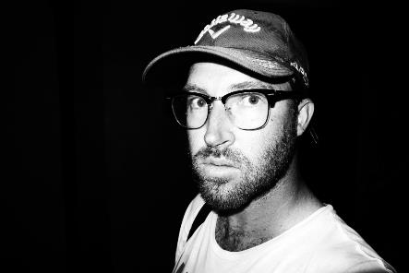

***Image:  Sean Flynn   2018***

A film director and fine art photographer, Flynn exhibits globally.

Recently, while in Los Angeles at Blank Space Gallery, where he was showing his work, Sean met the band **Incubus**. They saw is his work at the gallery and asked him to shoot a series of photos of the band during small private live shows that they were holding to promote their new album and world tour, titled “Incubus HQ.”  Incubus liked the photographs so much, that they began using the collection to promote “Incubus HQ” on countless major media outlets.

When the first set of photos was added to their **Facebook** *fan page,* **Incubus** told Sean that his photos had received over 6 million hits within the first couple of days and that the fans were loving them. Incubus followed this up by “*liking*” the “*Sean M Flynn Photography*” **Facebook** page, and for several weeks was their only “*like.*”

Consequently, Sean’s work is now internationally recognized, and has been viewed and appreciated by millions across the globe.

Since that time Sean has traveled to Rio de Janeiro with the band **LMFAO**, and on his second European trip photographing in England, France, Spain, Italy and Austria. His recent photographs of Jane Seymour on the beach in Malibu have won international acclaim, and have been published by ***Hello!* Magazine**, and other media outlets, creating a global buzz! Recently, he has been on tour with the band ***Cold War Kids.***

In addition to his photographic work, Sean has completed producing and directing a music video for **Shwayze** as well as numerous web-based commercials and promo spots for companies such as **Kay Jewelers, Coach, Fotiou Frames, Audi and many others.**

Recently, Sean released 3 critically acclaimed music videos for the band **Cold War Kids**, one of which was made out of 72,000 photos shot over the course of one day. Several of these photos are also in Sean’s “Kaleidoscope Series.”

Most recently, **Billboard Magazine** premiered his new music video **“Joan of Arc”** for indie Art Pop band **Bråves**. The video was made with a new cinematic method that Sean has spent the past year developing. **“The Sights and Sounds Music Magazine”** best described it as:  “….Bråves newest music video ‘[Joan of Arc](https://open.spotify.com/album/4IgXnEqBKwQWDrw0odVbfo)’ is not just a visual masterpiece, but a fearsome battle cry to others who are also sick and tired of the hateful, normalized acts of sexual violence happening every day…”  Sean was inspired to write the video based on his own traumatic #metoo experience, which he explains in detail in a recent social media post.

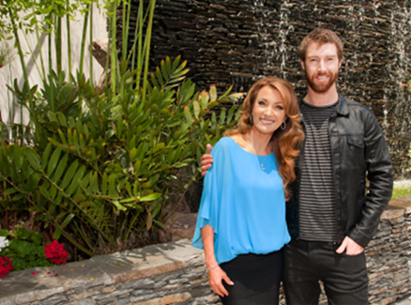

***Image: Jane Seymour and her son, Sean M. Flynn   2018***

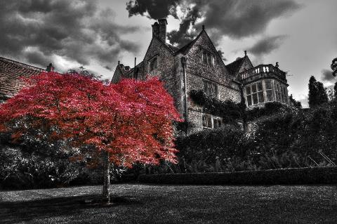

***Image:   The Red Tree         Sean M. Flynn***

**About Jane Seymour:**

A multiple Emmy® and Golden Globe® winner, recipient of the Officer of the British Empire (OBE) in the year 2000, which was bestowed upon her by Queen Elizabeth II at Buckingham Palace, Jane Seymour has proven her talents in virtually all media, the Broadway stage, motion pictures and television. Her love of art and color has led to her great success as a painter in watercolors and oils and as a designer.

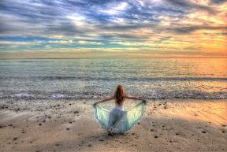A multiple Emmy and Golden Globe winner, recipient of the Officer of the British Empire (OBE) in the year 2000, which was bestowed upon her by Queen Elizabeth II at Buckingham Palace, Jane Seymour has proven her talents in virtually all media, the Broadway stage, motion pictures and television.  Her love of art and color has led to her great success as a painter in watercolors and oils and as a designer.

Seymour began painting nearlytwenty- five years ago prompted by a period of personal challenge, her art became the expression of a very private healing process. She emerged from this experience as an accomplished, passionate painter.  Today, Seymour sketches and paints at her Malibu studio, on movie sets and on her travels.  Over the past twenty-five years she has created an intimate world of delicate watercolors and colorful vibrant oil paintings, and has accepted select private commissions.

 Her talents as an established fine artist have led way to the artist being asked to create costume and set designs for the Houston Ballet’s production of “Five Poems” in 2001, the mounting of her first one woman museum exhibition in 2004 at the Butler Institute of American Art, as well as being selected as one of the official painters of the 2005 Torino Winter Olympics, and the official artist of the 2006 Naples Winter Wine Festival, and the 2008 Beijing Olympics, and the2010 Vancouver Winter Olympics.

The artist has exhibited her work at fine art galleries across North America during the past seventeen years and continues to reach new artistic levels by continually developing her technique, style and subject matter.  In recent years, Seymour and her art company, Coral Canyon Publishing, have partnered with Fotiou Frames, a luxury international molding manufacturer, to launch the JS Moulding Line to offer a wide selection of beautiful and elegant molding designs to quality framers nationwide to great success.

In 2009, Seymour released a collection of fine art Open Heart bronze sculptures and introduced the editions to the fine art world; the Open-Heart Icon and the Single Open-Heart designs are currently available in three different patinas.  Additional works of fine art bronze sculpture include a Portrait Head of a Girl, a Seated Nude, and a series of children’s sculptures of her twin boys, and their little girl playmate at the time, all in traditional patina.

To further illustrate the artist’s and her family’s commitment to the Open Hearts philosophy, the Open-Heart Icon Monumental fine art sculpture was born in 2012.  The very first example of the seven-foot tall bronze casting was installed in Seymour’s oceanside organic garden to commemorate her birthday in that year.   The second Open Heart Icon Monumental sculpture was introduced formally at the 2nd Annual Open Hearts Foundation Gala in 2012 and has since been installed outdoors in Akron, Ohio, gracing the corporate headquarters of Sterling Jewelers.  The third Open Heart Icon Monumental outdoor sculpture in sandstone was created in 2015, and unveiled in Calgary, Canada in the Fall of 2016, welcoming the residents and visitors of the grand new master-planned community called “Legacy.”  The first-ever monumental-sized Single Open-Heart sculpture, is currently in production, and is scheduled to be unveiled and installed in the lobby of a noted cardiac center in St. Cloud, MN in May of 2017.

With the creation of these four monumental sculptures a dream has become a reality, and a solid foundation has been established for the realization of a unique vision of inspiring people to fill their hearts with love by helping others, and reflected in a most tangible way.

Most importantly, Seymour continues to raise much needed funds and gives through donations of her artwork to numerous local and national charities which help children in need, raising awareness for women’s heart health and various other important issues dear to her heart.

Seymour resides in Malibu, is mother to six adult children and a grandmother of six.

**A full biography for both Artists, b-roll, video clips and additional 300 dpi photography are available upon request @** **allison@relevantcommunications.net**

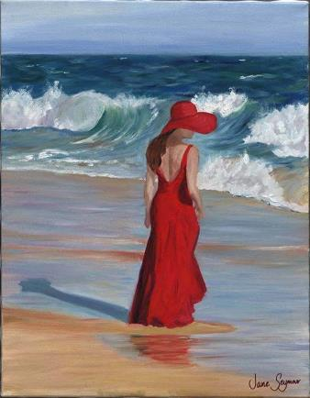

***Image:  Woman in A Red Dress***

**MEDIA INTERVIEWS are coordinated by:**

Allison Zucker-Perelman, Relevant Communication

561-715-9525 or [Allison@relevantcommunications.net](mailto:Allison@relevantcommunications.net)