**ROMERO BRITTO TO APPEAR LIVE IN PERSON IN SARASOTA**

**Chasen Galleries to Host Spectacular Collection of Pop Art**

**ROMERO BRITTO TO MAKE PERSONAL APPEARANCES IN SARASOTA**

**Works from Celebrated Pop Artists Romero Britto, Peter Max, Jim Dine, Robert Rauschenberg, Roy Lichtenstein**

***HIGH RESOLUTION IMAGERY AND B-ROLL:*** CLICK HERE

**FOR IMMEDIATE RELEASE:**

***Sarasota, Florida : December 2017*** An impressive and highly-curated collection by world-renowned Pop Art Icons Romero Britto, Peter Max, Jim Dine, Robert Rauschenberg and Roy Lichtenstein will be on exhibition and available for acquisition at a spectacular Fine Art Installation at the prestigious Chasen Galleries in Sarasota.  **The exhibition opens on January 13th , 2018, with a Preview event party from 6-8 pm on Friday evening, January 12th  and runs through January 21st , 2018.   Personal Appearances by Romero Britto: Saturday, January 20th 2018  from 6-8 pm and Sunday, January 21st2018  from 2-4 pm.**  **All artwork will be on exhibition and available for acquisition.**

<http://chasengalleries.com/sarasota/>

RSVP’s requested: 941.260.5787 or [art@chasengalleries.com](mailto:art@chasengalleries.com)

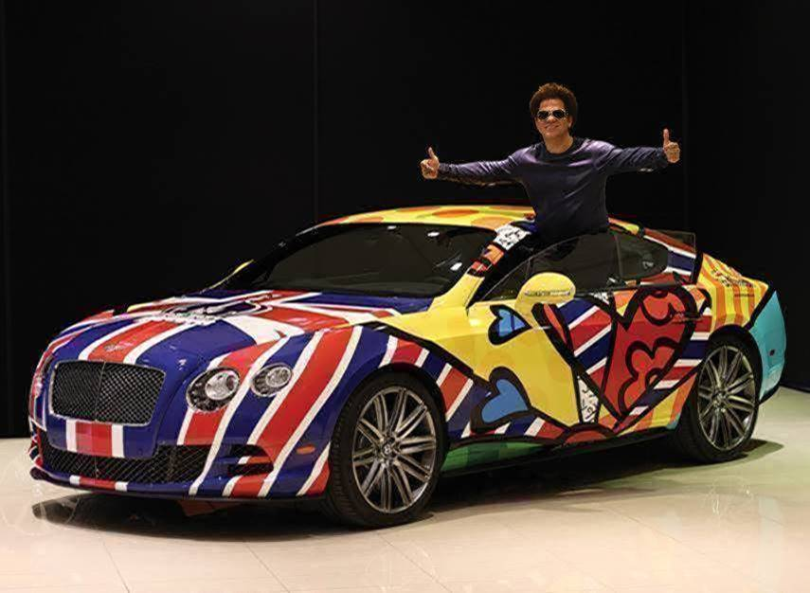

**IMAGE:  ROMERO BRITTO IN THE BRITTO BENTLEY**

**THE ARTIST WILL ACCEPT COMMISSIONS AT THIS PRESENTATION**

**IN-PERSON APPEARANCES BY ROMERO BRITTO ON**

**SATURDAY, JANUARY 20TH  2018             6:00 – 8:00 PM**

**SUNDAY, JANUARY 21ST   2018                 2:00 - 4:00 PM**

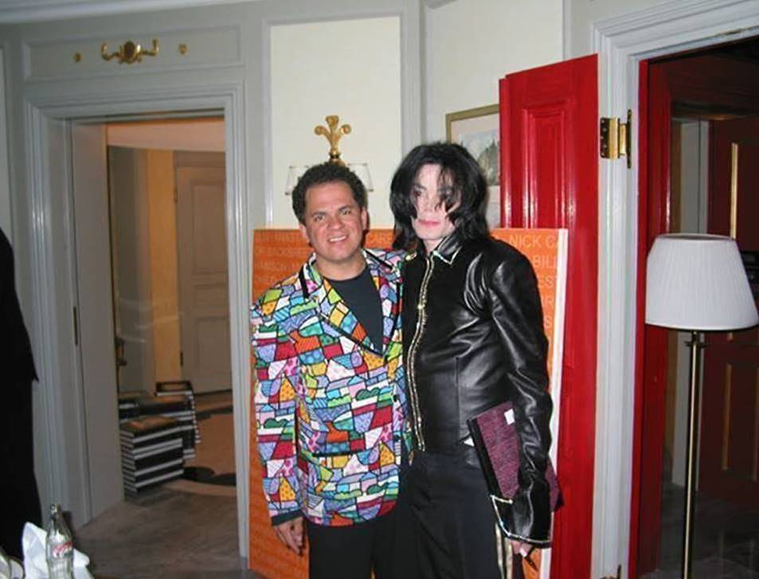

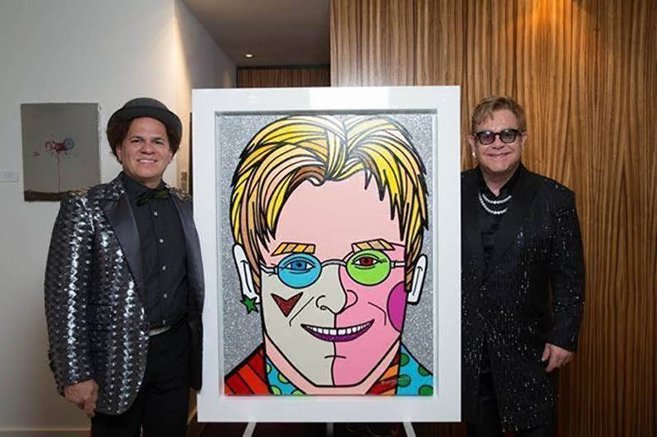

Pop art started with the New York artists Andy Warhol, Roy Lichtenstein, James Rosenquist, and Claes Oldenburg, all of whom drew on popular imagery and were actually part of an international phenomenon. Following the popularity of the Abstract Expressionists, Pop's reintroduction of identifiable imagery (drawn from mass media and popular culture) was a major shift for the direction of modernism. The subject matter became far from traditional "high art" themes of morality, mythology, and classic history; rather, Pop artists celebrated commonplace objects and people of everyday life, in this way seeking to elevate popular culture to the level of fine art. Perhaps owing to the incorporation of commercial images, Pop art has become one of the most recognizable styles of modern art.

**IMAGE:   PETER MAX   COSMIC RUNNER** 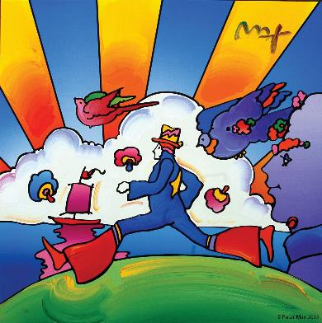

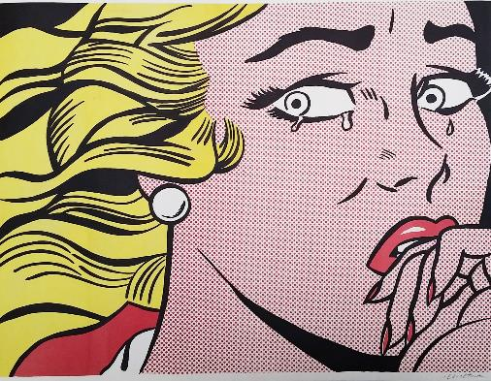

**IMAGE:  ROY LICHTENSTEIN         CRYING GIRL**

pop art

päp ˌärt/

*noun*

noun: **pop art**

art based on modern popular culture and the mass media, especially as a critical or ironic

comment on traditional fine art values.

By creating paintings or sculptures of mass culture objects and media stars, the Pop art movement aimed to blur the boundaries between "high" art and "low" culture. The concept that there is no hierarchy of culture and that art may borrow from any source has been one of the most influential characteristics of Pop art.

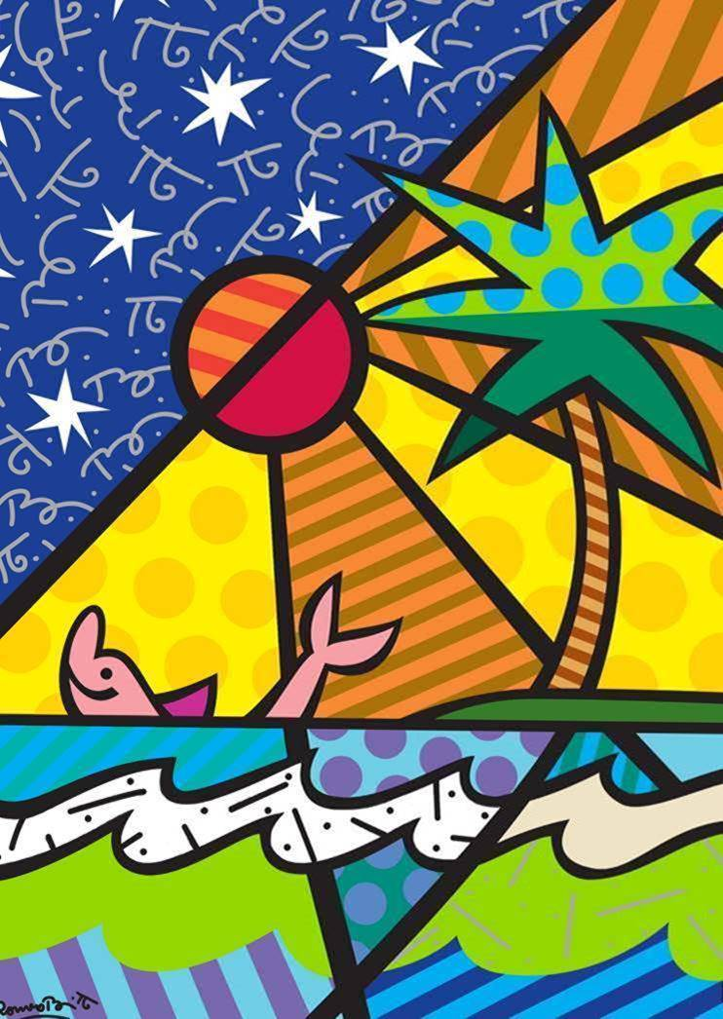

**IMAGE:  BEACH     ROMERO BRITTO**

**COMPLIMENTARY TO THE PUBLIC - RSVP’S REQUIRED or** [art@chasengalleries.com](mailto:art@chasengalleries.com)

**Chasen Galleries  
1830 South Osprey Avenue**

**Suite 102  
Sarasota, Florida  34239**

***Uncrating preview party:  Friday, January 12th, 2018  6-8 PM***

**IN-PERSON APPEARANCES BY ROMERO BRITTO ON**

**SATURDAY, JANUARY 20TH       2018          6:00-8:00PM**

**SUNDAY, JANUARY 21ST   2018          2:00-4:00PM**

**MEDIA INTERVIEWS are coordinated by:**

**Allison Zucker-Perelman, Relevant Communications,** **561.715.9525 or** [Allison@relevantcommunications.net](mailto:Allison@relevantcommunications.net)

