**GALLERIST LISA RUSSELL BRINGS FINE ART POP UP TO SAN ANTONIO**

**ICONIC ARTIST PETER MAX TO APPEAR LIVE IN SAN ANTONIO**

**Dropbox link to download press images** [**HERE**](https://www.dropbox.com/sh/79zfcdhnmf5o59a/AADO708tzub9ZZvVoxJURsvHa?dl=0)**.**

**FOR IMMEDIATE RELEASE**

**INTERVIEWS AVAILABLE WITH PETER MAX & NOTED GALLERIST LISA RUSSELL**

**HIGH RESOLUTION IMAGES IN DROPBOX AND B-ROLL EMBEDDED BELOW**

***PETER MAX RETROSPECTIVE – THE COLLECTED WORKS 1960-2017***

**THE RUSSELL COLLECTION PRESENTS A PREMIER POP UP**

**FINE ART, EXCLUSIVITY, ANTICIPATION &**

**AMERICA’S FAVORITE LIVING ARTIST IN PERSON**

**THE SHOPS AT LA CANTERA**

**PREVIEWS BEGIN SATURDAY, AUGUST 19TH,  2017**

**UNCRATING EVENT FRIDAY, AUGUST 18TH, 2017 AND VIP MEDIA EVENT**

**ARTIST APPEARANCES BY MAX**

**SATURDAY, AUGUST 26TH 2017     (6:00-8:00PM)**

**SUNDAY, AUGUST 27TH, 2017         (2:00-4:00PM)**

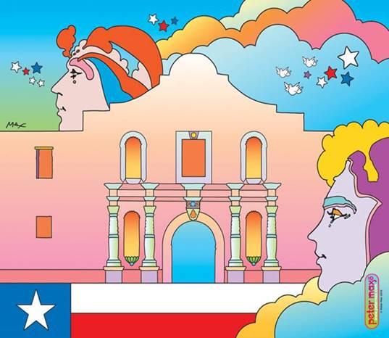

**IMAGE:  Cosmic Alamo        Peter Max**

**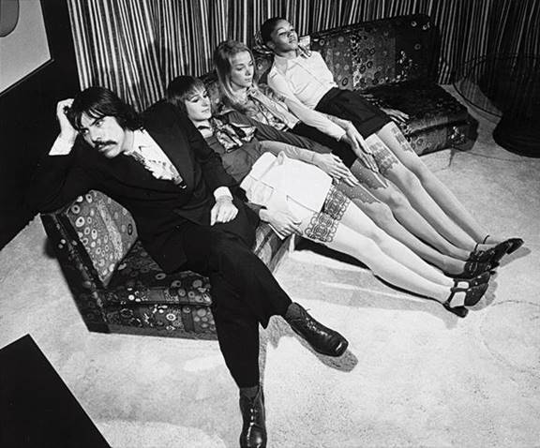   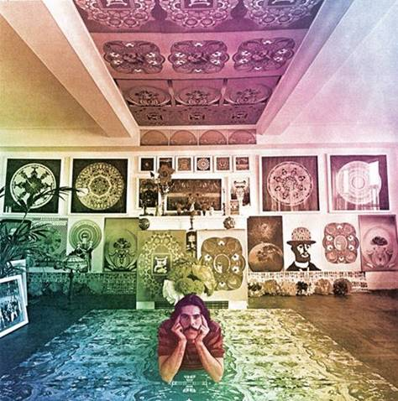**

**The Exhibition features the most famous works of legend Peter Max and houses never-before-seen archival photos and footage from the early years.  This is the *do not miss* Pop Up Event of the Summer.**

**San Antonio, Texas – (June 2017) –** ***PETER MAX RETROSPECTIVE – THE COLLECTED WORKS 1960-2017,*** a newly-curated and highly-anticipated Collection from Pop artist legend Peter Max, is the latest Pop Up luxury brand to hit the streets: and San Antonio is on the map for Austin’s  venerable Russell Collection’s  <http://russell-collection.com/> presentation of his works.  Noted Gallerist and innovator Lisa Russell has redefined the Pop Up model for this exhibition, and guests will have the opportunity to **Meet The Artist in person on Saturday and Sunday, August 26th & 27th .**

This extraordinary Pop Up is **open Friday August 18th until Sunday, August 27th**, and all artwork  is on exhibition & available for acquisition.  Admission is complimentary, and all appearances are open to the public.  ***Do not miss this once-in-a-lifetime opportunity to meet the world-renowned Pop Artist.  After August 27th it is done, over, done.***

The exhibit features Max’s iconic and most influential pieces, among them “Statue of Liberty,” Max’s famous “Flag” pieces, “Umbrella Man” and the prestigious “Cosmic Runner.”

**Dropbox link to download press images** [**HERE**](https://www.dropbox.com/sh/79zfcdhnmf5o59a/AADO708tzub9ZZvVoxJURsvHa?dl=0)**.**

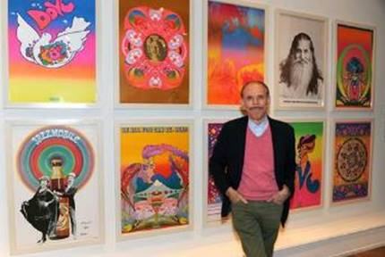Revered for his celebrity commissions and portraits, Max’s celebrity portraiture will also be included in the San Antonio Pop Up.

Commissions of portraits are available to all patrons and guests.

Considered to be one of the most significant artists in today’s pop culture landscape, Max was just commissioned to create a portrait of the honoree for the Grammy Awards MusiCares dinner. He has painted music legends including Lionel Richie, Bob Dylan, Bruce Springsteen and Paul McCartney, and just about every celebrity and musician there is.   Peter was the official artist for the Grammy Awards five times creating the poster and program cover.

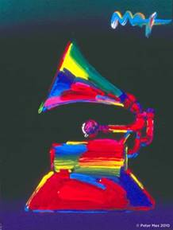               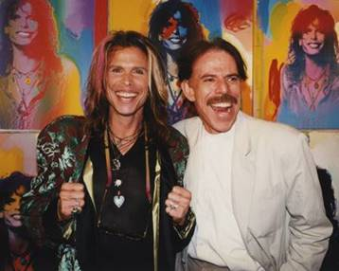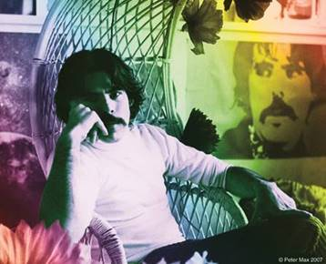

**This year, Tom Petty was honored as the 2017 MusiCares® Person of the Year on Friday, Feb. 10, 2017.**

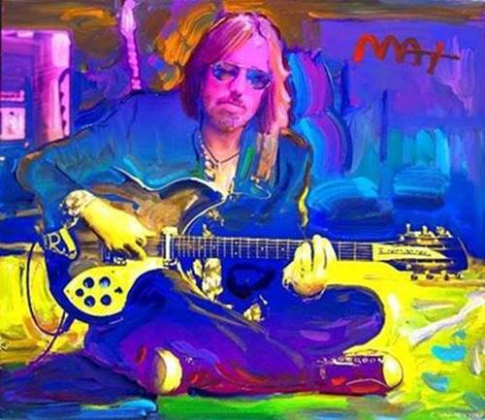

***Image: Tom Petty*by Peter Max                  February 2017**

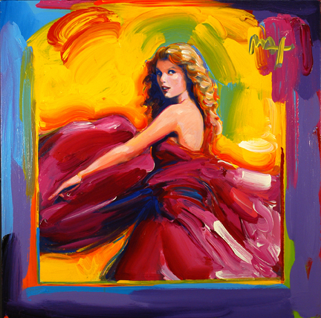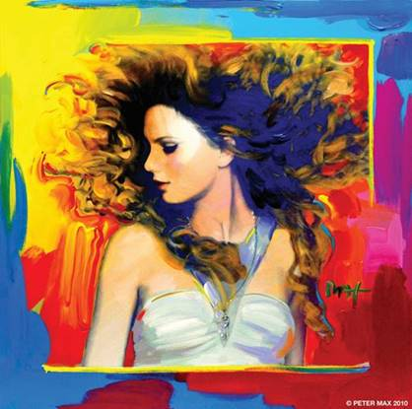

**Image:  Album Cover  “Speak Now”    Peter Max      Image:  Portrait of Taylor Swift    Peter Max**

**TAYLOR SWIFT SEES MAX’S ALBUM COVER & PORTRAIT OF HER FOR THE FIRST TIME:** <https://www.youtube.com/watch?v=keXe-VPVNb8>

<http://people.com/celebrity/taylor-swift-gets-the-pop-art-treatment/>

**Live B-Roll Link** [**HERE**](http://roadshowcompany.com/peter-max-interview/)**.**

Last year Max honored superstar Lionel Richie at the Grammy MusiCares Foundation dinner which serves to helps musicians in need. Recently, while flipping through the catalog Richie noticed a portrait of himself that was auctioned that evening. When Richie saw the painting was by Max, he immediately called the artist and asked to visit his studio in New York City. Once there, he and Max, a huge fan of Richie, traded hugs and Richie told Max he had missed the opportunity of meeting Andy Warhol as he was still living in 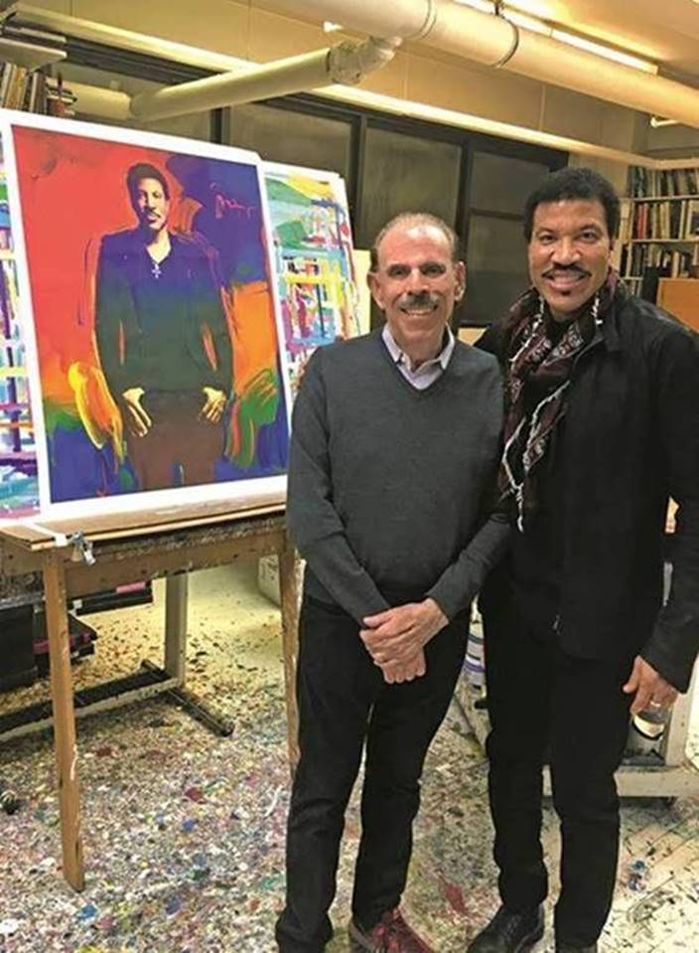Tuskegee, AL and was thrilled to meet Peter Max.

***Image (Right):******Artist Peter Max hosts Lionel Ritchie in his New York City studio on 1/20/2017 with the portrait he painted honoring Mr. Ritchie as MusiCares 2016 Person of the Year.***

Art World Innovator Lisa Russell has assembled this Collection of Max’s greatest and most-revered imagery spanning four decades, from his iconic Pop Art designs commemorating Woodstock to the 2013 unveiling of Max’s design for the cruise ship ***Breakaway and his latest project:***

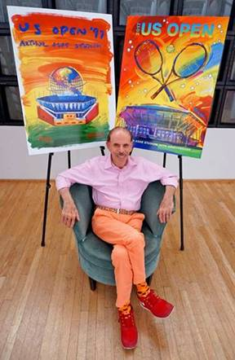

**Image:  The Artist June 14th, 2017   Unveiling of the 2017 USTA Theme Art**

***Artist Peter Max has created the 2017 US Open theme art, which celebrates the 20thanniversary of Arthur Ashe Stadium.  Max also was commissioned to create the US Open theme art in 1997, which featured Arthur Ashe Stadium for the first time.***

***This year’s theme art showcases Max’s signature style and the dynamic artwork features two crossed tennis racquets against a fiery sky. According to Max, the intent was to suggest two crossed swords, depicting the fierce competition of this final Grand Slam tennis tournament of the year. The artist’s expressionistic painting of the stadium brilliantly captures the passion and vibrancy that surround the event.***

***“We could not think of a better way to kick off the 20th anniversary of Arthur Ashe Stadium, than by ‘returning to source’ and having Peter Max create another signature work that truly captures the power of tennis’ grandest stadium,” said USTA Chairman of the Board and President Katrina Adams.***

This carefully curated collection is a museum-like retrospective of Max’s works. Max has painted for the past seven U.S. Presidents and his art is on display in museums, presidential libraries and in U.S. Embassies across the globe.  He has been the Official artist of the Grammy’s, five NFL Super Bowls, the 2006 Olympics, the World Cup USA, The World Series, The U.S. Open, The Indy 500, The NYC Marathon and The Kentucky Derby.

Max has been successively referred to as a “Pop Icon,” “Neo-Fauvist,” “Abstract Expressionist” and the United States "Painter Laureate."

**America’s most popular living Artist celebrates our world, our country and brings a message of unity, love and hope to all.**

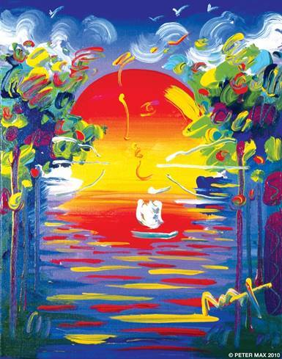

***Image:  Better World* ByPeter Max**

In 2015, Max was commissioned by *NBC* to create portraits of *The Voice* coaches **Adam Levine, Blake Shelton, Gwen Stefani and Pharell Williams** in celebration of the show’s ninth season premiere.

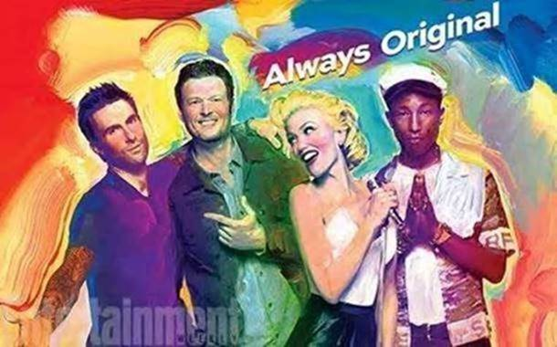

***The Voice* Season 9 Premiere by Peter Max**

Max made his footprint as an unstoppable force in the art world beginning at the prestigious Art Students League of New York, alongside such artists as Robert Rauschenberg, Jackson Pollack, Cy Twombly and Norman Rockwell.  The League was a formative influence on these artists’ innovative artwork, and has led each one to greatness and an important legacy in history.

**Max’s**Art Students League scholarly influence inspired all of his extraordinary artwork, and of late, his new Masters series; his interpretive works of **Vincent Van Gogh**, **Monet, Pablo Picasso, Renoir, and Edgar** **Degas**, conceived in Max’s signature style and colors.  These works speak to both a maturation of the artist’s illustrious career, as well as to his formidable training at the 130-year-old Art Students League.

***“Max has redefined the role of an artist in contemporary pop culture.” ~ Hype Magazine***

**COMPLIMENTARY TO THE PUBLIC - RSVP’S REQUIRED**

**512.478.4440 or**[sales@russell-collection.com](mailto:sales@russell-collection.com)

**The Russell Collection Peter Max Pop Up**

***The Shops of La Contera***

***Suite 20190  (ACROSS FROM H & M)***

***15900 La Contera Parkway***

**San Antonio, Texas**

<http://russell-collection.com/>

[cid:image028.png@01D2F0B7.F27F0DE0](https://www.facebook.com/russellcollection) [cid:image030.png@01D2F0B7.F27F0DE0](https://www.instagram.com/russellfineart)

**UNCRATING EVENT FRIDAY, AUGUST 18TH 2017**

**6:00-8:00 PM CST**

**IN-GALLERY APPEARANCES FROM PETER MAX ON**

**SATURDAY, AUGUST 26TH, 2017   (6:00-8:00PM CST)**

**SUNDAY, AUGUST 27TH , 2017       (2:00-4:00PM CST)**

<http://petermax.com>

[cid:image028.png@01D2F0B7.F27F0DE0](https://www.facebook.com/artofpetermax)[cid:image029.png@01D2F0B7.F27F0DE0](https://twitter.com/Peter_Max) [cid:image030.png@01D2F0B7.F27F0DE0](https://www.instagram.com/petermaxart)

A full biography, Additional b-roll, video clips and 300 dpi photography are available upon request @**allison@relevantcommunications.net**

***© Peter Max 2017 must appear next to each image in all print and digital/online displays. All photos courtesy of the artist.***

#   #   #

**MEDIA INTERVIEWS are coordinated by:**

Allison Zucker-Perelman, Relevant Communications,

561.715.9525   **allison@relevantcommunications.net**