**WORLD-RENOWNED ARTIST ROMERO BRITTO: EXCLUSIVE NEW YORK PRESENTATION**

**MEDIA INTERVIEWS are coordinated by:**

**Allison Zucker-Perelman, Relevant Communications,** **561.715.9525 or** [Allison@relevantcommunications.net](mailto:Allison@relevantcommunications.net)

**Interviews with Romero Britto, High-Resolution Images, B-Roll and Additional Copy Points Available Upon Request**

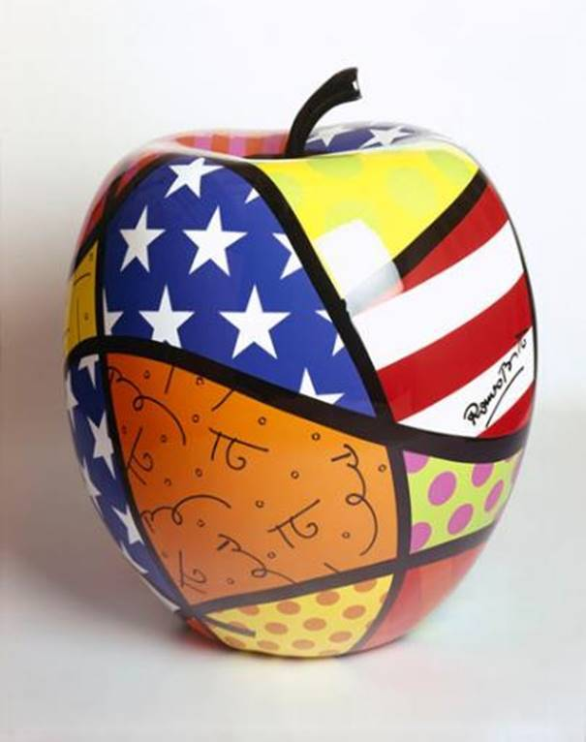

**Image:  Apple   Romero Britto**

**LaMANTIA GALLERY PRESENTS**

**WORLD-RENOWNED ARTIST**

**ROMERO BRITTO IN EXCLUSIVE NEW YORK PRESENTATION**

***ART ON EXHIBITION & AVAILABLE FOR ACQUISITION***

**ROMERO BRITTO**

***WORLD’S MOST FAMOUS POP-ARTIST***

***BRINGS HIS EXTRAORDINARY COLLECTION TO NORTHPORT’S DISTINGUISHED LaMANTIA GALLERY***

***Limited Engagement:  July 14th, 2017 through July 23rd, 2017***

**Northport, New York.:  May, 2017** - An impressive collection of artworks and sculpture by world-renowned artist Romero Britto will be on exhibition and available for acquisition at LaMantia Gallery in Northport, New York.   **The exhibition previews July 15th, 2017 and opens to the public on Saturday, July 22nd, 2017 with a series of live Artist Appearances:  The gallery will host public exhibitions on Saturday, July 22nd from 6-8 pm and Sunday, July 23rd, 2017**

**from 2-4 pm.**  [www.lamantiagallery.com](http://www.lamantiagallery.com)

**RSVP’s required:  631.754.8414 or** [**info@lamantiagallery.com**](mailto:info@lamantiagallery.com)



**ABOUT THE ARTIST:**

**Video Bio for All Platforms:** [**https://www.dropbox.com/s/zyixy1uuvdsksl2/BrittoLife1.mov?dl=0**](https://www.dropbox.com/s/zyixy1uuvdsksl2/BrittoLife1.mov?dl=0)

With an iconic style that The New York Times described, “exudes warmth, optimism and love,”, Romero Britto is an international artist that uses vibrant, bold and colorful patterns to reflect his optimistic view of the world around him. His playful themes and hard‐edged compositions, combined with his unique talent, unshakable resolve and belief in his art, have granted him worldwide recognition, with exhibition in galleries and museums in over 100 countries and counting. The artist’s pop sensibility has leant itself to collaborations with global brands such as Audi, Bentley, Coca‐Cola, Walt Disney, Evian, Hublot, and Mattel, to name a few. Britto’s work evokes happiness and hope using a visual language all its own and is, simply, relatable to all.

One only must look around New York City and its environs to see the Artists’ extraordinary works; gracing New York’s venerable and iconic buildings and public spaces.

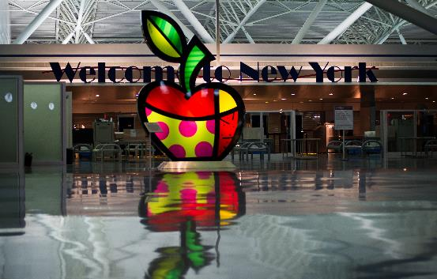

**Image:  Kennedy Airport     New York**

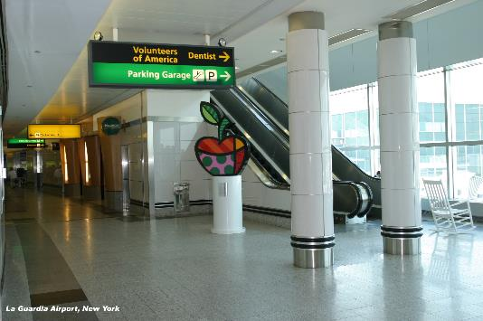

**Image:  LaGuardia Airport          New York**

Romero Britto was born in Recife, Brazil in 1963. Self-taught at an early age, he painted on surfaces such as newspapers. In 1983, he traveled to Paris where he was introduced to the work of Matisse and Picasso. He combined influences from cubism with pop, to create a vibrant, iconic style that The New York Times describes, “exudes warmth, optimism and love.”

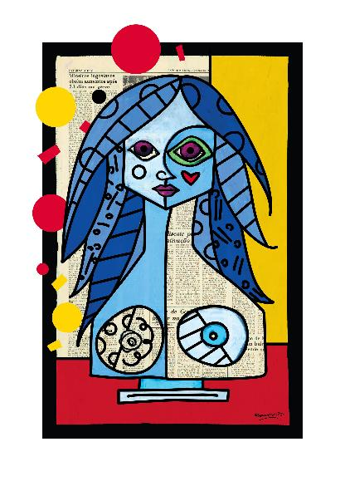

**Image:     Blue, Red & Yellow     ROMERO BRITTO**

In 1988, Britto moved to Miami and emerged as an international artist. In the following year, he was selected alongside Andy Warhol and Keith Haring for Absolut Vodka’s “Absolut Art” campaign. Britto’s pop sensibility has since leant itself to many collaborations with such brands as Audi, Bentley, Disney, Technomarine, Evian and FIFA, for whom he created an official poster for the 2010 World Cup.

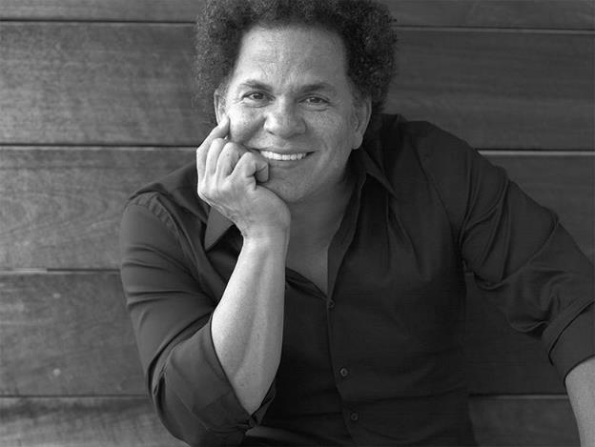

**The Artist Romero Britto   Photo Credit: Sergey Bermeniev   All Rights Reserved**

He has also illustrated several books published by Simon & Schuster and Rizzoli. Britto’s work has been exhibited in galleries and museums in over 100 countries, including the Salon Nationale des Beaux-Arts exhibition at the Carrousel du Louvre in 2008 and 2010. He has also created public art installations for the O2 Dome (Berlin), Hyde Park (London), John F. Kennedy Airport (New York), and Cirque du Soleil at Super Bowl XLI.

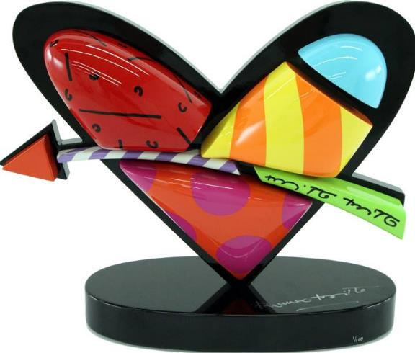

**Image:  In Love     Sculpture  Romero Britto**

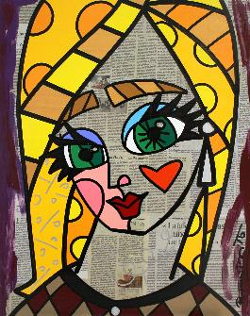  
Britto considers the role of an artist to be an agent of positive change. He serves as a benefactor, donating time, art and resources to over 250 charitable organizations and several boards such as Best Buddies International, and St. Jude’s Children’s Research Hospital. He was recently named a founding inaugural benefactor of Harvard’s “International Negotiation Program," by Dr. Daniel Shapiro, in his quest for peaceful conflict resolution.

Britto has also spoken at the World Economic Forum in Davos, and at countless schools and institutions. In early 2011 the President of Brazil, Dilma Rousseff, invited Britto to create the logo for Rede Cegonha, a project to reach over 61 million pre-and post-natal mothers and babies.

***"Art can make you look at something in an exciting and totally different way. It can give you the power to 'fly”.***

***“I get my inspiration from simple things in life… From beautiful things that happen around me, things that make me happy leave me inspired”!***

***“Everything is based on education. With knowledge and education, you can understand the world. ““I believe that every human being has the power to do good for someone else”.        Romero Britto***

**Where:**        **LaMantia Gallery**

**127 Main Street**

**Northport, New York   11768**

**When:        Receptions with Romero Britto:**

**Saturday, July 22nd   2017        6:00 pm - 8:00 pm**

**Sunday, July 23rd   2017         2:00 pm – 4:00 pm**

**Website:**   [www.lamantiagallery.com](http://www.lamantiagallery.com)

**RSVP Telephone:** 631.754.8414 or [info@lamantiagallery.com](mailto:info@lamantiagallery.com)

**COMPLIMENTARY TO THE PUBLIC – RSVP’S REQUIRED**

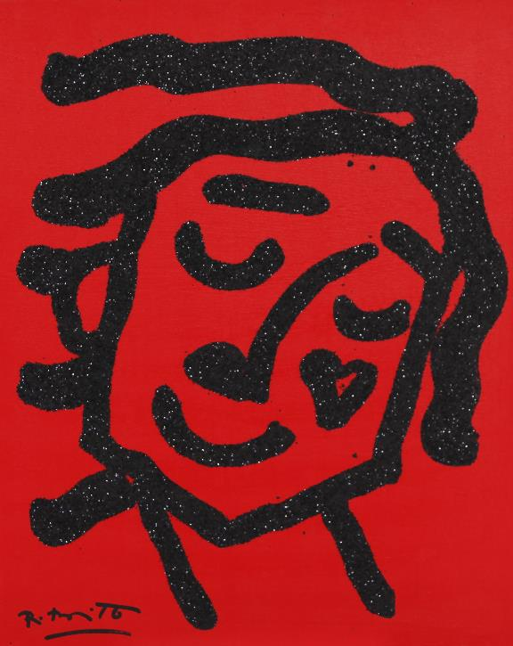

**Image:   Happy           Romero Britto**

**MEDIA INTERVIEWS are coordinated by:**

**Allison Zucker-Perelman, Relevant Communications,** **561.715.9525 or** [Allison@relevantcommunications.net](mailto:Allison@relevantcommunications.net)

A full biography, b-roll, video clips and 300 dpi photography are available upon request:  please contact [allison@relevantcommunications.net](mailto:allison@relevantcommunications.net)

**© Romero Britto 2016 must appear next to each image in all print and digital/online displays. All photos courtesy of the artist.**

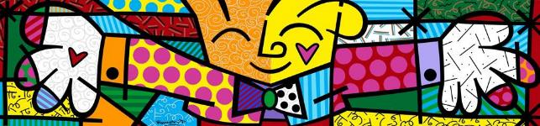

**Image: :  The Hug                   Romero Britto**

