FOR IMMEDIATE RELEASE:

PETER MAX – THE COLLECTED WORKS 1960-2017

AMERICA’S FAVORITE LIVING ARTIST
TO APPEAR AT BOSTON’S OWN DZIAN GALLERY

PREVIEWS BEGINNING SATURDAY, APRIL 29

IN-GALLERY ARTIST APPEARANCES BY MAX
SATURDAY, MAY 6th (6:00-8:00PM)
SUNDAY, MAY 7th (1:00-4:00PM)

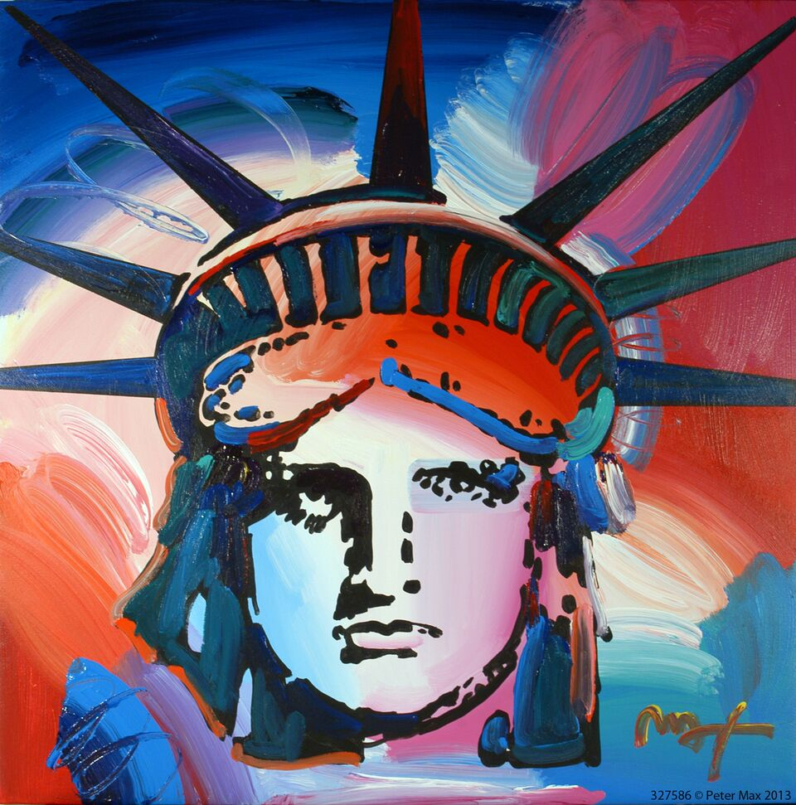
Statue of Liberty by Peter Max

Boston, MA – (April 2017) – PETER MAX – THE COLLECTED WORKS 1960-2017, a newly-curated collection from Pop artist legend Peter Max, will be on exhibition and available for acquisition at Boston’s Dzian Gallery beginning Saturday, April 29 for previews only. Max will make in-gallery appearances on Saturday, May 6 (6:00-8:00pm EST) and Sunday, May 7 (1:00-4:00pm EST).

The exhibit features Max’s iconic and most infamous pieces, among them “Statue of Liberty,” Max’s famous “Flag” pieces, “Umbrella Man” and the prestigious “Cosmic Runner.”

Dropbox link to download press images HERE.
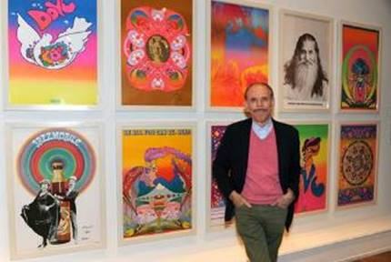
Revered for his celebrity commissions and portraits, Max’s celebrity portraiture will also be included in the Boston exhibit. Commissions of portraits are available to all patrons and guests at the gallery.

Considered to be one of the most significant artists in today’s pop culture landscape, Max has been commissioned to create a portrait of the honoree for the Grammy Awards MusiCares dinner. He has painted music legends including Lionel Richie, Bob Dylan, Bruce Springsteen and Paul McCartney, to name a few. Peter was the official artist for the Grammy Awards five times creating the poster and program cover.
Image: Peter Max in his NYC Studio

This year, Tom Petty was honored as the 2017 MusiCares® Person of the Year on Friday, Feb. 10, 2017.

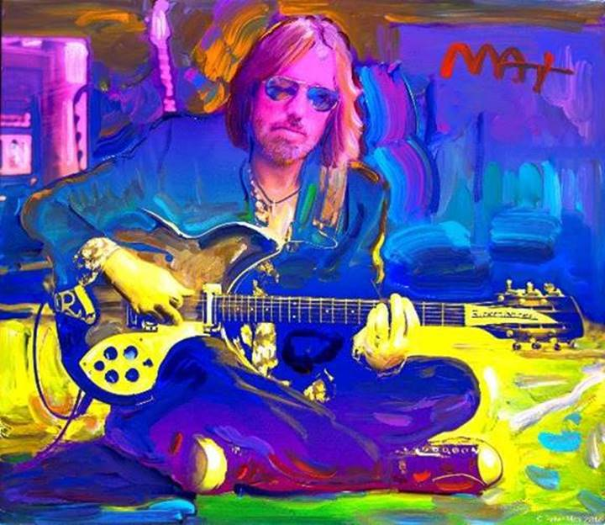
Tom Petty by Peter Max (February 2017

Live B-Roll Link HERE.

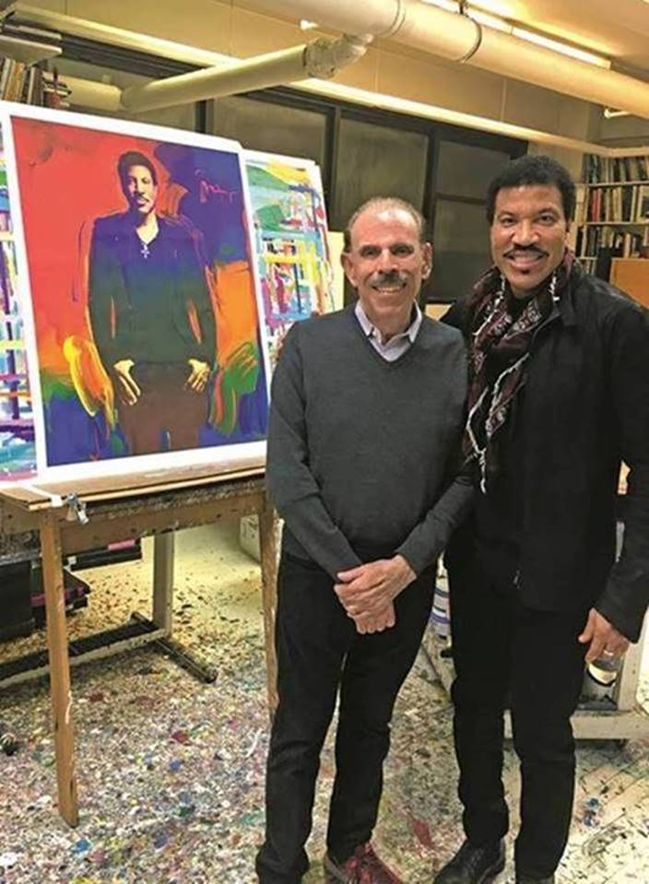
Last year Max honored superstar Lionel Richie at the Grammy MusiCares Foundation dinner which serves to helps musicians in need. Recently, while flipping through the catalog Richie noticed a portrait of himself that was auctioned that evening. When Richie saw the painting was by Max, he immediately called the artist and asked to visit his studio in New York City. Once there, he and Max, a huge fan of Richie, traded hugs and Richie told Max he had missed the opportunity of meeting Andy Warhol as he was still living in Tuskegee, AL and was thrilled to meet Peter Max.

Image (Right): Artist Peter Max hosts Lionel Ritchie in his New York City studio on 1/20/2017 with the portrait he painted honoring Mr. Ritchie as MusiCares 2016 Person of the Year.

Max has assembled a collection of his greatest and most-revered imagery spanning four decades, from his iconic Pop Art designs commemorating Woodstock to the 2013 unveiling of Max’s design for the cruise ship Breakaway and the exquisite Masters series. His latest exhibition speaks to the evolution and maturation of America’s most popular living artist.

This carefully curated collection is a museum-like retrospective of Max’s works. Max has painted for the past seven U.S. Presidents and his art is on display in museums, presidential libraries and in U.S. Embassies across the globe. He has been the Official artist of the Grammy’s, five NFL Super Bowls, the 2006 Olympics, the World Cup USA, The World Series, The U.S. Open, The Indy 500, The NYC Marathon and The Kentucky Derby.

Max has been successively referred to as a “Pop Icon,” “Neo-Fauvist,” “Abstract Expressionist” and the United States "Painter Laureate."

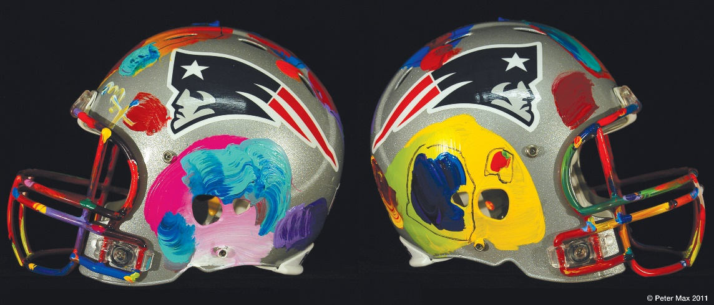
New England Patriots NFL Helmet
All NFL Helmets on exhibition & available for acquisition

In 2015, Max was commissioned by NBC to create portraits of The Voice coaches Adam Levine, Blake Shelton, Gwen Stefani and Pharell Williams in celebration of the show’s ninth season premiere.

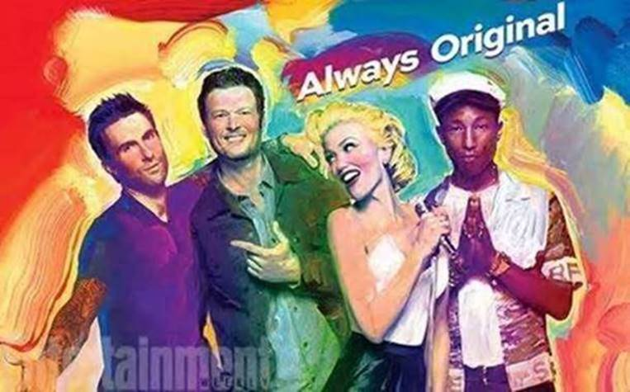
The Voice Season 9 Premiere by Peter Max

Max also previously painted portraits of global Pop superstar Taylor Swift in anticipation of her 2008 album “Fearless” and 2010 album “Speak Now.”
Max made his footprint as an unstoppable force in the art world beginning at the prestigious Art Students League of New York, alongside such artists as Robert Rauschenberg, Jackson Pollack, Cy Twombly and Norman Rockwell. The League was a formative influence on these artists’ innovative artwork, and has led each one to greatness and an important legacy in history.

Max’s Art Students League scholarly influence inspired all of his extraordinary artwork, and of late, his new Masters series; his interpretive works of Vincent Van Gogh, Monet, Pablo Picasso, Renoir, and Edgar Degas, conceived in Max’s signature style and colors. These works speak to both a maturation of the artist’s illustrious career, as well as to his formidable training at the 130-year-old Art Students League.

America’s most popular living Artist celebrates our world, our country and brings a message of unity, love and hope to all.

“Max has redefined the role of an artist in contemporary pop culture.” ~ Hype Magazine

COMPLIMENTARY TO THE PUBLIC - RSVP’S REQUIRED
508.655.6522 or info@dzian.net

DZIAN GALLERY
Natick Mall
First Floor – Macy’s Wing
1245 Worcester Street
Natick, MA 01760
http://www.dzian.net

UNCRATING EVENT FRIDAY, APRIL 28
6:00-8:00PM EST

IN-GALLERY APPEARANCES FROM PETER MAX ON
SATURDAY, MAY 6th (6:00-8:00PM)
SUNDAY, MAY 7th (1:00-4:00PM)

http://petermax.com

A full biography, b-roll, video clips and 300 dpi photography are available upon request @allison@relevantcommunications.net

© Peter Max 2017 must appear next to each image in all print and digital/online displays. All photos courtesy of the artist.

# # #

MEDIA INTERVIEWS are coordinated by:
Allison Zucker-Perelman, Relevant Communications,
561.715.9525 allison@relevantcommunications.net

