Madame Christine Argillet to Accompany Salvador Dali Exhibition

INTERVIEWS WITH MADAME ARGILLET AVAILABLE

MEDIA INTERVIEWS are coordinated by:
Allison Zucker-Perelman, Relevant Communications
561-715-9525 or allison@relevantcommunications.net
______________________________________________________________________________
Press Release
Old Towne Gallery Presents:
SALVADOR DALI: THE ARGILLET COLLECTION

Venerable Park City Gallery Presents the Art Event of the Season
Collection on Exhibition & Available for Acquisition
March 10th, 2017 through March 22nd , 2017

Special Appearances by Madame Christine Argillet March 17th, 18th & 19th

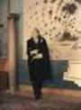 | 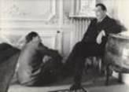 | 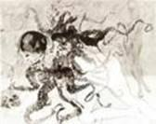 | 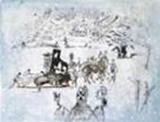
"Dali devant tablo"  Dali foreground with Tapestry of Argus | Salvador Dali & Pierre Argillet working  on the Venus in Furs project. Paris 1967 | Medusa  Salvador Dali - Mythologie | Piano Under Snow  Surrealist Bullfight  Salvador Dali

Madame Christine Argillet to accompany rare and extraordinary collection of Salvador Dali's and Pierre Argillet's collaborative works of original etchings, Aubusson Tapestries & original watercolors.

Salt Lake City & Park City, Utah : Old Towne Gallery, Park City’s most prestigious fine art gallery, is proud to announce its presentation of Salvador Dali: The Argillet Collection. The collection is on exhibition and available for acquisition at the gallery: previews begin on March 10th, 2017.
http://oldtownegallery.com/

The exhibition is a rare opportunity to meet Madame Christine Argillet, daughter of Dali's legendary publisher and confidante Pierre Argillet, during scheduled special appearances by Madame Argillet for the public: Friday, March 17th 2017, 7:00 pm – to 9:00 pm: Saturday, March 18th from 11:00 am – 1:00 pm and 7:00 pm – 9:00 pm, Sunday, March 19th 2017 from 1:00 pm – to 3 :00 pm.
Previews begin March 10th, 2017.

All appearances are complimentary to the public, and RSVP’s are required.

Meet Madame Argillet

Friday, March 17th , 2017
7:00 pm – 9:00 pm

Saturday, March 18th , 2017
11:00 am – 1:00 pm & 7:00 pm – 9:00 pm

Sunday, March 19th , 2017
1:00 pm – 3:00 pm

Previews Begin March 10th , 2017

Website: www.oldtownegallery.com

Where: Old Towne Gallery
580 Main Street
Park City, Utah 84060

RSVP’s are required: 435.655.3910 or info@oldtownegallery.com

All Art is On Exhibition & Available for Acquisition

Salvador Dali's publisher, Pierre Argillet (1910-2001) and Dali enjoyed a collaboration and a friendship that spanned five decades; and produced what art historians have termed "the finest bodies of the Master's Art". This collection made available by the Argillet Estate is...truly… A privilege and an opportunity for the collector to own a prominent piece of Dali's legacy.

Pierre Argillet's body of Dali's etchings, original works and books appear in museums throughout the world, and have enjoyed a home at the Museum of Surrealism in Melun, France (Pierre Argillet's former home "Chateau Vaux-le-Penil" and former museum) as well as in the Dali Museum in St. Petersburg, Florida. The collection is also housed at the prestigious Los Angeles County Museum of Art (LACMA). Together, Argillet & Dali created remarkable editions of original prints, lived the life of a committed "Surrealist” and developed images that are highly-valued and prized by collectors today.

This exhibition and collection opportunity offers works from Dali's Suites, including Mythologie, Les Hippies, Goethe's Faust, and the incomparable Poemes Secrets d'Apollinaire. Madame Argillet has also graciously included the rare titles, Etchings and Watercolors from 1934 to the late 1960's.

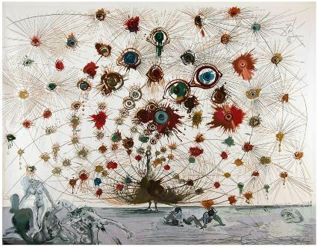
Argus, 1972-1973, Aubusson Tapestry, 249 x 307cm.

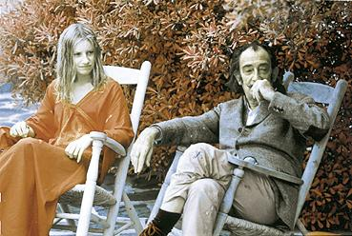

Image: Christine Argillet and Dali 1970’s

Salvador Dali: The Argillet Collection
A Rare & Impassioned Collaboration between Artist and Publisher

It has often been said by those in the art world that: "Salvador Dali was the creative genius....and Pierre Argillet was the publishing genius"

Madame Christine Argillet, Los Angeles, CA - 2016

High-Resolution Artwork (300dpi) Available to Media/Press Upon Request

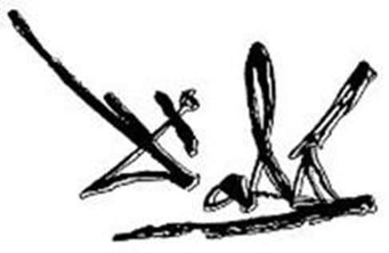

MEDIA INTERVIEWS are coordinated by:
Allison Zucker-Perelman, Relevant Communications
561-715-9525 or allison@relevantcommunications.net

Additional Copy Points, High Resolution Photography, B-Roll and Archived Digital Stills Available Upon request @ allison@relevantcommunications.net

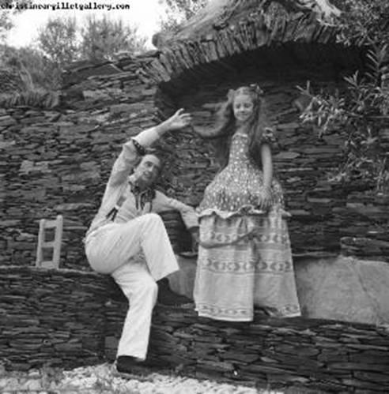 THE ARTIST AND MADAME ARGILLET 1972
.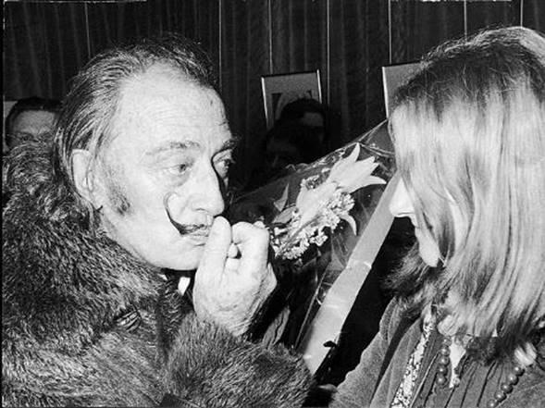

MEDIA INTERVIEWS are coordinated by:
Allison Zucker-Perelman, Relevant Communications
561-715-9525 or allison@relevantcommunications.net

SELECTED IMAGES

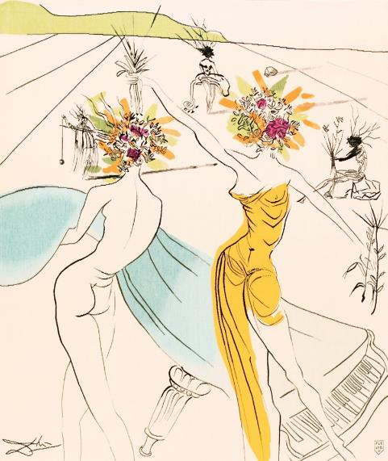
Tapestries

Flower Woman with Soft Piano, 1972 Handwoven Aubusson Tapestry, 160 x 127cm Edition size – 6.

Porcelain Plates
Gretchen (Marguerite)
Porcelain with Gold Leaf, 25.5cm diameter, Edition of 2000 Includes Atelier's stamp: Raynaud, In Limoges, France.
Porcelain Plates
Gretchen (Marguerite)
Porcelain with Gold Leaf, 25.5cm diameter, Edition of 2000 Includes Atelier's stamp: Raynaud, In Limoges, France.

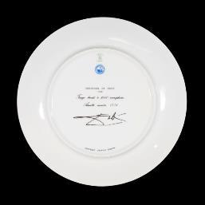
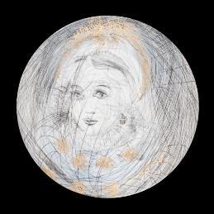

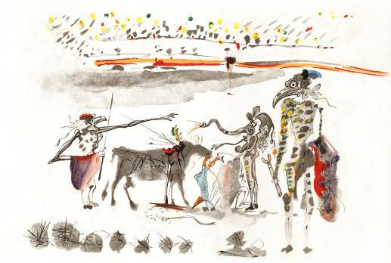
Original Etchings

Bullfight with Parrots, 1967
Heliogravure reworked in drypoint and hand-coloured on paper, 51 x 66cm Editions I-C on Japanese paper, 1-150 on Arches paper.

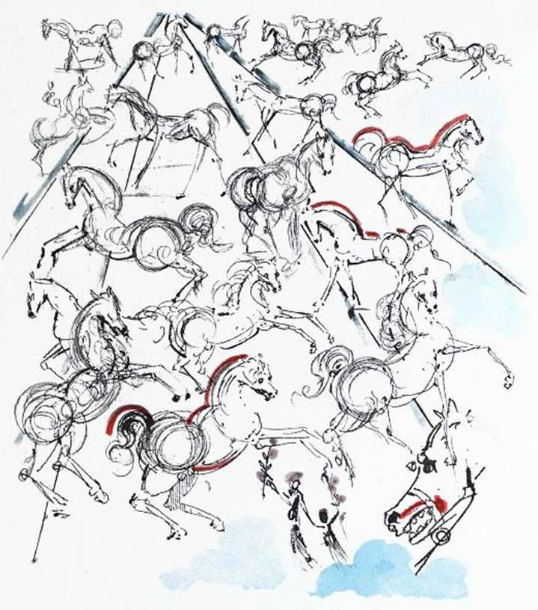

Blue Horses, 1966
Drypoint etching, hand-coloured, 66 x 51cm Editions I-C on Japanese paper, 1-150 on Arches paper.

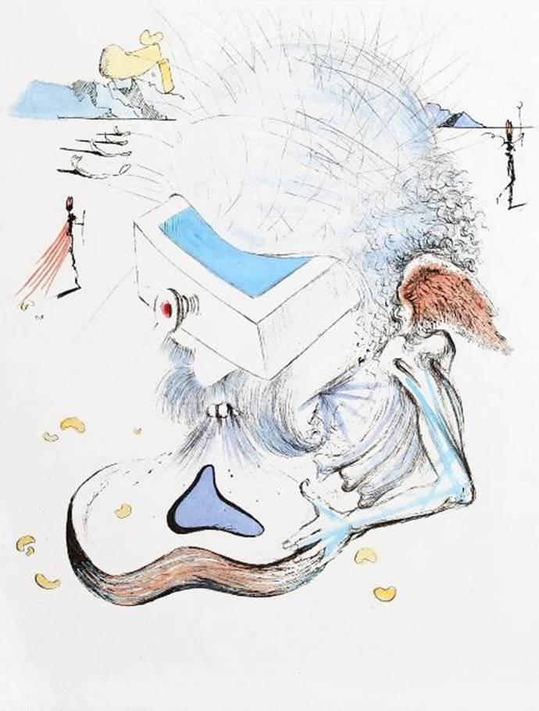

The Drawers, 1967
Drypoint etching on Japanese paper, 38 x 29cm Edition size – 145.

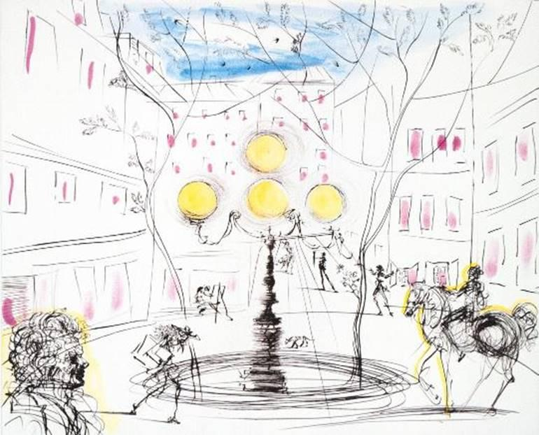

Place Furstenberg, 1971 Drypoint etching on paper, 51 x 66cm
Editions I-C on Japanese paper, 1-150 on Arches paper.

About Old Towne Gallery
With a unique vision, and a sterling reputation for bringing world-class artwork to its established Collectors, patrons and new clients, Old Towne Gallery is recognized as a premier fine art gallery and has established itself as an integral part of the Northwestern art scene. Old Towne Gallery has utilized their relationships developed with painters, sculptors and dealers across the world, thus bringing the highest quality fine art to Collectors.
The gallery specializes in the work of the Masters, as well as today's most recognizable artists; both established and emerging, creating a gallery that is known for the highest level of trust and confidence in its offerings.
Old Towne’s gallerists have curated their works both nationally and abroad, resulting in a collection of art that is quite extensive and thus are Park City’s premier source for building quality collections each and every day.

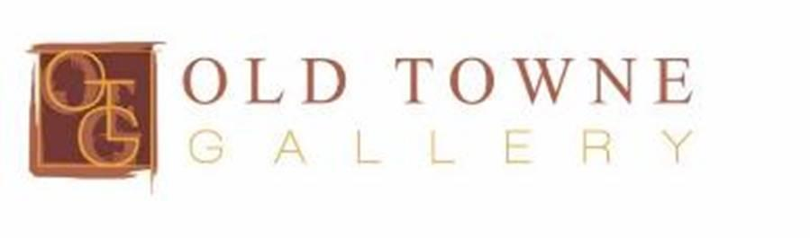

COMPLIMENTARY TO THE PUBLIC

All artwork is on exhibition and available for acquisition.

MEDIA INTERVIEWS are coordinated by:
Allison Zucker-Perelman, Relevant Communications,
561.715.9525 allison@relevantcommunications.net

A full biography, b-roll, video clips and 300 dpi photography are available upon request @ allison@relevantcommunications.net

