**MEDIA INTERVIEWS are coordinated by:**

**Allison Zucker-Perelman, Relevant Communications,** **561.715.9525 or** [Allison@relevantcommunications.net](mailto:Allison@relevantcommunications.net)

**Interviews with Romero Britto, High-Resolution Images, B-Roll and Additional Copy Points Available Upon Request**

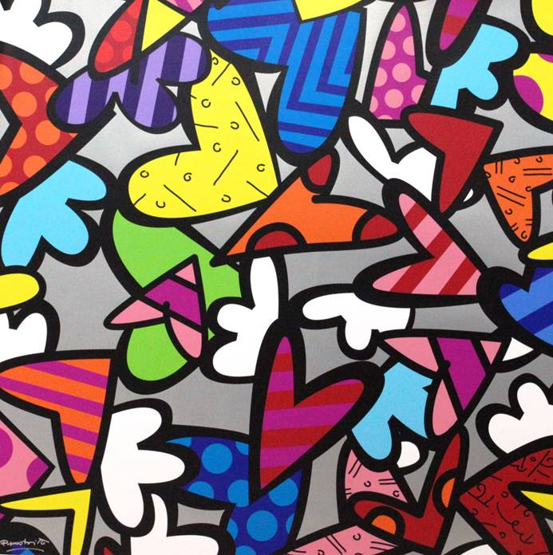

**Photo Caption: Alive Again**

**FOR IMMEDIATE RELEASE:**

**CHASEN GALLERIES PRESENTS WORLD-RENOWNED ARTIST**

**ROMERO BRITTO IN EXCLUSIVE RICHMOND PRESENTATION**

**ROMERO BRITTO**

**ART ON EXHIBITION & AVAILABLE FOR ACQUISITION**

**ROMERO BRITTO**

***WORLD’S MOST FAMOUS POP-ARTIST***

***BRINGS HIS EXTRAORDINARY COLLECTION TO RICHMOND’S DISTINGUISHED CHASEN GALLERIES***

***Limited Engagement:  April 21st, 2017 through April 30th, 2017***

**RICHMOND, VA.: February, 2017** - An impressive collection of artworks and sculpture by world-renowned artist Romero Britto will be on exhibition and available for acquisition at Chasen Galleries in Richmond.   **The exhibition previews April 21st ,2017 and opens to the public on Saturday, April 29th 2017 with a series of live Artist Appearances:  The gallery will host public exhibitions on Saturday, April 29th from 6-8 pm and Sunday, April 30th, 2017 from 1-4 pm.**

**The limited engagement exhibition begins on April 21st and runs through April 30th, 2017**.

RSVP’s required: 804.204.1048 or visit [art@chasengalleries.com](mailto:art@chasengalleries.com)

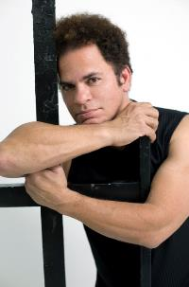

**ABOUT THE ARTIST:**

**Video Bio for All Platforms:** [**https://www.dropbox.com/s/zyixy1uuvdsksl2/BrittoLife1.mov?dl=0**](https://www.dropbox.com/s/zyixy1uuvdsksl2/BrittoLife1.mov?dl=0)

With an iconic style that The New York Times described, “exudes warmth, optimism and love,”, Romero Britto is an international artist that uses vibrant, bold and colorful patterns to reflect his optimistic view of the world around him. His playful themes and hard‐edged compositions, combined with his unique talent, unshakable resolve and belief in his art, have granted him worldwide recognition, with exhibition in galleries and museums in over 100 countries and counting. The artist’s pop sensibility has leant itself to collaborations with global brands such as Audi, Bentley, Coca‐Cola, Walt Disney, Evian, Hublot, and Mattel, to name a few. Britto’s work evokes happiness and hope using a visual language all its own and is, simply, relatable to all.

Romero Britto was born in Recife, Brazil in 1963. Self-taught at an early age, he painted on surfaces such as newspapers. In 1983, he traveled to Paris where he was introduced to the work of Matisse and Picasso. He combined influences from cubism with pop, to create a vibrant, iconic style that The New York Times describes, “exudes warmth, optimism and love.”

In 1988, Britto moved to Miami and emerged as an international artist. In the following year, he was selected alongside Andy Warhol and Keith Haring for Absolut Vodka’s “Absolut Art” campaign. Britto’s pop sensibility has since leant itself to many collaborations with such brands as Audi, Bentley, Disney, Technomarine, Evian and FIFA, for whom he created an official poster for the 2010 World Cup.

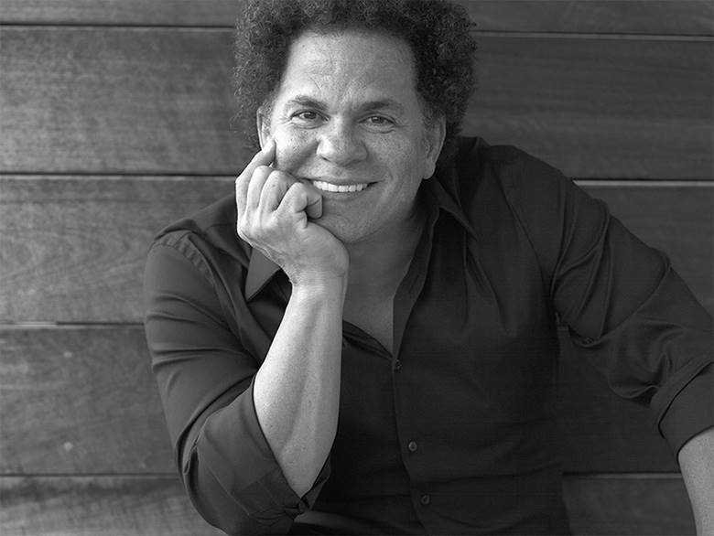

**The Artist Romero Britto Photo Credit: Sergey Bermeniev All Rights Reserved**

He has also illustrated several books published by Simon & Schuster and Rizzoli. Britto’s work has been exhibited in galleries and museums in over 100 countries, including the Salon Nationale des Beaux-Arts exhibition at the Carrousel du Louvre in 2008 and 2010. He has also created public art installations for the O2 Dome (Berlin), Hyde Park (London), John F. Kennedy Airport (New York), and Cirque du Soleil at Super Bowl XLI.

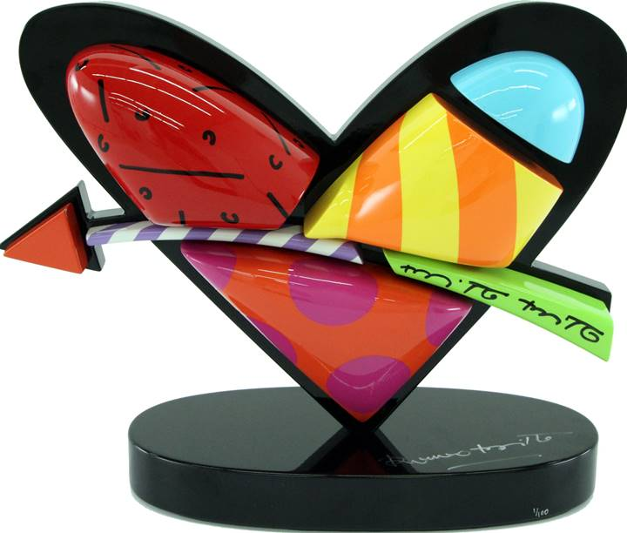

**Photo Caption:  In Love     Sculpture**

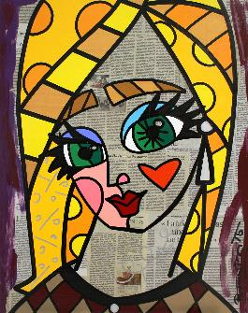  
Britto considers the role of an artist to be an agent of positive change. He serves as a benefactor, donating time, art and resources to over 250 charitable organizations and several boards such as Best Buddies International, and St. Jude’s Children’s Research Hospital. He was recently named a founding inaugural benefactor of Harvard’s “International Negotiation Program," by Dr. Daniel Shapiro, in his quest for peaceful conflict resolution.

Britto has also spoken at the World Economic Forum in Davos, and at countless schools and institutions. In early 2011 the President of Brazil, Dilma Rousseff, invited Britto to create the logo for Rede Cegonha, a project to reach over 61 million pre-and post-natal mothers and babies.

***"Art can make you look at something in an exciting and totally different way. It can give you the power to 'fly”.***

***“I get my inspiration from simple things in life… From beautiful things that happen around me, things that make me happy leave me inspired”!***

***“Everything is based on education. With knowledge and education, you can understand the world. ““I believe that every human being has the power to do good for someone else”.        Romero Britto***

**For more information about Romero Britto:**

A full biography, b-roll, video clips and 300 dpi photography are available upon request:  please contact [allison@relevantcommunications.net](mailto:allison@relevantcommunications.net)

**Where:**       **Chasen Galleries of Fine Art**

**3554 West Cary Street**

**Richmond, Virginia 23221**

**When:        Receptions with Romero Britto:**

**Saturday, April 29th 2017        6:00 pm - 8:00 pm**

**Sunday, April 30th 2017         1:00 pm – 4:00 pm**

**Website:**   [art@chasengalleries.com](mailto:art@chasengalleries.com)

**RSVP Telephone:** 804.204.1048 or [art@chasengalleries.com](mailto:art@chasengalleries.com)

**COMPLIMENTARY TO THE PUBLIC – RSVP’S REQUIRED**

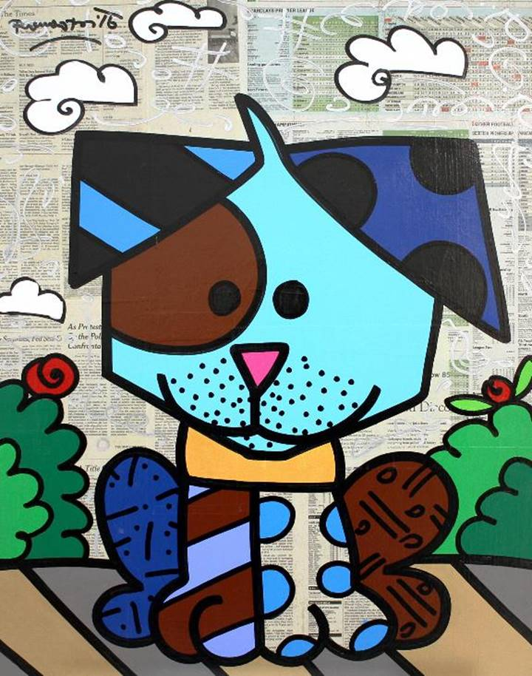

**Photo Caption:  Dog**

**About Chasen Galleries**

Chasen Galleries is a fine art gallery representing art and artists from around the world. Offering a diverse array of options, the gallery is dedicated to pairing clients with the perfect work of art for their home or space. Over the last several years, the gallery has hosted extensive collections by world-renowned masters such as Peter Max and Salvador Dali, and will continue that tradition into 2017 with this exclusive collection of works by Romero Britto.



**MEDIA INTERVIEWS are coordinated by:**

**Allison Zucker-Perelman, Relevant Communications,** **561.715.9525 or** [Allison@relevantcommunications.net](mailto:Allison@relevantcommunications.net)

**© Romero Britto 2016 must appear next to each image in all print and digital/online displays. All photos courtesy of the artist.**

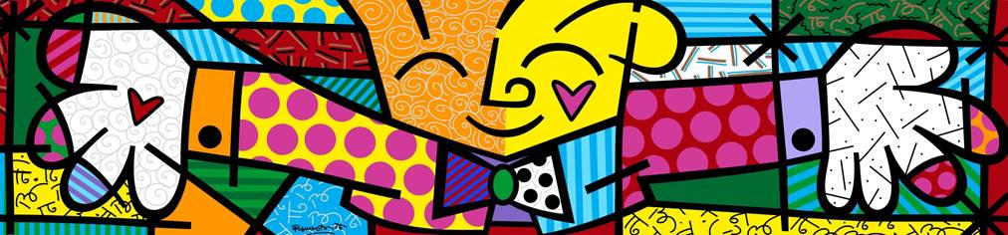

**Photo Caption:  The Hug**

