**PETER MAX AVAILABLE FOR INTERVIEWS**

**ICONIC AMERICAN ARTIST PETER MAX TO EXHIBIT IN FORT WORTH**

**America’s Favorite Living Artist to Appear at Milan Gallery**

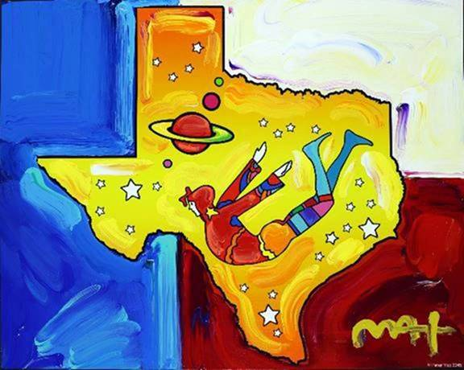**Cosmic Texas             Peter Max**

**America’s most popular living Artist celebrates our world, our country and brings a message of unity, love and hope to all.**

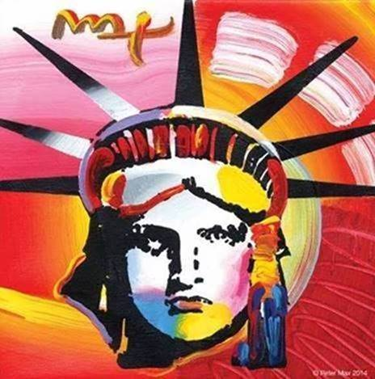

***Image:  LIBERTY            PETER MAX***

**FOR IMMEDIATE RELEASE:**

**PETER MAX – THE COLLECTED WORKS 1960-2017**

**AN EXHIBITION OF NEWLY-CURATED WORKS FROM AMERICA’S ICONIC ARTIST**

**Journey through the career of a Pop Culture Icon:**

**Peter Max to Appear in Fort Worth**

***An artistic diversity that has defined American Art: Captured by the Artist who began a new visual culture***

**Fort Worth, Texas – (February 2017) –** A newly-curated collection by artist legend, Peter Max’s exquisite paintings will be on exhibition and available for acquisition in a presentation at Fort Worth’s Milan Gallery.

[www.milangallery.com](http://www.milangallery.com)

**Live B-Roll Link:**[**http://roadshowcompany.com/peter-max-interview/**](http://roadshowcompany.com/peter-max-interview/)

Peter Max will make two very special appearances at the gallery and all appearances are complimentary and open to the public with RSVP’s required.   Previews begin **Saturday, March 18TH, 2017 with a fabulous Preview Event from 6-8pm.   There are** **two scheduled *Meet the Artist receptions:  Friday, March 24th, 2017 from 6-8 pm and Saturday, March 25th from 1pm – 3 pm.  All artworks are on exhibition and available for acquisition.  RSVP’s are required: 817.338.4278 or*** [tal@milangallery.com](mailto:tal@milangallery.com)

***.***

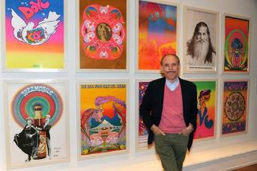The Artist has assembled a collection of his greatest and most-revered imagery spanning four decades: from his iconic Pop Art designs commemorating Woodstock to the 2013 unveiling of Max’s design for the cruise ship ***Breakaway and the exquisite Masters series.*** This new exhibition speaks to the evolution and maturation of America’s most popular living Artist.

***The Artist in his NYC Studio***

This carefully curated collection is a museum-like retrospective of Max’s works:  **Peter Max** has painted for five U.S. Presidents and his art is on display in Museums, Presidential Libraries and in U.S. Embassies across the globe.   He has been the Official Artist of the Grammy’s, five NFL Super Bowls, the 2006 Olympics, the World Cup USA, The World Series, The U.S. Open, The Indy 500, The NYC Marathon and The Kentucky Derby.

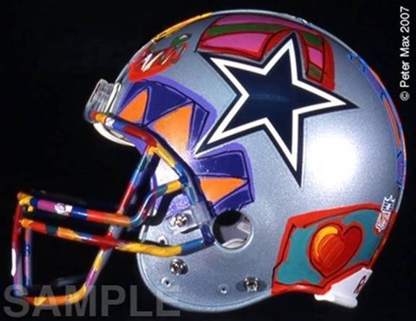

***Dallas Cowboys NFL Helmet***

***All NFL Helmets On Exhibition & Available for Acquisition***

Peter Max emerged as a powerful force in the Art World from the prestigious Art Students League, alongside such artists as Robert Rauschenberg, Jackson Pollack, Cy Twombly and Norman Rockwell.  The League was a formative influence on these artists’ innovative artwork, and has led each and every one to greatness and an important legacy in history.

**Max’s** Art Students League scholarly influence inspired all of his extraordinary artwork, and of late, his new Masters series; his interpretive works of **Vincent Van Gogh**, **Monet, Pablo Picasso, Renoir, and Edgar** **Degas**, conceived in Max’s signature style and colors.  These works speak to both a maturation of the artist’s illustrious career, as well as to his formidable training at the 130-year-old Art Students League of New York.

Image: **Love -** Peter Max 2010

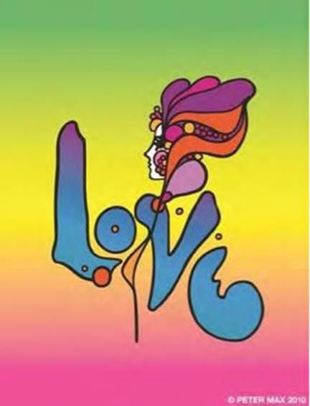

**Max’s iconic ‘Love,’ first created as his   
acclaimed Art Nouveau-inspired ‘Love’  
poster for the ‘60s generation, now   
flows with his signature, expressionistic   
brushstrokes.**

______________________________

**Important pieces of the Retrospective Collection and the Masters Series will be available for acquisition in the Fort Worth presentation.**

**Live B-Roll Link** [**http://roadshowcompany.com/video/**](http://roadshowcompany.com/video/)

With paintings on exhibition in hundreds of museums and galleries worldwide, Peter Max and his vibrant colors have become part of the fabric of contemporary culture. Max has been successively called a Pop Icon, Neo Fauvist, Abstract Expressionist and the United States "Painter Laureate."    
The artist has had the distinct honor of painting the last seven Presidents of the United States and the world's best loved celebrities, among them the young sensation Taylor Swift.

***The public and gallery patrons have the opportunity to Commission a Portrait at this presentation.***

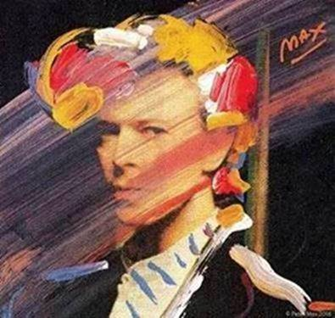   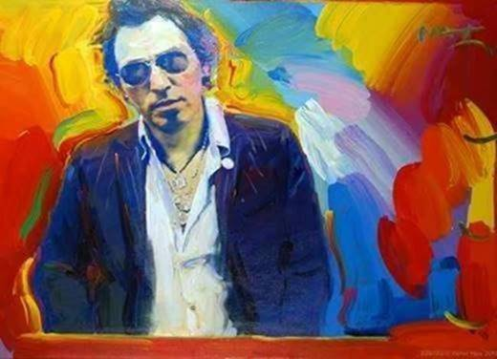

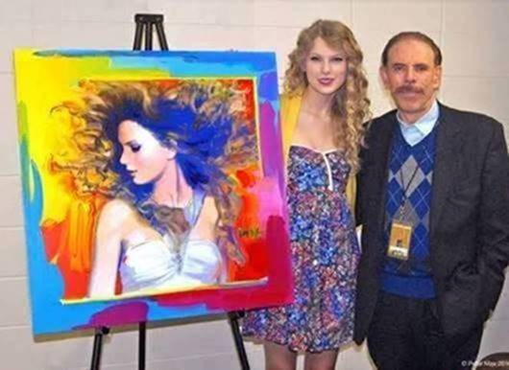   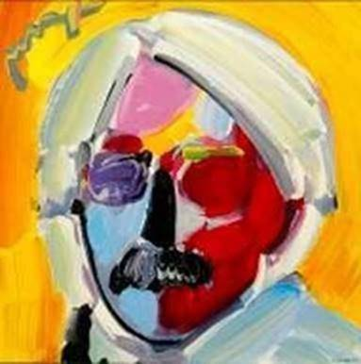

**Artist Peter Max hosts Lionel Ritchie in his New York City studio on 1/20/2017 with the portrait he painted honoring Mr Ritchie as MusiCares 2016 Person of the Year.**

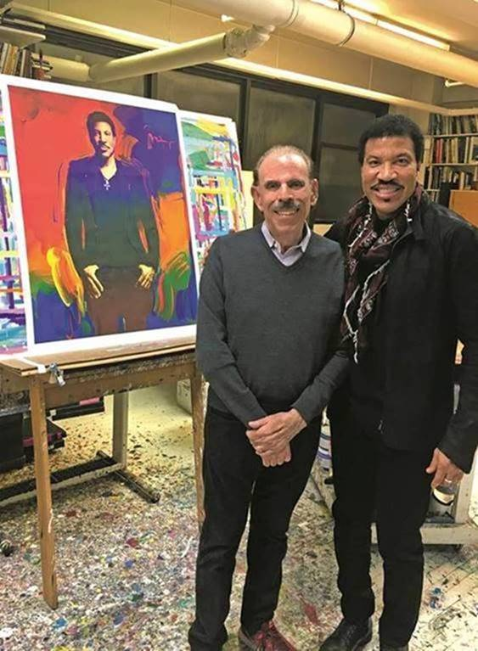

Last year superstar Lionel Richie was honored at the Grammy MusiCares Foundation dinner which helps musicians in need. Recently, while flipping through the catalog he noticed a portrait of himself that was auctioned that evening. When he saw the painting was by legendary pop artist Peter Max, he got so excited he called the artist and asked to visit his studio in New York City. Once there he and Max, a huge fan of Richie, traded hugs and Richie told Max he missed meeting Andy Warhol as he was still living in Tuskegee, Alabama and was so thrilled to meet Peter Max. Lionel will be in NYC to rehearse for his upcoming tour with Maria Carey.

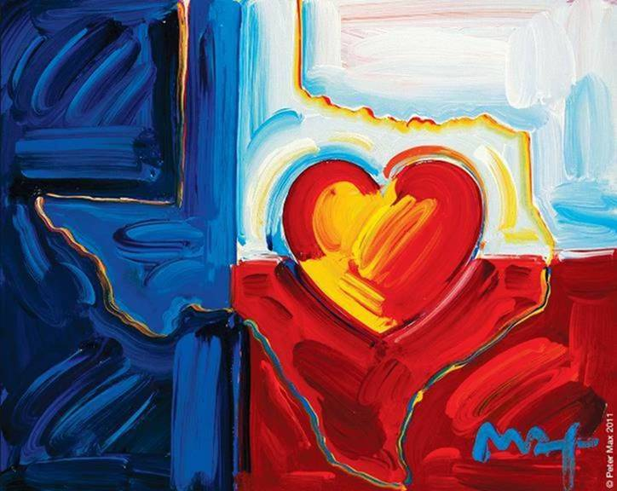

**Image:  Flag of Texas - Peter Max**

This exhibit features his iconic and best-known pieces as well, among them “Statue of Liberty,” Max’s famous “Flag” pieces, “Umbrella Man” and the prestigious “Cosmic Runner.”             
There will also be presentations of his celebrity portraiture in Fort Worth, as Peter Max is revered for his celebrity commissions and portraits.  Commissions of Portraits are available to all patrons & guests at the gallery.

______________________________

**PETER MAX CREATES NBC’S**

**THE VOICE FALL PREMIERE CAMPAIGN**

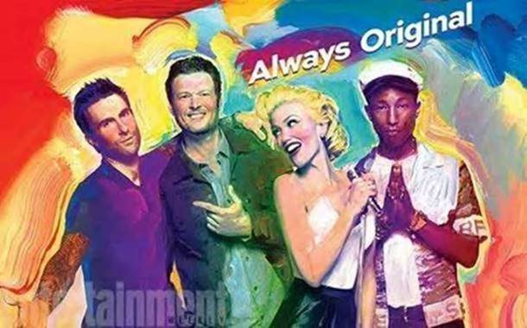

Click to load web page:

[**http://www.nbc.com/the-voice/video/peter-max-brings-his-color-to-the-voice/2905555**](http://www.nbc.com/the-voice/video/peter-max-brings-his-color-to-the-voice/2905555)

The Artist has assembled a collection of his greatest and most-revered imagery spanning four decades:

From his iconic Pop Art designs commemorating Woodstock to the 2013 unveiling of Max’s design for the cruise ship Breakaway and the 2016 exquisite Masters series.

This new exhibition speaks to the evolution and maturation of America’s most popular living Artist.

______________________________

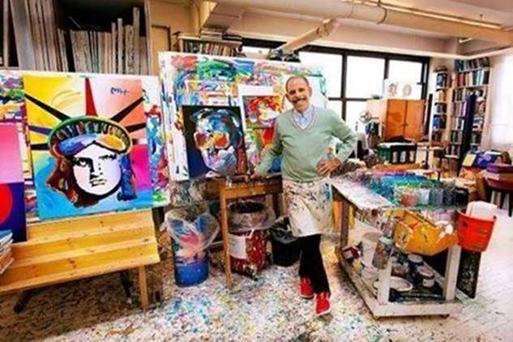

**Image: The Artist in his Studio     2017**

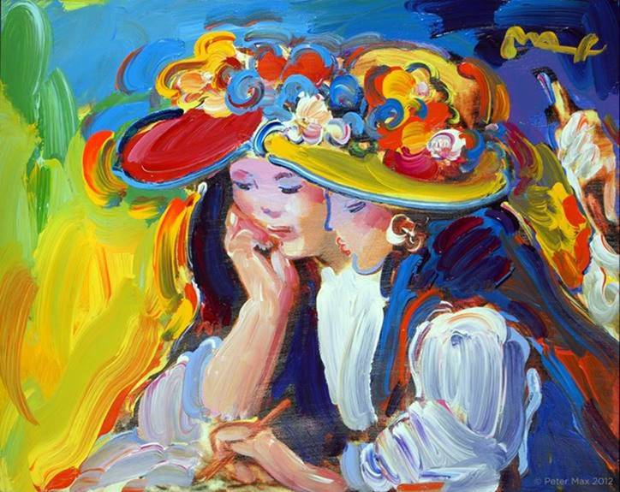

**IMAGE:  Homage to Renoir**

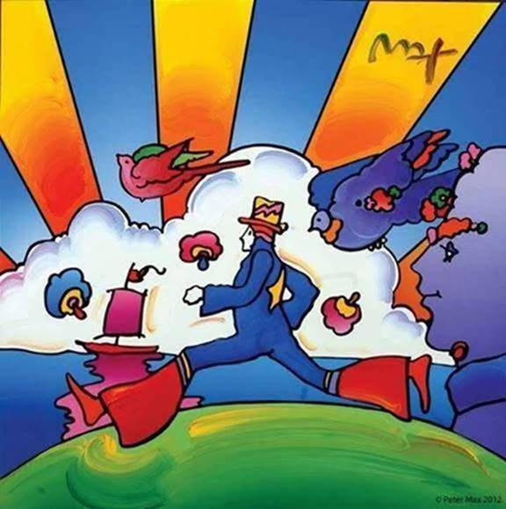

Image: **The Iconic Cosmic Runner**-  Peter Max

__________________________

For more information about Peter Max, America’s most well-known and most collected artist, go to [www.petermax.com.](http://www.petermax.com/)

**COMPLIMENTARY TO THE PUBLIC - RSVP’S REQUIRED**

**Website:** [www.milangallery.com](http://www.milangallery.com)

**RSVP Telephone:   817.338.4278 or** [tal@milangallery.com](mailto:tal@milangallery.com)

**Where:      Milan Gallery**

**505 Houston Street**

**Fort Worth, Texas  76102**

**When:          Receptions with Peter Max**

**Friday, March 24th, 2017                      6-8 pm**

**Saturday, March 25th, 2017                 1-3 pm**

***Previews Begin Saturday, March 18th 2017***

***All artwork is on exhibition and available for acquisition.***

**MEDIA INTERVIEWS are coordinated by:**

Allison Zucker-Perelman, Relevant Communications,

561.715.9525   **allison@relevantcommunications.net**

A full biography, b-roll, video clips and 300 dpi photography are available upon request @**allison@relevantcommunications.net**

© Peter Max 2016 must appear next to each image in all print and digital/online displays. All photos courtesy of the artist.