MEDIA INTERVIEWS are coordinated by:
Allison Zucker-Perelman, Relevant Communications, 561.715.9525 or Allison@relevantcommunications.net
Interviews with Romero Britto, High-Resolution Images, B-Roll and Additional Copy Points Available Upon Request

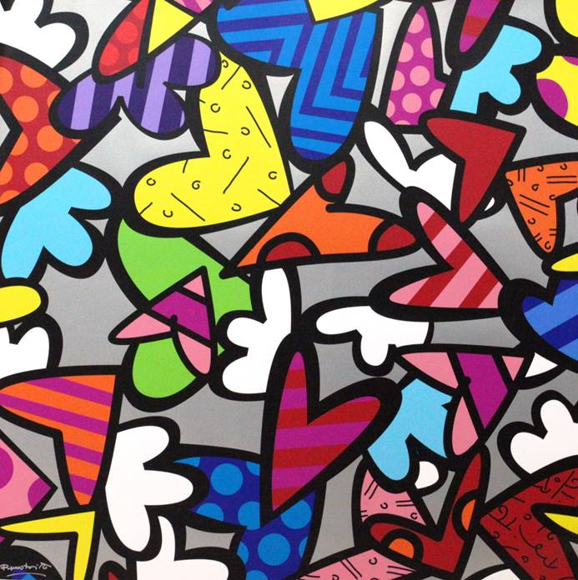

Photo Caption: Alive Again
FOR IMMEDIATE RELEASE:

OFF THE WALL GALLERY PRESENTS WORLD-RENOWNED ARTIST
ROMERO BRITTO IN EXCLUSIVE HOUSTON PRESENTATION

ROMERO BRITTO

ART ON EXHIBITION & AVAILABLE FOR ACQUISITION

ROMERO BRITTO
WORLD’S MOST FAMOUS POP-ARTIST
BRINGS HIS EXTRAORDINARY COLLECTION TO HOUSTON’S DISTINGUISHED OFF THE WALL GALLERY

Limited Engagement: January 14th, 2017 through January 22nd, 2017

HOUSTON, TX: December 2016 - An impressive collection by world-renowned artist Romero Britto will be on exhibition and available for acquisition at Off the Wall Gallery at the Galleria in Houston, Texas. The exhibition previews January 14th and opens on Friday, January 20th, 2017 with a series of live Artist Appearances: The limited engagement exhibition begins on January 14th and runs through January 22nd, 2017. The gallery will host public exhibitions on Friday, January 20th from 6-9pm, Saturday, January 21st from 6-9 pm and Sunday January 22nd from 1-4 pm in the afternoon.

RSVP’s required: 713-871-0940 or visit www.offthewallgallery.com.

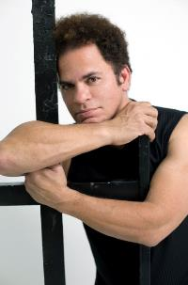

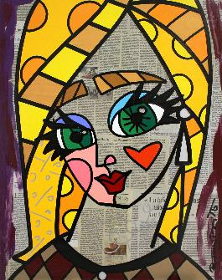

ABOUT THE ARTIST:

Video Bio for All Platforms: https://www.dropbox.com/s/zyixy1uuvdsksl2/BrittoLife1.mov?dl=0

With an iconic style that The New York Times described, “exudes warmth, optimism and love,”, Romero Britto is an international artist that uses vibrant, bold and colorful patterns to reflect his optimistic view of the world around him. His playful themes and hard‐edged compositions, combined with his unique talent, unshakable resolve and belief in his art, have granted him worldwide recognition, with exhibition in galleries and museums in over 100 countries and counting. The artist’s pop sensibility has leant itself to collaborations with global brands such as Audi, Bentley, Coca‐Cola, Walt Disney, Evian, Hublot, and Mattel, to name a few. Britto’s work evokes happiness and hope using a visual language all its own and is, simply, relatable to all.

Romero Britto was born in Recife, Brazil in 1963. Self-taught at an early age, he painted on surfaces such as newspapers. In 1983, he traveled to Paris where he was introduced to the work of Matisse and Picasso. He combined influences from cubism with pop, to create a vibrant, iconic style that The New York Times describes, “exudes warmth, optimism and love.”
In 1988, Britto moved to Miami and emerged as an international artist. In the following year, he was selected alongside Andy Warhol and Keith Haring for Absolut Vodka’s “Absolut Art” campaign. Britto’s pop sensibility has since leant itself to many collaborations with such brands as Audi, Bentley, Disney, Technomarine, Evian and FIFA, for whom he created an official poster for the 2010 World Cup.

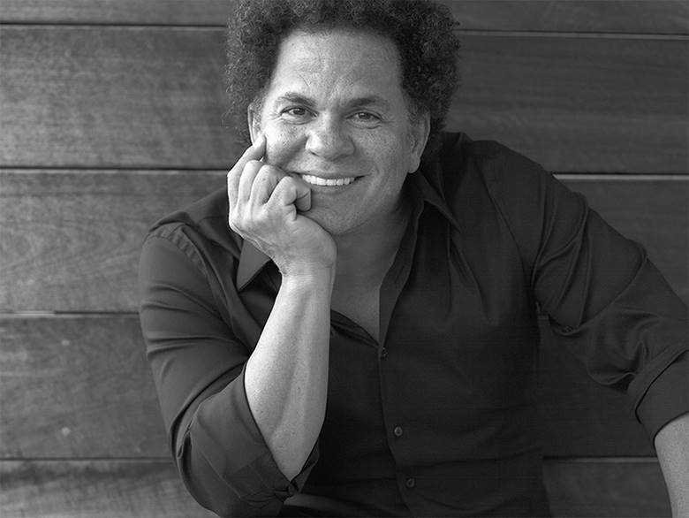
The Artist Romero Britto Photo Credit: Sergey Bermeniev All Rights Reserved

He has also illustrated several books published by Simon & Schuster and Rizzoli. Britto’s work has been exhibited in galleries and museums in over 100 countries, including the Salon Nationale des Beaux-Arts exhibition at the Carrousel du Louvre in 2008 and 2010. He has also created public art installations for the O2 Dome (Berlin), Hyde Park (London), John F. Kennedy Airport (New York), and Cirque du Soleil at Super Bowl XLI.

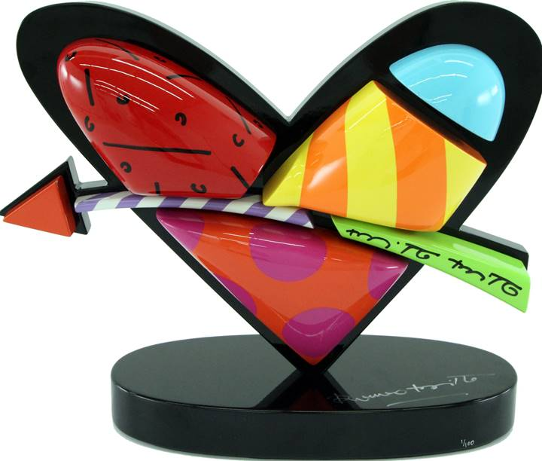

Photo Caption: In Love Sculpture

Britto considers the role of an artist to be an agent of positive change. He serves as a benefactor, donating time, art and resources to over 250 charitable organizations and several boards such as Best Buddies International, and St. Jude’s Children’s Research Hospital. He was recently named a founding inaugural benefactor of Harvard’s “International Negotiation Program," by Dr. Daniel Shapiro, in his quest for peaceful conflict resolution.

Britto has also spoken at the World Economic Forum in Davos, and at countless schools and institutions. In early 2011 the President of Brazil, Dilma Rousseff, invited Britto to create the logo for Rede Cegonha, a project to reach over 61 million pre-and post-natal mothers and babies.

"Art can make you look at something in an exciting and totally different way. It can give you the power to 'fly”.

“I get my inspiration from simple things in life… From beautiful things that happen around me, things that make me happy leave me inspired”!

“Everything is based on education. With knowledge and education, you can understand the world. ““I believe that every human being has the power to do good for someone else”. Romero Britto

For more information about Romero Britto:

A full biography, b-roll, video clips and 300 dpi photography are available upon request: please contact allison@relevantcommunications.net

Where: OFF THE WALL GALLERY
GALLERIA I Houston (Adjacent to Neiman Marcus - entrance through valet)
5015 WESTHEIMER SUITE #2208
HOUSTON, TEXAS 77056

When: Receptions with Romero Britto:

Friday, January 20th, 2017 6:00 pm - 9:00 pm

Saturday, January 21st, 2017 6:00 pm - 9:00 pm

Sunday, January 22nd, 2017 1:00 pm – 4:00 pm

Website: www.offthewallgallery.com

RSVP Telephone: 713.871.0940 (RSVP) or mimi@offthewallgallery.com

COMPLIMENTARY TO THE PUBLIC – RSVP’S REQUIRED

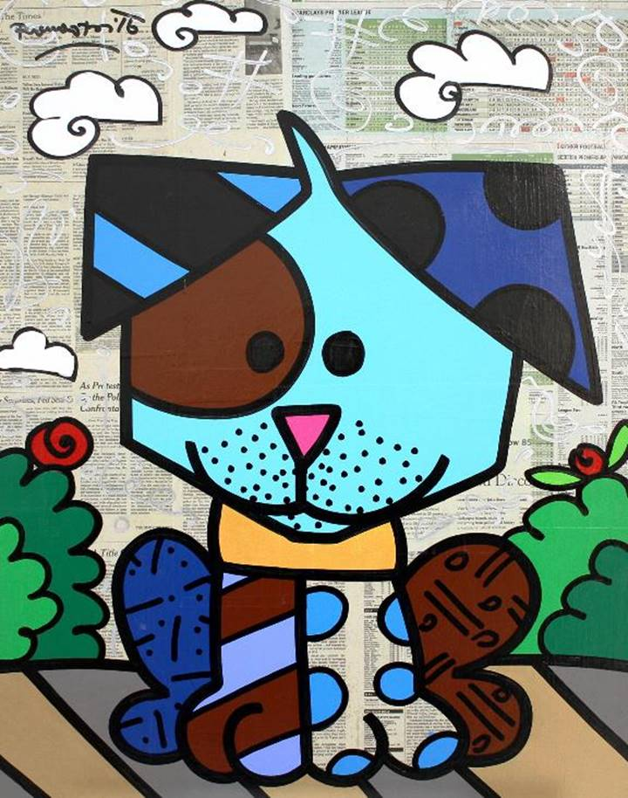
Photo Caption: Dog

About Off the Wall Gallery:
Off The Wall Gallery is Houston’s premier Fine Art Gallery, and is known globally for their curatorial expertise and Collections.. The gallery exhibits a wealth of art, including fine art originals, prints and sculpture. We also have an exceptional staff who can assist collector and novice alike.
World-renowned Gallerist Mimi Sperber has created an art gallery which embodies what she terms Urban Eclecticism; pieces which blend artistic elements into a unique creation providing nourishment for today's urban souls. Visit Off the Wall, and experience this unique Urban Eclecticism for yourself.

MEDIA INTERVIEWS are coordinated by:
Allison Zucker-Perelman, Relevant Communications, 561.715.9525 or Allison@relevantcommunications.net

© Romero Britto 2016 must appear next to each image in all print and digital/online displays. All photos courtesy of the artist.
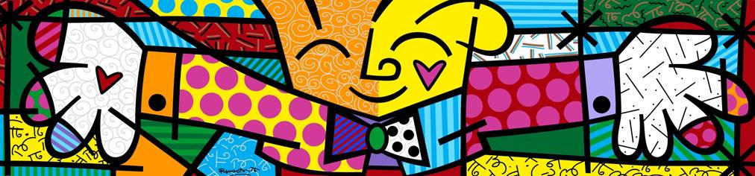
Photo Caption: The Hug

RSVP’s are coordinated by:
Off the Wall Gallery
713.871.0940

