**Peter Max Brings Retrospective Exhibition to Naples**

**For your editorial consideration.  Interviews Available with Peter Max**

**ICONIC AMERICAN ARTIST**

**PETER MAX   
TO EXHIBIT IN NAPLES**

**Key West Gallery & Road Show Company join forces to present a newly-curated Collection of the works of Peter Max**

**America’s Favorite Living Artist to Appear at**

**The Mercato**

Media Interviews are coordinated by: Allison Zucker-Perelman, Relevant Communications, 561.715.9525

[**allison@relevantcommunications.net**](mailto:allison@relevantcommunications.net)

B-Roll, High Resolution 300dpi images available. Interviews with Peter Max upon request.

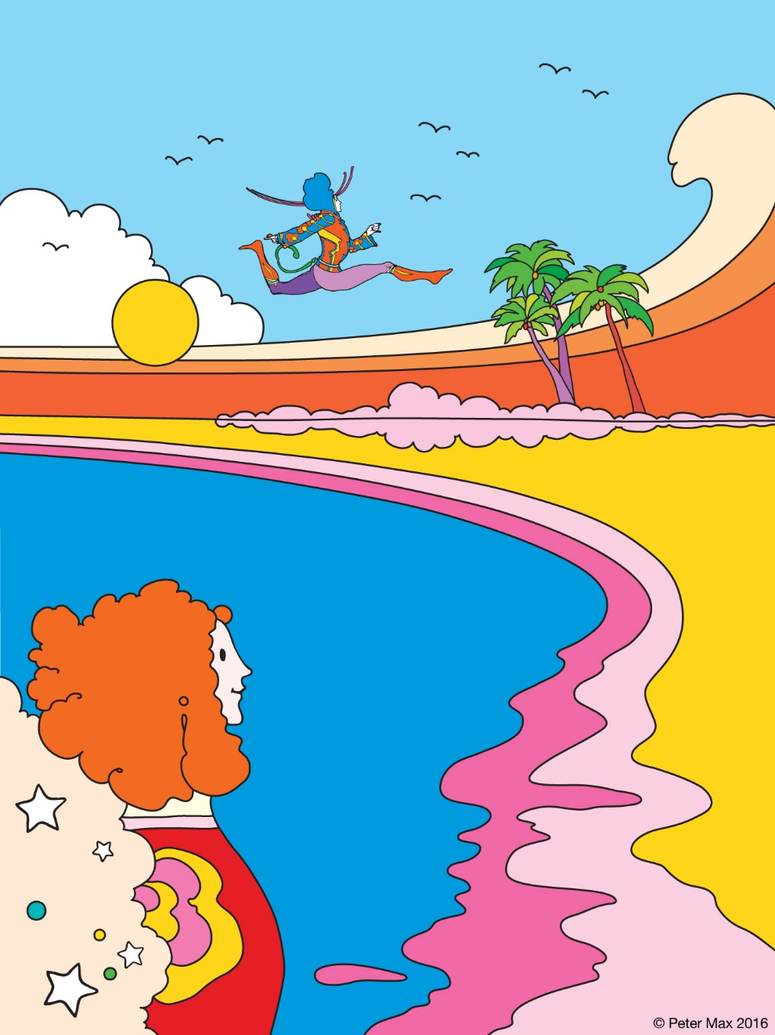

**Image: COSMIC BEACH PETER MAX 2016**

______________________________

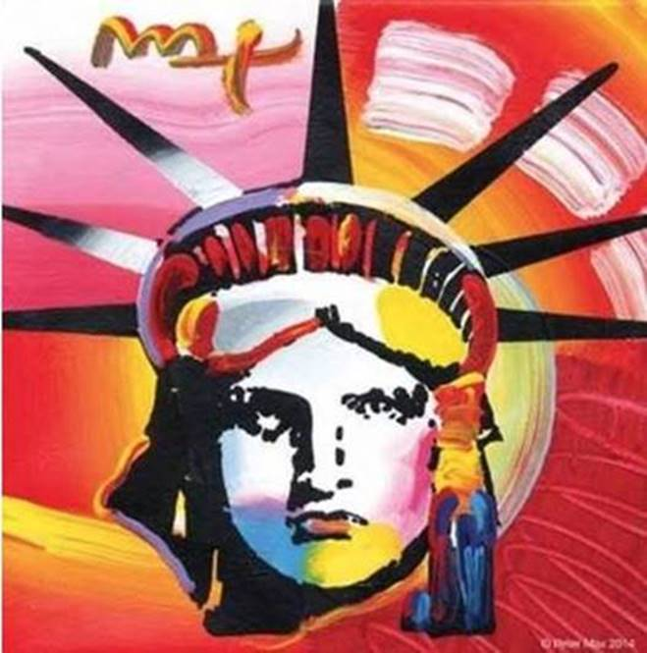

Image: **Liberty -** Peter Max 2014

**America’s most popular living Artist   
celebrates America and the symbols   
that gave us our freedom.**

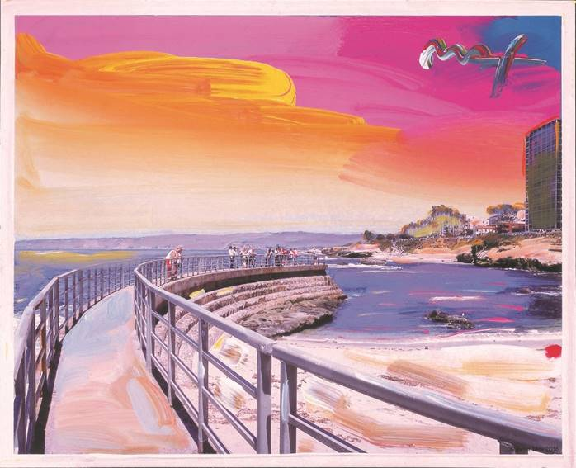

**Image:  Cosmic Beach   Peter Max  2016**

Image: **Love -** Peter Max 2010

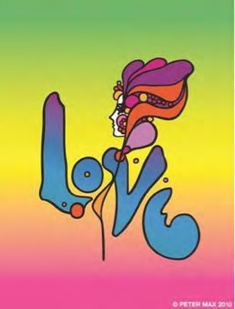**Max’s iconic ‘Love,’ first created as his   
acclaimed Art Nouveau-inspired ‘Love’  
poster for the ‘60s generation, now   
flows with his signature, expressionistic   
brushstrokes.**

______________________________

**FOR IMMEDIATE RELEASE:**

**PETER MAX - THE RETROSPECTIVE**

**1960 - 2017**

**AN EXHIBITION OF WORKS FROM AMERICA’S ICONIC ARTIST**

***An artistic diversity that has defined American Art:   
Captured by the Artist who began a new visual culture***

***Naples, Florida – (November 2016)*** – A newly-curated collection by artist legend, Peter Max’s exquisite paintings will be on exhibition and available for acquisition in a presentation at Naples’ premier lifestyle destination, The Mercato at the fine art gallery on Strata Place.  This unique and newly curated Collection is a partnership between Key West Gallery, one of Florida’s most highly-respected galleries and Road Show Company, the world leader in traveling exhibition for fine art.

[www.roadshowcompany.com](http://www.roadshowcompany.com)

Peter Max will make three very special appearances at the gallery and all appearances are complimentary and open to the public with RSVP’s required.

**Previews begin Friday, January 20th,  2017 with a Preview Uncrating Event on Friday, January 20th, 2017  from 6-8 pm.         
  
There are three scheduled Meet the Artist receptions:   
Friday, January 27th, 2017 from 6-9 pm, Saturday, January 28th 2017 from 6-8 pm and Sunday, January 29th, 2017 from 1-4 pm.**

**All artworks are on exhibition and available for acquisition.**

RSVP’s are required: 844.810.9100 or[naples@roadshowcompany.com](mailto:naples@roadshowcompany.com)

______________________________

With paintings on exhibition in hundreds of museums and galleries worldwide, Peter Max and his vibrant colors have become part of the fabric of contemporary culture. Max has been successively called a Pop Icon, Neo Fauvist, Abstract Expressionist and the United States "Painter Laureate."    
The artist has had the distinct honor of painting the last seven Presidents of the United States and the world's best loved celebrities, among them the young sensation Taylor Swift.

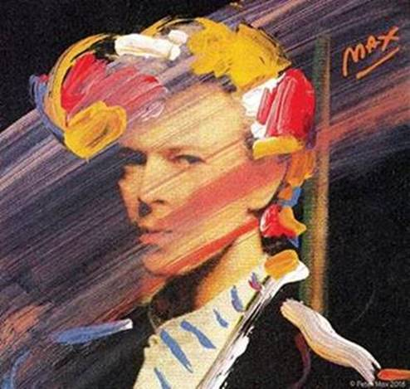   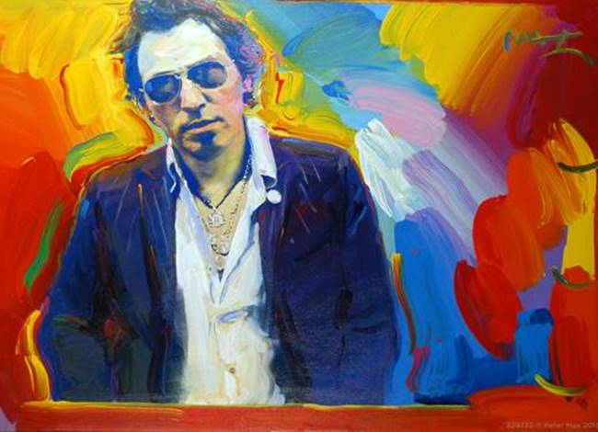

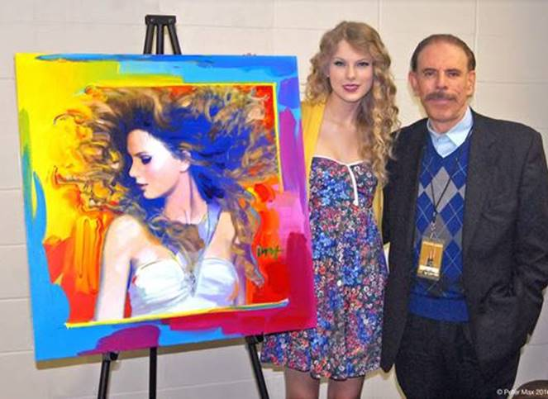   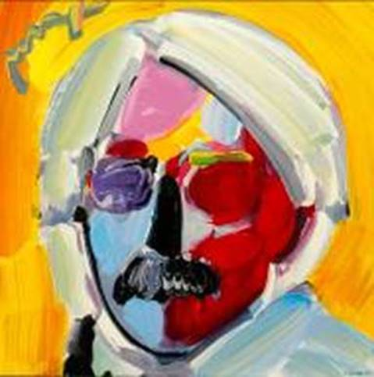

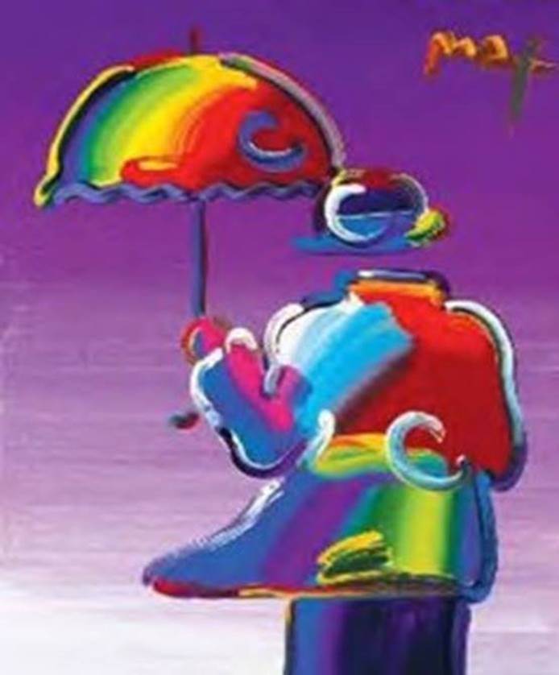

Image: **Umbrella Man** - Peter Max

This exhibit features his iconic and best-known pieces as well, among them “Statue of Liberty,” Max’s famous “Flag” pieces, “Umbrella Man” and the prestigious “Cosmic Runner.”             
There will also be presentations of his celebrity portraiture in Naples, as Peter Max is revered for his celebrity commissions and portraits.

______________________________

**PETER MAX CREATES NBC’S**

**THE VOICE FALL PREMIERE CAMPAIGN**

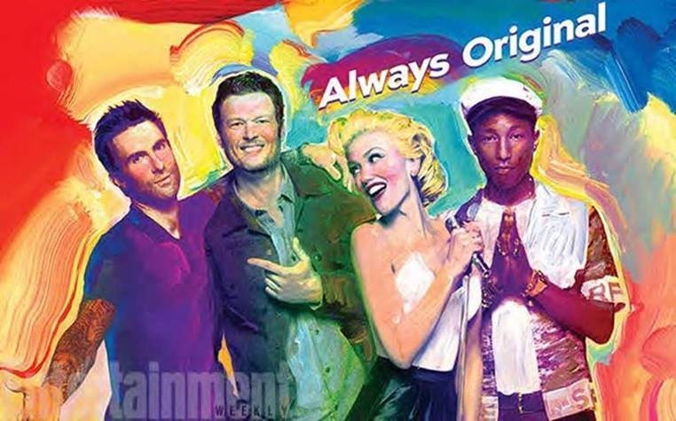

Click to load web page:

[**http://www.nbc.com/the-voice/video/peter-max-brings-his-color-to-the-voice/2905555**](http://www.nbc.com/the-voice/video/peter-max-brings-his-color-to-the-voice/2905555)

With paintings on exhibition in hundreds of museums and galleries worldwide, Peter Max and his vibrant colors have become part of the fabric of contemporary culture.

Max has been successively called a Pop Icon, Neo Fauvist, Abstract Expressionist and the United States “Painter Laureate.”  
The artist has had the distinct honor of painting the last seven Presidents of the United States and the world’s best-loved celebrities, among them the young sensation Taylor Swift.

The Artist has assembled a collection of his greatest and most-revered imagery spanning four decades:

From his iconic Pop Art designs commemorating Woodstock to the 2013 unveiling of Max’s design for the cruise ship Breakaway and the 2016 exquisite Masters series.

This new exhibition speaks to the evolution and maturation of America’s most popular living Artist.

______________________________

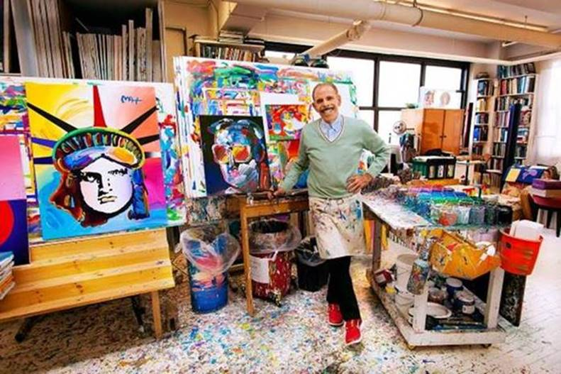

**Image: The Artist in his Studio 2016**

He has been the Official Artist of the Grammy’s, five NFL Super Bowls, the 2006 Olympics, the World Cup USA, The World Series, The U.S. Open, The Indy 500, The NYC Marathon and The Kentucky Derby.

**Peter Max CBS This Morning 1/2/2015**

[www.cbsnews.com/videos/artist-peter-maxs-colorful-creations-span-50-years/](http://www.cbsnews.com/videos/artist-peter-maxs-colorful-creations-span-50-years/)

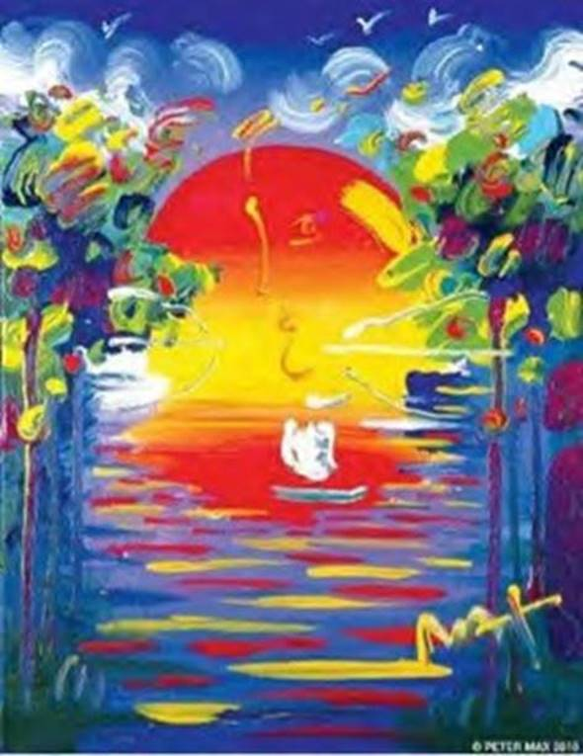

Image: **A Better World** – Peter Max

Max’s Art Students League scholarly influence inspired all of his extraordinary artwork, and of late, his new Masters series; his interpretive works of Vincent Van Gogh, Monet, Pablo Picasso, Renoir, and Edgar Degas, conceived in Max’s signature style and colors.

These works speak to both a maturation of the artist’s illustrious career, as well as to his formidable training at the 130-year-old Art Students League of New York.

**Important pieces of the Retrospective Collection and the Masters Series will be available for acquisition in the Naples presentation.**

Live B-Roll Link: <http://roadshowcompany.com/peter-max/>

______________________________



**Image: The Peter Max Designed Continental Boeing**

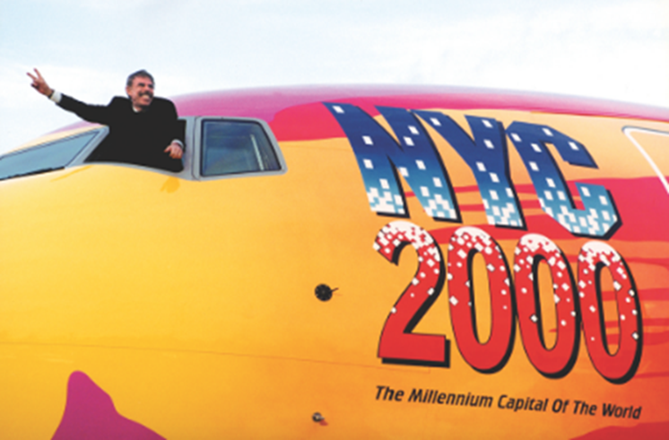

**The Artist Piloting His Flying Work of Art**

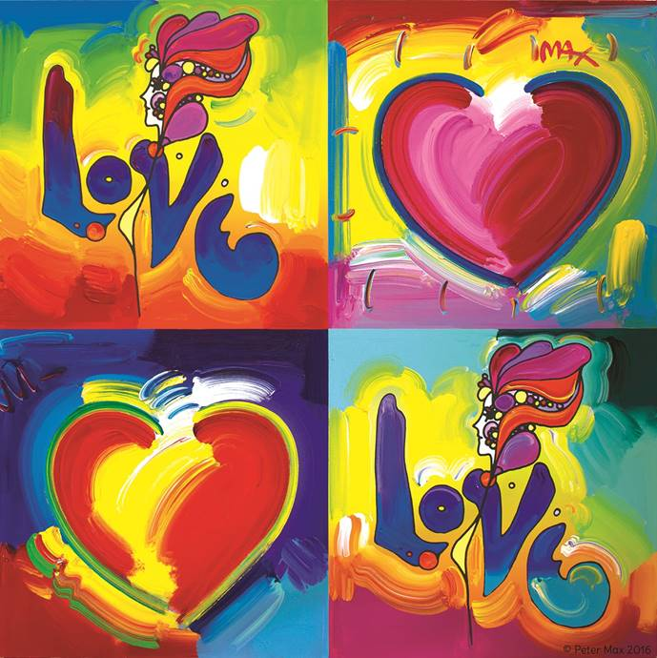

Image: Hearts and Love    Peter Max.  All Rights Reserved 2016

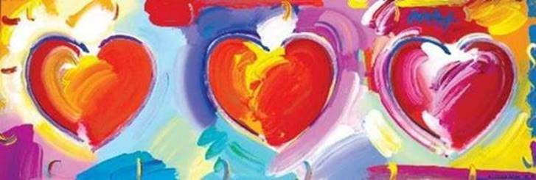

**Image: Hearts New Series – Peter Max 2016**

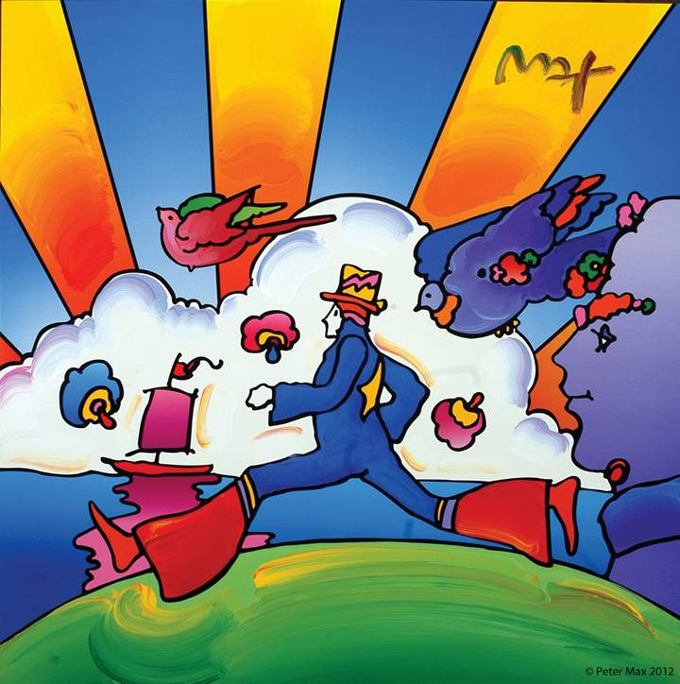

Image: **The Iconic Cosmic Runner**-  Peter Max 2016

________________________________________

**Website:** [www.roadshowcompany.com](http://www.roadshowcompany.com)

**RSVP’s are required:   84.810.9100 or**

[naples@roadshowcompany.com](mailto:naples@roadshowcompany.com)

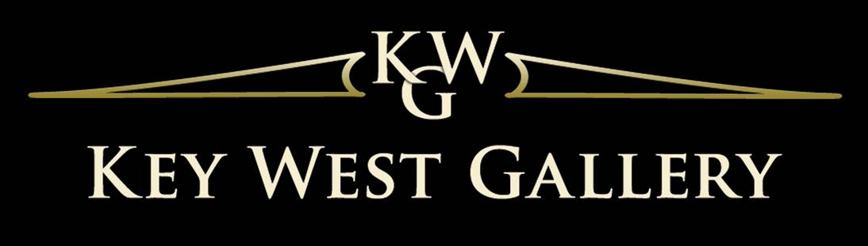

Where:    Peter Max at The Mercato

9115 Strata Place   # 5155

Naples, Florida

When:     Receptions with Peter Max

Friday, January 27th, 2017  6-8 pm

Saturday, January 28th 2017  from 6-8 pm

Sunday, January 29th  2017   from 1-4 pm

***All artwork is on exhibition and available for acquisition.***

**MEDIA INTERVIEWS are coordinated by:**

Allison Zucker-Perelman, Relevant Communications,

561.715.9525   **allison@relevantcommunications.net**

A full biography, b-roll, video clips and 300 dpi photography are available upon request @**allison@relevantcommunications.net**

© Peter Max 2016 must appear next to each image in all print and digital/online displays. All photos courtesy of the artist.