**Madame Christine Argillet to Accompany Salvador Dali Collection to South Florida on Its North American Art Tour**

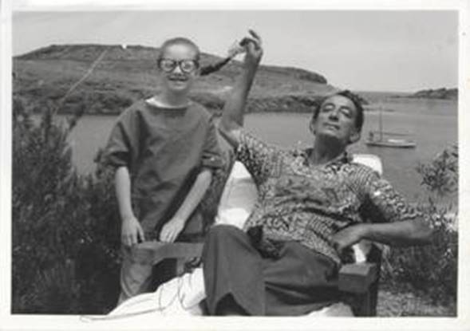

**Salvador Dali & Christine Argillet   1970’s**

I did wish to contact you regarding the opportunity for an exclusive interview with Ms. Christine Argillet, who will be appearing in Palm Beach Gardens, Florida in support of an exhibition of the extraordinary collection ***DALI: THE ARGILLET COLLECTION*** this coming January of 2017.  This is an extraordinary, museum quality presentation; the Collection has toured in galleries across the globe, and presented in many US cities; among them Washington, D.C., Chicago, New York, Dallas, Los Angeles, Houston, Los Angeles and San Diego.

A personal documentary depicting the relationship between Dali and Christine Argillet :  *This video is for proprietary editorial viewing only. No usage may be made of this video on any platform prior to the express approval of Viken Productions.*

**Copyright 2016 Viken Productions All Rights Reserved. Link:** [**https://vimeo.com/108317280**](https://vimeo.com/108317280)

**Password:   SVACA1232**

Madame Argillet is both the Curator of this Dali Collection, as well as the daughter of the famed Pierre Argillet, Salvador Dali's publisher and confidante for over fifty years.  Her story is unapparelled, and as compelling as any I have encountered in terms of artistic knowledge and family history with regard to Dadaism....the Surrealists..and the stories behind the artists who shaped these most important Art Movements.

The Argillet Collection is unequivocally the most authenticated collection of Dali's work throughout his career.  The Pierre Argillet Collection demonstrates high standards of quality and the works have appeared in the world's most prestigious museums: Musee Boymans, Rotterdam;  Musee Pushkin, Moscow;  The Dali Museum, St. Petersburg, Florida; Kunsthaus Zurich and Staatsgalarie, Stuttgart;  Isetan Museum of Art, Tokyo; Daimaru Art Museum, Osaka and Hiroshima Prefectural Museum of Art, Japan.  The collection's permanent home is at the Museum of Surrealism in Melun, France and the Dali Museum in Figueres, Spain.

Dali’s open-mindedness and innate ability to embrace a plethora of topics and themes can also be seen in his etchings and drawings, which address different topics, from religion to eroticism. Pierre Argillet’s daughter, Christine Argillet, spent much of her childhood in the presence of Salvador Dali, and experienced his receptivity and broad-mindedness first-hand. Her presence in Onessimo Fine Art the opening week of this exhibition will provide invaluable insights into the collaboration be- tween her father and Dali, and works they produced together.

***Madame Argillet describes this exhibition as "A tribute to the work of my father, Pierre Argillet, as an extraordinary publisher of the Dada and Surrealist group.  This collection reflects a constant endeavor and a close collaboration with the artists of these two movements, especially Salvador Dali.  My goal is to have this collection presented in the finest museums and galleries in the world".***

I have included some photos for your initial review, among them personal photos of Christine and Dali through the years, as well as a photo of Madame Argillet.  I have a wealth of high resolution images of the contents of the Collection and an exhibition catalogue as well, if you wish further images.

This is an opportunity for your audience to meet one of the cultural icons of the Art World, and I can think of no better landscape than your outlet in which to do so.

I look quite forward to speaking with you to discuss this opportunity.

Please contact me at your very earliest convenience.

**Madame Christine Argillet to Accompany Salvador Dali Exhibition**

**INTERVIEWS WITH MADAME ARGILLET AVAILABLE**

**MEDIA INTERVIEWS are coordinated by:**

Allison Zucker-Perelman, Relevant Communications

561-715-9525 or [allison@relevantcommunications.net](mailto:allison@relevantcommunications.net)

­­­­­­­­­­­­­­­­­­­­­­_________________________________________________________________________________

# Press Release

### Onessimo Fine Art Presents:

### **SALVADOR DALI:   THE ARGILLET COLLECTION**

­­

Venerable South Florida Gallery Presents the Art Event of the Season

Collection on Exhibition & Available for Acquisition

January 1st , 2017 through January 15th , 2017

Special Appearances by Madame Christine Argillet

|  |  |  |  |
| --- | --- | --- | --- |
| cid:image002.jpg@01D247B7.4B88CED0 | cid:image003.jpg@01D247B7.4B88CED0 | cid:image004.jpg@01D247B7.4B88CED0 | cid:image005.jpg@01D247B7.4B88CED0 |
| "Dali devant tablo"  Dali foreground with Tapestry of Argus  Argillet Museum  France 1973 | Salvador Dali & Pierre Argillet working  on the Venus in Furs project.  Paris 1967 | Medusa  Salvador Dali - Mythologie | Piano Under Snow  Surrealist Bullfight  Salvador Dali |

Madame Christine Argillet to accompany rare and extraordinary collection of Salvador Dali's and Pierre Argillet's collaborative works of original etchings, Aubusson Tapestries & original watercolors.

***Palm Beach Gardens, Florida*** Onessimo Fine Art, Palm Beach Gardens’ most prestigious fine art gallery, is proud to announce its presentation of ***Salvador Dali: The Argillet Collection.***  The collection is on exhibition and available for acquisition at the gallery:  previews begin on January 2nd , 2017.

<http://www.onessimofineart.com/>

The exhibition is a rare opportunity to meet Madame Christine Argillet, daughter of Dali's legendary publisher and confidante Pierre Argillet, during scheduled special appearances by Madame Argillet for the public: **Friday, January 6th, 2017,  6:00 pm – to 9:00 pm:  Saturday, January 7th from 5:00 pm – 8:00 pm, Sunday, January 8th, 2017 from 2:00 pm – to 5:00 pm.**

**All appearances are complimentary to the public, and RSVP’s are required.**

**Meet Madame Argillet**

**Friday, January 6th, 2017**

**6:00 pm – 9:00 pm**

**Saturday, January 7th, 2017 5:00 pm – 8:00 pm**

**Sunday, January 8th, 2017**

**2:00 pm – 5:00 pm**

**Previews Begin January 2nd , 2017**

**WHERE:        Onessimo Fine Art**

**4530 Palm Beach Gardens Blvd.  Suite 101  
Palm Beach Gardens,    Florida   33418**

**RSVP: 561.355.8061 (RSVP) or** [contact@onessimofineart.com](mailto:contact@onessimofineart.com)

***All Art is On Exhibition & Available for Acquisition***

Salvador Dali's publisher, Pierre Argillet (1910-2001) and Dali enjoyed a collaboration and a friendship that spanned five decades; and produced what art historians have termed "the finest bodies of the Master's Art".  This collection made available by the Argillet Estate is...truly… A privilege and an opportunity for the collector to own a prominent piece of Dali's legacy.

Pierre Argillet's body of Dali's etchings, original works and books appear in museums throughout the world, and have enjoyed a home at the Museum of Surrealism in Melun, France (Pierre Argillet's former home "Chateau Vaux-le-Penil" and former museum) as well as in the Dali Museum in St. Petersburg, Florida.  The collection is also housed at the prestigious Los Angeles County Museum of Art (LACMA).  Together, Argillet & Dali created remarkable editions of original prints, lived the life of a committed "Surrealist” and developed images that are highly-valued and prized by collectors today.

This exhibition and collection opportunity offers works from Dali's Suites, including ***Mythologie, Les Hippies, Goethe's Faust***, and the incomparable ***Poemes Secrets d'Apollinaire.*** Madame Argillet has also graciously included the rare titles, Etchings and Watercolors from 1934 to the late 1960's.

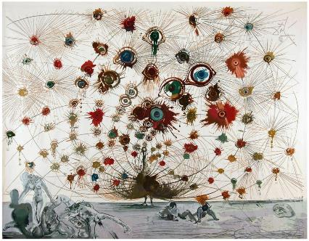

***Argus*, 1972-1973, Aubusson Tapestry, 249 x 307cm.**

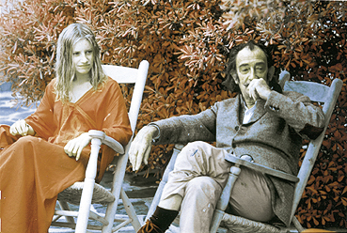

**Image: Christine Argillet and Dali 1970’s**

**Salvador Dali:  The Argillet Collection**

**A Rare & Impassioned Collaboration between Artist and Publisher**

**It has often been said by those in the art world that: "Salvador Dali was the creative genius....and Pierre Argillet was the publishing genius"**

Madame Christine Argillet, Los Angeles, CA - 2016

High-Resolution Artwork (300dpi) Available to Media/Press Upon Request



**MEDIA INTERVIEWS are coordinated by:**

Allison Zucker-Perelman, Relevant Communications

561-715-9525 or [allison@relevantcommunications.net](mailto:allison@relevantcommunications.net)

Additional Copy Points, High Resolution Photography, B-Roll and Archived Digital Stills Available Upon request @ [allison@relevantcommunications.net](mailto:allison@relevantcommunications.net)

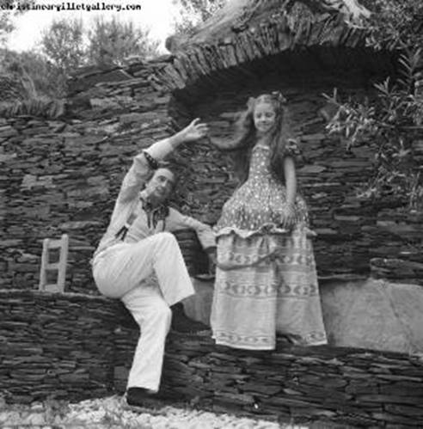   THE ARTIST AND MADAME ARGILLET   1972

.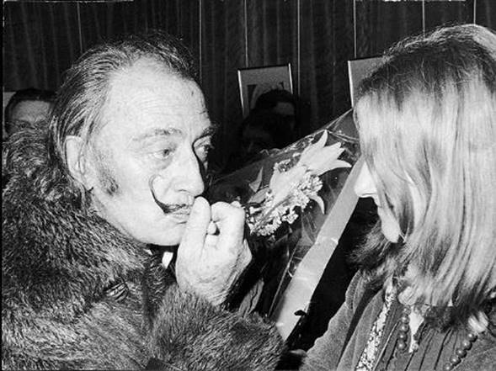

**MEDIA INTERVIEWS are coordinated by:**

Allison Zucker-Perelman, Relevant Communications

561-715-9525 or [allison@relevantcommunications.net](mailto:allison@relevantcommunications.net)

# 

# SELECTED IMAGES

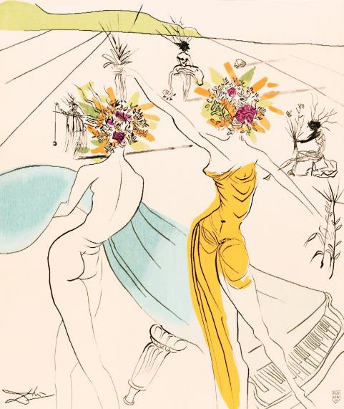

**Tapestries**

*Flower Woman with Soft Piano*, 1972 Handwoven Aubusson Tapestry, 160 x 127cm Edition size – 6.

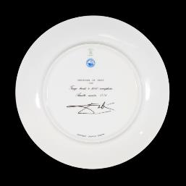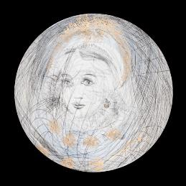

# Porcelain Plates

*Gretchen* (Marguerite)

Porcelain with Gold Leaf, 25.5cm diameter, Edition of 2000 Includes Atelier's stamp: Raynaud, In Limoges, France.

# Original Etchings

*Bullfight with Parrots,* 1967

Heliogravure reworked in drypoint and hand-coloured on paper, 51 x 66cm Editions I-C on Japanese paper, 1-150 on Arches paper.

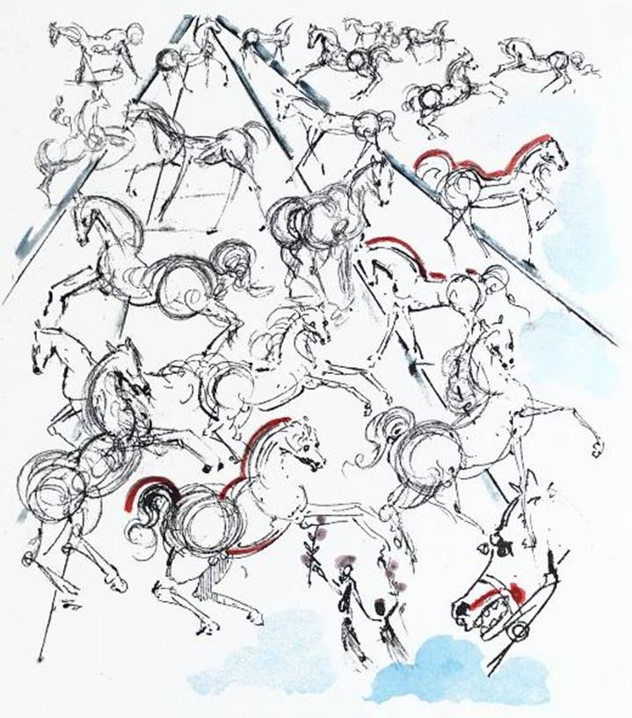

*Blue Horses*, 1966

Drypoint etching, hand-coloured, 66 x 51cm Editions I-C on Japanese paper, 1-150 on Arches paper.

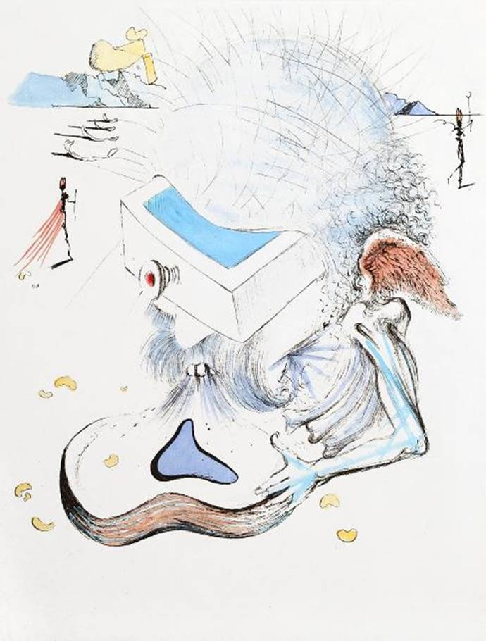

*The Drawers,* 1967

         Drypoint etching on Japanese paper, 38 x 29cm Edition size – 145.

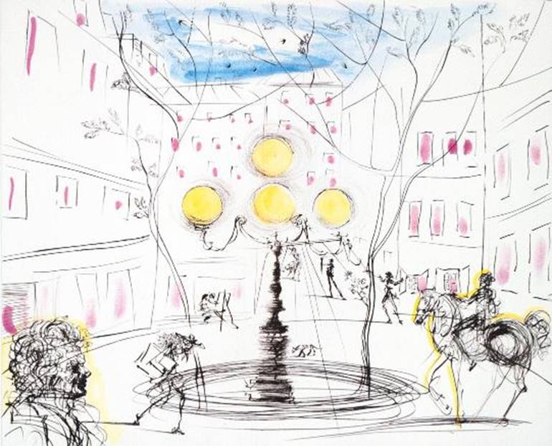

*Place Furstenberg,* 1971 Drypoint etching on paper, 51 x 66cm

           Editions I-C on Japanese paper, 1-150 on Arches paper.

